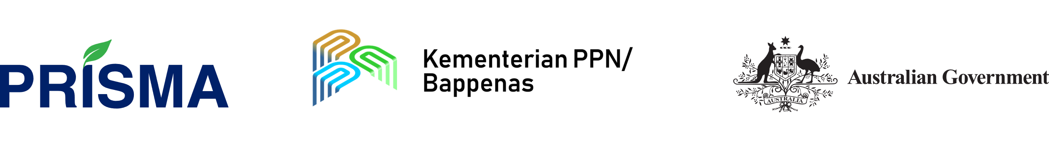

PRISMA Progress Report and Implementation Plan
January – June 2023
Accessible Word Document

This report follows accessible and inclusive design principles. The report is published in Word format for easy navigation. PRISMA welcomes comments to improve the accessibility of the document. Please contact: info@prisma.or.id

Contents

1. Purpose of this report 6
2. Executive Summary 12
2.1. Overall Summary 12
2.2. Program Relevance 12
2.3. Delivery Context 13
2.4. Portfolio Progress 13
2.4.1. Progress towards systemic change 13
2.5. Program Achievements 19
2.6. Social Impact 20
2.7. Progress in Cross-cutting Areas 21
2.7.1. Policy engagement 21
2.7.2. Strategic communications 22
2.7.3. Gender equality disability and social inclusion 22
2.7.4. Environment and climate change 23
2.8. Lessons Learned 23
3. Program Relevance 26
3.1. Relevance to the GOI Strategy 26
3.2. Relevance to the GOA Strategy 27
3.3. Relevance to Sustainable Development Goals 27
4. Portfolio Overview and Progress 29
4.1. Program Context 29
4.2. Progress Toward Systemic Change 29
4.2.1. Sector highlights - systemic change stories 31
Finance 31
ICT 37
Beef 43
Soil Treatment 52
4.2.2. Other sector progress 60
4.2.3. Challenges, risks and management response 62
5. Cross-cutting Area Progress 64
5.1. Policy Engagement 64
5.1.1. National Level 64
5.1.2. Sub-national level 65
5.1.3. Influencing the influencers 65
5.2. Strategic Communications 66
5.2.1. Vision 66
5.2.2. Strategy highlights 66
5.2.3. Early achievements 66
5.2.4. Activities 67
5.3. Gender Equality, Disability and Social Inclusion 68
5.3.1. Women’s economic empowerment 68
5.3.2. Disability inclusion 70
5.3.3. Youth inclusion 71
5.3.4. Indigenous inclusion 72
5.4. Results Measurement and Learning 72
5.4.1. Outreach 72
5.4.2. Partnership and wider market outreach 73
5.4.3. Net attributable income change 74
5.4.4. Other key performance indicators 74
5.5. Value for Money 76
5.6. Environment and Climate Change 77
5.6.1. Environment desk assessments 77
5.6.2. Climate-smart agriculture 77
6. Operations and Finance 80
6.1. Human Resources 80
6.2. Operations 80
7. Annexures 82
7.1. Annex 1: Progress against MSS 82
7.1.1. Crop protection 82
7.1.2. Dairy 85
7.1.3. Maize Madura 88
7.1.4. Maize Central Java 90
7.1.5. Maize NTT 91
7.1.6. Mechanisation: rice 94
7.1.7. Mechanisation: maize 97
7.1.8. Mungbeans in Central and East Java 99
7.1.9. Pigs 101
7.1.10. Rice 104
7.1.11. Vegetables 107
7.2. Annex 2: Detailed Key Performance Indicators 110
KPI 1 - Outreach 110
KPI 2 - NAIC 111
KPI 3 - Number of ISPs providing additional or improved access to innovation
to farm households 111
KPI 4 – WEE effectiveness within PRISMA innovations 111
KPI 5 – Value of additional turnover of ISPs 112
KPI 6 - Number of intervention partners (private and public sector) 112
KPI 7 - Value of additional turnover of PSPs 112
KPI 8 - Value of attributable additional and/or more inclusive investment by PSPs,
ISPs, and farmers 112
KPI 9 - Number of crowding in businesses/institutions 112
KPI 10 - Number of responding businesses/institutions 113
KPI 11 - Number of policy engagements 113
7.3. Annex 5: Value for Money 114
7.4. Annex 6: Risk Matrix 116

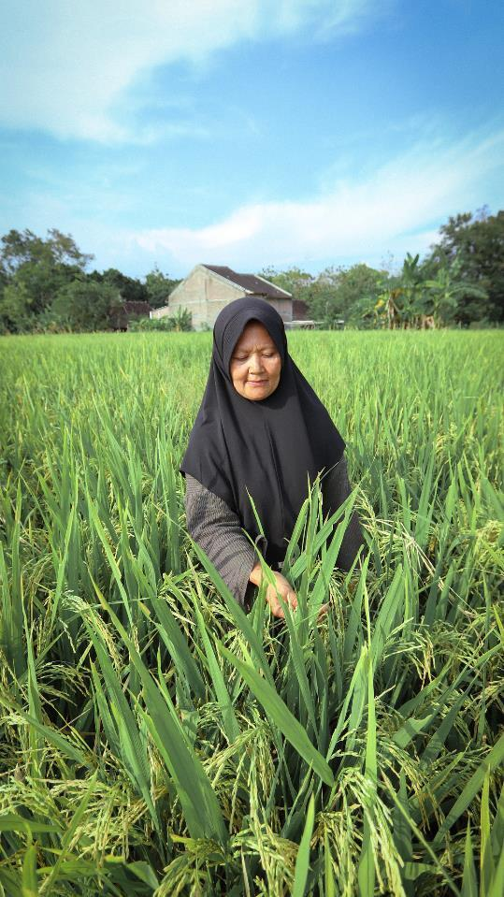
Ibu Narto, a rice farmer in Java satisfied with the crops from her high-yielding, climate-resilient rice seeds.
Purpose of this report
This report outlines the semester progress of the Australian-Indonesia Partnership for Rural Incomes Through the Support for Markets in Agriculture (PRISMA) against the previous annual plan. The report follows the Australian Department of Foreign Affairs and Trade (DFAT) guidelines on progress reporting.
Audience
This report has been written for DFAT employees, the Indonesian National Development Planning Agency (Bappenas), and other program stakeholders.
The Progress Report and Implementation Plan (PRIP) is the main coordination document between the Government of Australia and the Government of Indonesia.
Reporting Period
This PRIP covers PRISMA’s performance between 1 January and 30 June 2023. This period is referred to as ‘semester 1’, ‘S1’ or the ‘reporting period’ in this report.

Purpose of this report
List of abbreviations
Name | Abbreviation
ACIAR | Australian Centre for International Agricultural Research
ADG | Average daily Gain
AI | Artificial Insemination
Agrosid | PT Agrosid Manunggal Sentosa
AIHSP | Australia-Indonesia Health Security Partnership
ARISA | Applied Research and Innovation System in Agriculture program
ASF | African Swine Fever
AUD | Australian Dollar
AWP | Annual Work Plan
Bappenas | Badan Perencanaan Pembangunan Nasional (National Development Planning Agency)
BAST | Berita Acara Serah Terima (Records of Transfers)
BBSDLP | Balai Besar Litbang Sumberdaya Lahan Pertanian (Center for Research and Development of Agricultural Land Resources)
BEAM | Building Effective and Accessible Markets
BITPRO | Direktorat Perbibitan dan Produksi Ternak (Livestock Breeding and Production Directorate)
BNI | Bank Negara Indonesia
BNPL | Buy-Now-Pay-Later
BPTP | Balai Pengkajian Teknologi Pertanian (Agricultural Technology Study Center)
BSN | Badan Standardisasi Nasional (National Standardisation Agency)
B2B | Business to Business
B2C | Business to Consumer
B2G | Business to Government
CBA | Cost Benefit Analysis
CEO | Chief Executive Officer
CO2e | Carbon Dioxide Equivalent
CV | Commanditaire Vennootschap (Limited Partnership)
DFAT | Department of Foreign Affairs and Trade, Australia
DISTAN-KP | Dinas Pertanian dan Ketahanan Pangan (Provincial Agriculture Office)
DPI | Dairy Processing Industries
EDA | Environmental Desk Assessment
EOPO | End of Program Outcomes
EWINDO | East West Indonesia (seed company)
FBI | Feterna Business Incubator
FGD | Focus Group Discussion
FI | Financial Institution
Fintech | Financial Technology
FMD | Foot-and-Mouth Disease
GAP | Good Agricultural Practices
GCP | Good Crop Protection Practices
GEDSI | Gender Equality, Disability and Social Inclusion
GFP | Good Fertilising Practices
GHP | Good Handling Practices, Good Husbandry Practices or Good Harvesting Practices
GOA | Government of Australia
GOI | Government of Indonesia
Ha | Hectare
HH | Household
HYV | High-yielding Rice Seed Variety
ICN | Intervention Concept Note
ICT | Information and Communications Technology
IDR | Indonesian Rupiah
IP | Intervention Plan
IPB | Institut Pertanian Bogor (Bogor Agricultural University)
ISP | Intermediary Service Providers
ISR | Independent Strategic Review
KUR | Kredit Usaha Rakyat (Smallholder Credit Scheme)
KPI | Key Performance Indicator
LPEM UI | Lembaga Penyelidikan Ekonomi dan Masyarakat Universitas Indonesia (Institute for Economic and Social Research)
LSD | Lumpy Skin Disease
MoA | Kementrian Pertanian (Indonesian Ministry of Agriculture)
MSD | Market Systems Development
MSMB | PT. Mitra Sejahtera Membangun Bangsa, an agricultural startup
MSP | Machinery Service Provider
MSS | Market System Strategy
MT | Metric Tonnes
NAIC | Net Attributable Income Change
NKP | Nitrogen, Phosphate, Potassium
NTB | Nusa Tenggara Barat (West Nusa Tenggara province)
NTT | Nusa Tenggara Timur (East Nusa Tenggara province)
OJK | Otoritas Jasa Keuangan (Financial Service Authority)
OPD | Organisation of People with Disabilities
OPV | Open-Pollinated Variety (a hybrid seed)
PCC | Program Coordinating Committee
PDHI | Indonesian Veterinary Medical Association
PKT | PT Pupuk Kalimantan Timur
PPP | Purchasing Power Parity
PRISMA | Promoting Rural Income through Support for Markets in Agriculture
PRIP | Progress Report and Implementation Plan
PSEKP | Pusat Sosial Ekonomi dan Kebijakan Pertanian (Indonesian Center for Agricultural Socio Economic and Policy Studies)
PSP | Private Sector Partners
RKP | Rencana Kerja Pemerintah (Government Work Plan)
RML | Result Measurement and Learning
RPJMN | Rencana Pembangunan Jangka Menengah Nasional (National Mid-Term Development Planning)
SDGs | Sustainable Development Goals
SME | Small and Medium Enterprise
SNI | Standard Nasional Indonesia (National Standards)
SOE | State-Owned Enterprise
UD | Universal Design
UGM | Universitas Gadjah Mada (Gadjah Mada University)
USD | American Dollar
VAT | Value-added Tax
WEE | Women's Economic Empowerment

Indicator definitions

Indicator | Definition
Direct Intervention Cost | PRISMA’s contributions to the intervention-related budget, as described in the partnership agreement or memorandum of understanding
Existing Intervention | Intervention that is currently running and/or commenced this semester
Intervention Concept Note (ICN) | An intervention concept note is an initial document outlining the main features and context of a planned intervention
Indirect Intervention Cost | PRISMA’s contribution to implementation staff costs (and travel costs), result, management and learning costs (including studies) connected to the intervention, and implementation related capacity building, and communication costs
Investment Leverage by Partner | The ratio of the actual value of additional investments by partners to the actual intervention costs
Investment Leverage by Sector | The ratio of the actual value of additional investments by partners, intermediate service providers, and farmers to the actual intervention costs
Investment Per Farm Household | The average actual intervention costs per farm household
Intervention Plan (IP) | An intervention plan is a detailed document containing all information and data relevant to the decision to start the intervention
Intermediary Service Providers (ISP) | Intermediary service providers are small or medium-sized enterprises in the up- or down-stream value chain of a partner enterprise of PRISMA (i.e., either buying from farmers and selling to partners or buying from partners and selling to farmers); they can also have important functions, e.g., as information providers or lenders
KPI 1 | Number of smallholder farming households with increased net income attributable to PRISMA’s interventions
KPI 1a (new) | Number of smallholder farming households under the USD2.50 purchasing power parity poverty line with increased net income
KPI 1a (old) | Number of smallholder farming households under the USD2.00 purchasing power parity poverty line with increased net income
KPI 1b (new) | Number of smallholder farming households under the USD5.50 purchasing power parity poverty line with increased net income
KPI 1b (old) | Number of smallholder farming households under the USD2.50 purchasing power parity poverty line with increased net income
KPI 2 | Net attributable additional income for benefited farming households in IDR
KPI 2a | Net attributable additional income for benefited farming households under the USD1.90 purchasing power parity poverty line (extreme poverty) in IDR
KPI 2b | Net attributable additional income for benefited farming households under the USD2.50 purchasing power parity poverty line in IDR
KPI 3 | Number of intermediary service providers providing farmers additional/improved access to innovation
KPI 4 | Women’s economic empowerment effectiveness within PRISMA innovations
KPI 5 | Value of additional turnover of intermediary service providers in IDR
KPI 6 | Number of intervention partners (private and public sector)
KPI 7 | Number of intervention partners (private and public sector)
KPI 8 | Value of attributable additional and/or more inclusive investment by the public and private sector in IDR
KPI 8a | Value of attributable additional and/or more inclusive investment by public and private partners in IDR
KPI 9 | Number of crowding in businesses/institutions induced by PRISMA
KPI 10 | Number of responding businesses/institutions induced by PRISMA
KPI 11 | Number of policy engagements
NAIC | Net attributable income change is an additional income generated from a specific technology or input promoted by PRISMA during one production cycle. For livestock, the measurement period is 6 months.
New Intervention | An intervention that started this semester
Outreach | Number of smallholder farming households with increased incomes
Partnership Outreach | Outreach that comes directly from PRISMA’s partner in the targeted area
Pipeline | Projection value from potential new interventions which are still at the idea/ICN/IP stage
Projection | Projection value from existing and new interventions
Quality Management Tool | A tool to assess intervention quality over time, from ICN to IP and implementation.
Social Return on Investment | The ratio of the actual value of farming households’ net-income increase compared to the actual intervention costs
Total Intervention Cost | Total of direct and indirect intervention costs
Total Outreach | Partnership and wider market outreach
Wider Market Outreach or Households | Outreach that comes from PRISMA’s partners in other areas, other market actors in the targeted areas, and other market actors in other areas that are attributable to PRISMA’s interventions

Glossary
PRISMA uses a market systems development approach, and like all approaches, it has developed its own specific language and terms. This section provides definitions of relevant terms to help the reader navigate this report.
Term | Explanation
Copying | This is when a number of market players (competitors) adopt comparable changes instigated by PRISMA partners – either direct copies or variants on the original innovation – that are upheld without PRISMA support. This is also a key indicator of systemic change.
Crowding in | Crowding in is the process of stimulating a number of market players to react to the system-level changes instigated through the intervention activities. It results in greater breadth and depth within the core market functions and is a key indicator of systemic change.
Market Systems Development (MSD) | In poorly performing markets, such as agriculture, critical functions, such as information, technology, infrastructure, finance, skills, standards, regulations, etc., are either absent or not working as they should. Instead of supporting sector performance, they tend to inhibit it. Changes in these functions and rules are therefore needed if a sector is to perform better.  In practical terms, it is these ‘supporting functions’ of the market that PRISMA seeks to influence, to make them more supportive of sector competitiveness and inclusivity.
Market System Strategy (MSS) | PRISMA uses a MSS framework for each sector to link its activities with partners to what it hopes to achieve in the ‘market system’ and towards achieving the program objectives. PRISMA uses a three-tiered system as a basis for the MSS – intervention area; market function; and market system change, which contribute to the sector vision.
Results Chain | A model showing the chain of causality through which PRISMA’s activities lead to poverty-reducing benefits. Results chains are tailored to specific interventions and are consequently more detailed than a MSS.
Systemic Change | When PRISMA refers to systemic change, it is describing the improvements in how a market’s supporting functions are performed, and how they contribute to improved sector performance and inclusivity. This usually involves permanent change in the way the market actors conduct business.
Wider Market Outreach or Households | Outreach that comes from PRISMA’s partners in other areas, other market actors in the targeted areas, and other market actors in other areas that are attributable to PRISMA’s interventions.
Resilience | The ability of the market actors to withstand shocks, respond to unexpected threats, and continue business operations under stress.

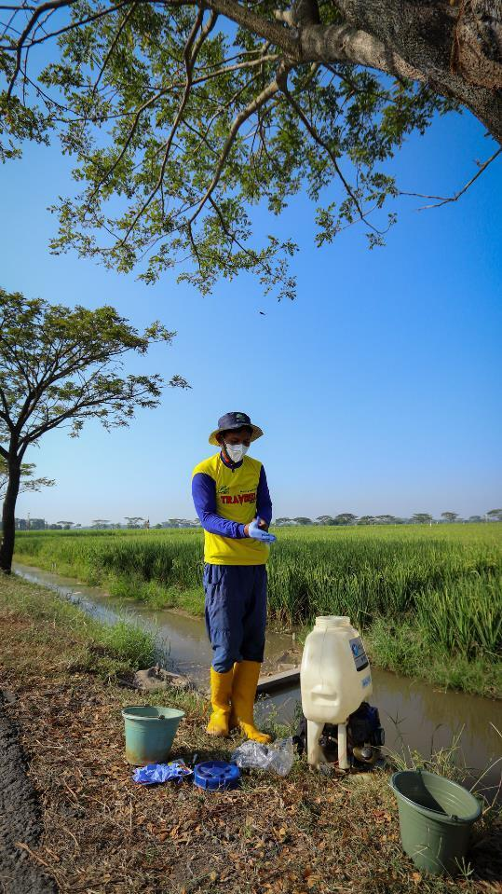
Andi Kristanto, a rice farmer in Sukoharjo, Central Java, wears a set of personal protection equipment before spraying pesticides.

Executive Summary

Overall Summary
PRISMA is a market systems development (MSD) program working in 12 agricultural sectors across 6 provinces in eastern Indonesia: Central Java, East Java, East Nusa Tenggara (NTT), West Nusa Tenggara (NTB), Papua and West Papua.0F The Australian government (GOA) funds PRISMA through the Department of Foreign Affairs and Trade (DFAT) in cooperation with the Government of Indonesia (GOI) through the National Development Planning Agency (Bappenas).
PRISMA’s investments seek to change how the private sector does business in rural Indonesia so that poor smallholder farmers can increase farm productivity.1F Achieving rural growth through the private sector will alleviate poverty for smallholder farmers and put Indonesia in a better position to improve its food security.
PRISMA does this by:
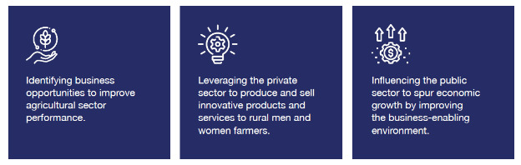
PRISMA’s end-of-program outcome (EOPO) is to increase the income of one million smallholder farming households by 30 per cent.

Program Relevance
PRISMA is aligned with the GOI’s National Medium Term Development Plan (RPJMN) for 2020-2024 and is contributing to the development of Indonesia’s next 5-year plan through its policy engagement work. PRISMA is supporting Bappenas in developing a background paper on modernisation of agriculture, which will inform the 2025-2029 RPJMN. The background paper will be informed by desk study and 2 provincial level multistakeholder consultation workshops and validated through a national level workshop in Jakarta in semester 2. Bappenas supports the program’s efforts to ensure smallholder farmers have access to agri-inputs in line with the Ministry of Agriculture’s (MoA) strategic plan for 2020-2024.
PRISMA is aligned with the GOI and GOA’s post-COVID-19 recovery strategies. PRISMA supports DFAT’s development strategy by contributing to Indonesia’s stability and economic recovery by strengthening agricultural markets and food security while safeguarding poor farmers’ livelihoods. PRISMA remains well placed to help reduce economic hardship and ensure that women and vulnerable groups play a critical role in Indonesia’s rural development.

Delivery Context
PRISMA has shown that working through the private sector in agriculture is an effective model to alleviate rural poverty by increasing farmer productivity sustainably (see progress towards systemic change graph in section 2.4.1). Supporting the private sector to change its behaviour to more inclusive business models ensures farmers have continual access to critical inputs and services that lead to increased productivity.
PRISMA is coming towards the final year of the program, and ensuring the sustainability of the innovations and the sector changes becomes even more important. This semester all sectors were evaluated to determine what more is needed in specific market functions to ensure that high-level change in each market system is sustained. 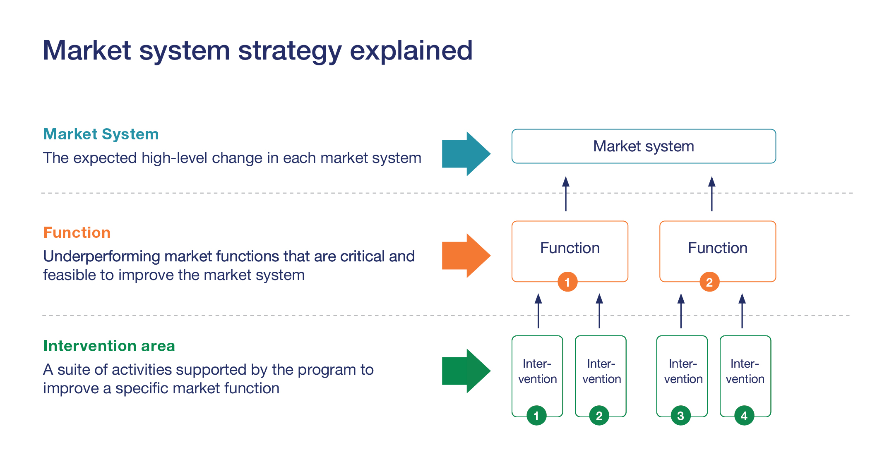
- Diagram of the market system strategy

Portfolio Progress
PRISMA continues to progress towards systemic change in each of the sectors. Every semester PRISMA reviews 3-4 sectors and rotates sectors each semester. During this reporting period, the 6-monthly sector reviews were undertaken for the information and communications technology (ICT) and finance sectors, which show the least progress towards systemic change compared to the more mature sectors. Sectors reviews were also repeated for the beef and soil treatment sectors, showing significant and adequate progress towards systemic change, respectively.
This semester exit strategies were developed for each of the sectors, resulting in changes to some market system strategies (MSS). These include phasing out market functions that are performing independently, such as beef, dairy and pig feed, maize seed in Madura, and product marketing for mechanisation in East and Central Java. Some market functions have been dropped due to a lack of progress, including small and medium enterprise (SME) financing consulting services, SME financial services, and digital agricultural ecosystem functions related to animal health services. However, these dropped functions will not affect the market system change significantly.

Progress towards systemic change
There has been further progress towards systemic change this semester, as highlighted in Figure 2.
The Progress Report and Implementation Plan (PRIP) highlights the progress towards systemic change in 4 sectors: finance, ICT, beef, and soil treatment. The selected sectors for this semester’s PRIP have experienced varied levels of systemic change. Beef has made significant progress, soil treatment made adequate progress, and finance and ICT are to be further monitored. Meanwhile, PRISMA downgraded the progress towards systemic change of Maize NTT from significant to early progress (details in annex 7.1.5). The growth of the maize sector in NTT is constrained by the limited availability of parent seeds, private sector capacity and large-scale off-takers. In addition, the fluctuation in the subsidy allocation pushed back the behaviour changes of market actors in the last 2 years, and the progress towards systemic change has reduced. A summary of the progress can be found below, with a more complete explanation in Chapter 4.
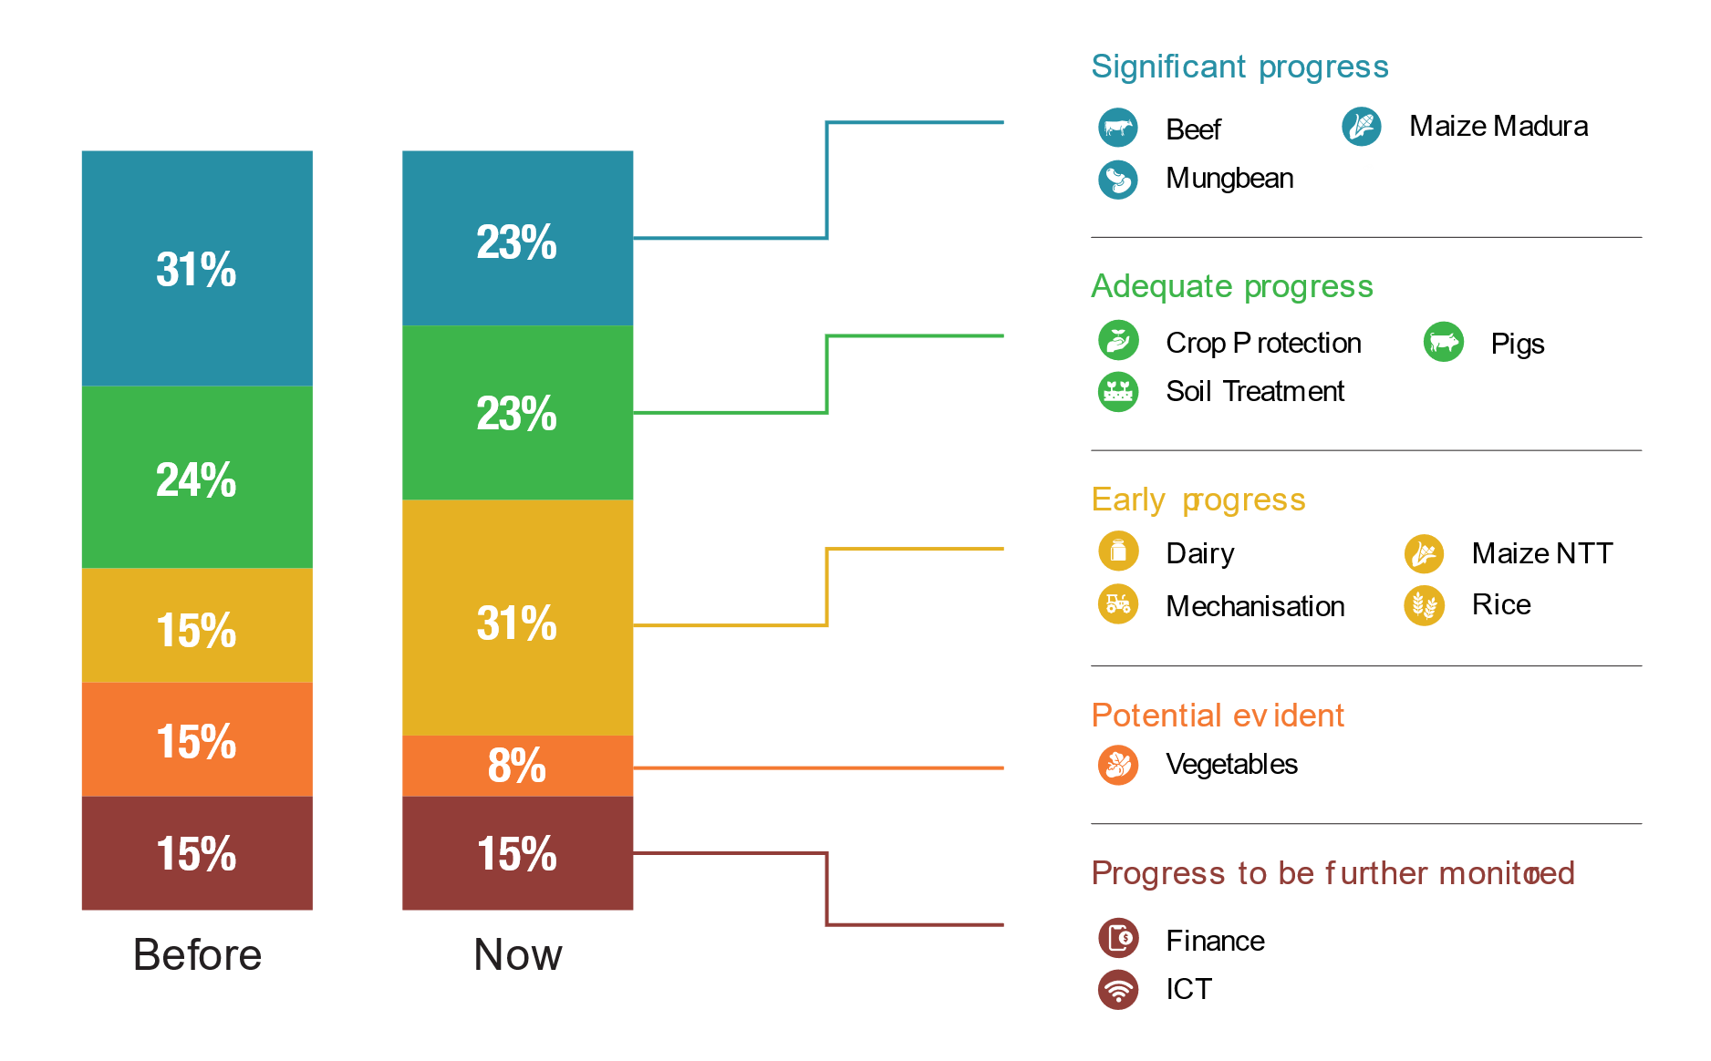
- Portfolio progress towards systemic change
Beef
Significant progress
Significant progress has been made in the beef sector. PRISMA’s support to the GOI to change the national feed standards (announced by the GOI in December 2022) has the potential to trigger transformational change for all livestock feed in Indonesia. As a result of interventions in the livestock feed sector, more than 641,316 farmers are now continuously using concentrate feed with an income increase of 145 per cent.
This semester, PRISMA looked at expanding distribution channels for livestock feed to the thinner markets in eastern Indonesia, with some light touch activities with existing partners. To support youth engagement, PRISMA’s partner PT Sreeya Sewu (Sreeya) and PT Cipta Ternak Sehat Indonesia (CTSI), in collaboration with the University of Nahdlatul Wathan (UNW), launched the Feterna Business Incubator (FBI) program and trained 25 students on business management, digital marketing, feed and animal health practices. The 25 students have started educating farmers on good feeding and animal husbandry practices and run 5 demonstration plots of lead farmers in the village.
PRISMA’s pharmaceutical partners continue to promote and expand their product lines for beef animal health.
This semester, the trial of molasses blocks for cattle to reduce methane emissions from livestock continued in 2 districts in Central Java. The results are expected next semester.

Soil treatment
Adequate progress
Adequate progress is being made in the soil treatment sector with an expansion of the commercial fertiliser market and PRISMA partners adopting and implementing education-based marketing and promotion. This semester, PRISMA’s partners invested further in marketing training for their core staff using the education-based approach. ATS is exploring a collaboration model with district governments in Sampang, Pamekasan and Sumenep, designing demo plots and embedded good fertilising practices (GFP) promotion activities for mineral-based fertilisers.
With a reduction in fertiliser subsidies, farmers are incentivised to buy from the commercial market. All partners expanded their distribution channels and agents. PT Petrokimia has invested further in the multi-stakeholder Makmur program, which now incorporates a youth apprenticeship program. Makmur hired 38 new ‘Taruna Makmur’ youth apprenticeship staff in Central, East, and West Java and NTB.
Going forward, PRISMA will try to increase the scale by expanding the existing markets of partners or finding a new scale agent. The aim is to ensure sufficient scale to reach a comfortable ‘tipping point’ so that farmers will adopt the new practices from neighbours.
Finance
Progress to be monitored
The finance sector strategy was reviewed in September 2021, and the revised strategy was introduced in December 2021. The revised strategy focuses primarily on strengthening agri-kiosks' access to more flexible credit to fit their seasonal capital demands. More flexible working capital will help agri-kiosks better manage their cash flow, stock sufficient products for the agricultural season, and potentially offer flexible payment options to farmers. PRISMA dedicated resources to gain quick traction from the financial market actors. The goal was to introduce new loan products by the second semester of 2022. However, progress in this sector has been slower than expected. Banks are risk-averse and are still considering flexible loan options. Potential agri-kiosks were mapped, but of the 3 banks signed last semester (Mandiri, Sinarmas and BNI), only Mandiri has commenced any funding activities, with 21 agri-kiosks taking out their first commercial loans. Mandiri is yet to develop a more flexible lending product.
The partner banks now have a deeper understanding of agri-kiosks and improved capacity and information about what works and does not work in financing agri-kiosks. The next semester will focus on developing short-term, revolving loan products for kiosks and other related SMEs.
ICT
Progress to be monitored
PRISMA’s ICT and finance sectors share the same overall aim to improve the ecosystem around agri-kiosks so that they become better managed, stocked, and informed. Progress in the ICT sector has also been slower than expected, but PRISMA has progressed the kiosk platform of Semaai, an agricultural technology startup, by embedding more product information and a clinic option for kiosks to better serve smallholder farmers. A similar application with Bayer was delayed. PRISMA has supported 2 companies, EWINDO (through Yayasan Bina Tani Sejahtera [YBTS]) and the agricultural startup PT. Mitra Sejahtera Membangun Bangsa (MSMB) to develop a fertiliser dosage calculation application, which can be pitched to fertiliser companies.
PRISMA also supported the Indonesia veterinarian association to develop a code of conduct that could be used by any private sector company wishing to develop digital animal health services in the future. To avoid duplication of work, PRISMA will link the veterinarian association with another DFAT program, i.e., the Australia-Indonesia Health Security Partnership (AIHSP), which has a specific mandate to work on animal health issues. Going forward, the ICT sector will focus on the input supply chain and marketing functions.
A summary of progress for the remaining sectors can be found in Table 1 below and in Annex 1.

Table 1. Sector Progress for Semester 1
For more details on the finance, ICT, beef and soil treatment sectors, see Chapter 4; for the remaining sectors, see Annex 1.
Sector | Vision | Sector status
Beef | Small-scale women and men beef producers increase cattle productivity through improved livestock management practices in Central and East Java and NTB. | Around 64 per cent of farmers in East Java and 33 per cent of farmers in Central Java are using high-quality feed. Over 640,000 of these farmers increased their incomes by 145 per cent. From PRISMA’s baseline survey, only 2 per cent of farmers in Indonesia used high-quality feed. In East Java, from a baseline of 2 companies, there are now 62 feed companies selling concentrate feed through 1,097 agents. PRISMA’s partner companies have invested AUD4.83 million in feed production and distribution systems and continue to expand to new provinces, with activities in NTB increasing in this semester. It is too early to report on results, but the early signs are promising. In response, the government changed the feed national standard (SNI) to enable more companies to enter the feed market and produce good-quality feed at the price point that smallholder farmers can afford. In addition, 5 pharmaceuticals now actively promote pharma products and educate farmers in good livestock management.
Crop Protection | Smallholder women and men rice and maize farmers in East and Central Java use safer crop protection products in an appropriate way. | After 4 years of PRISMA’s engagement, more than 110,000 rice and maize farmers in East and Central Java have reduced harvest loss by 22.5 per cent, equivalent to a saving of IDR1 million per planting season (AUD100). The average income per hectare per planting season is IDR 4.95 million. This result was achieved through working with 5 crop protection companies (FMC, Agricon, UPL, MKD and e-Tong). Cumulatively, these companies continue serving approximately 12 per cent of the total crop protection market and educating smallholder farmers on good crop protection practices. Before PRISMA, 74 per cent of rice farmers and 51 per cent of maize farmers experienced harvest loss even after using pesticides.
Dairy | Small-scale women and men dairy farmers have improved milk quality and productivity by adopting good practices in rearing, feeding and health management in East Java and Central Java. | To date, around 6,518 farmers have increased their incomes by 74 per cent, using high-quality feed, good management, and milking practices. Now, 26 companies sell affordable feed to farmers in East Java and Central Java, compared to only 12 feed companies in 2019. PRISMA also induced pharmaceutical companies to target dairy farmers and educate them on disease prevention and treatment. With PRISMA’s support, the MoA is developing a roadmap for increasing cattle population and milk production in Indonesia.
Maize Madura | Women and men maize farmers in Madura use quality seed and good agricultural practices (GAP) to improve productivity. | More than 126,000 farmers (around 30 per cent of the total farmers) in Madura have increased their income from increased maize yield. Smallholder farmers in Madura use hybrid maize seeds and apply GAP. Now, 8 companies sell hybrid seeds through 95 kiosks and educate farmers on GAP. This is because the local government revised its geographic targets for subsidy distribution. Before PRISMA’s intervention, access to hybrid seeds was limited, with only 2 companies struggling to develop seed businesses in Madura.
Maize NTT | Smallholder women and men farmers in NTT use certified maize seeds and apply GAP properly. | Over 40,000 smallholder farmers in NTT benefitted from using certified maize seeds and applying GAP. Certified seeds are available in the main maize-producing areas, although the supply fluctuates every year. While only 3 local seed producers actively promote certified seeds, another 5 companies are ready to enter the market. Before PRISMA’s work, the availability of certified seeds in the commercial market was negligible, as no seed producers actively promoted and built a distribution network. With PRISMA’s support, the provincial government has strengthened the GAP service in its seed assistance programs and improved its seed certification capacity. However, the growth of the maize sector in NTT is still constrained by the limited availability of parent seeds and large-scale off-takers (businesses that purchase produce).
Mechanisation – Rice | Women and men rice farmers increasingly use agriculture machinery (combine harvesters and drone sprayers) services resulting in reduced production cost and harvest loss.​ | After 3 years, more than 42,000 farmers have used mechanisation services and increased their incomes by 17 per cent. Over 80 service providers now offer mechanisation services to these farmers. This was achieved by working with Rutan, Argo Jaya, Terra Agro Digital, Pillar Putra and Galaxy Partani Mas companies promoting machinery services across 6 provinces. Companies also provide after-sales services for machine owners to ensure the durability and optimum lifetime of the machines. Before PRISMA, companies did not offer after-sales services or marketing strategies, leading to a low penetration rate and low durability of machines.
Mechanisation – Maize | Women and men rice and maize farmers have increased access to and use of agriculture machinery services to reduce labour costs. | In 3 years, more than 1,000 farmers have saved on labour costs and reduced their workload by using maize planters. Two companies in 2 provinces continue improving their capacity to better capture demand. Companies also offer after-sales services to machine owners to ensure the durability and optimum lifetime of the machines.
Mungbeans | Improved quality, competitiveness, and continuity of local mungbean supply. | After 6 years, more than 48,000 mungbean farming households have used quality seeds. The government research has found 24.8 per cent of planted mungbeans now use quality seeds. Before PRISMA, there was no commercial market for high-yielding seeds. Currently, 6 seed producers have entered the commercial market and sell quality seeds. Government research institutes have commercialised parent seeds to increase seed propagation.
Pigs | Women and men farmers and market players in the pig industry gain benefit from increased availability and appropriate use of quality inputs, use improved husbandry practices, and have access to the downstream market supported by a conducive regulatory environment. | More than 130,000 smallholder farmers increased their incomes by 405 per cent from pig rearing as a result of PRISMA’s partnerships to improve the genetic stocks of pigs, introduce innovations in breeding and increase access to high-quality concentrate feed for faster fattening times. These farmers continue to restock their farms with high-quality piglets, use concentrated feed, and apply biosecurity measures, leading to low mortality and increased productivity of pigs. This is because 13 breeding farms invested in improved breed genetics, farm management, and biosecurity measures. Thirteen feed companies sell affordable pig feed and educate farmers on good rearing practices. Before PRISMA, farmers followed traditional feeding practices, with only 2 feed companies having indirect operations in NTT.
Rice | Women and men rice farmers in East and Central Java adopt high-yield rice seeds and have increased productivity. | In 4 years, more than 90,000 farming households have adopted high-yielding rice seeds and increased their yield. This was achieved by working with PT Botani, CV JTM, CV Anisa, CV Fiona and PT Agrosid . These seed companies continued to promote high-yielding varieties and have produced over 1,500 tonnes of seeds to date. All 5 companies expanded into new districts in Central and East Java, even to new provinces. All partners have implemented inclusive business models and reached people with minor visual impairments through improved packaging.
Soil Treatment | Staple, horticulture, and estate crop farmers in Central Java, East Java, and NTB have access to and safely use quality fertiliser. | In 4 years, more than 223,000 farming households have benefitted from using good quality fertilisers and applying GFP. Now, farmers can access commercial fertilisers through 290 kiosks in Central Java, East Java, and NTB. This was achieved by working with 6 companies that invested AUD1.97 million in developing the commercial markets. Now, 9 companies actively promote commercial fertilisers and educate farmers on GFPs. Before PRISMA’s work, most companies, including 5 state-owned enterprises (SOE), focused on the government’s subsidy market but not on farmers’ education.
Vegetables | Women and men farmers' income increases from producing and selling more vegetables. | From having no direct distribution channel in Tanah Papua, 3 seed companies now sell quality vegetable seeds and provide GAP information. Companies have hired local-based field staff, including indigenous Papuans, modified marketing tools to fit the local context, and continued implementing inclusive business strategies. With a gradual increase in sales through 5 active distributors, more than 7,000 farmers have benefitted from these interventions.

Program Achievements
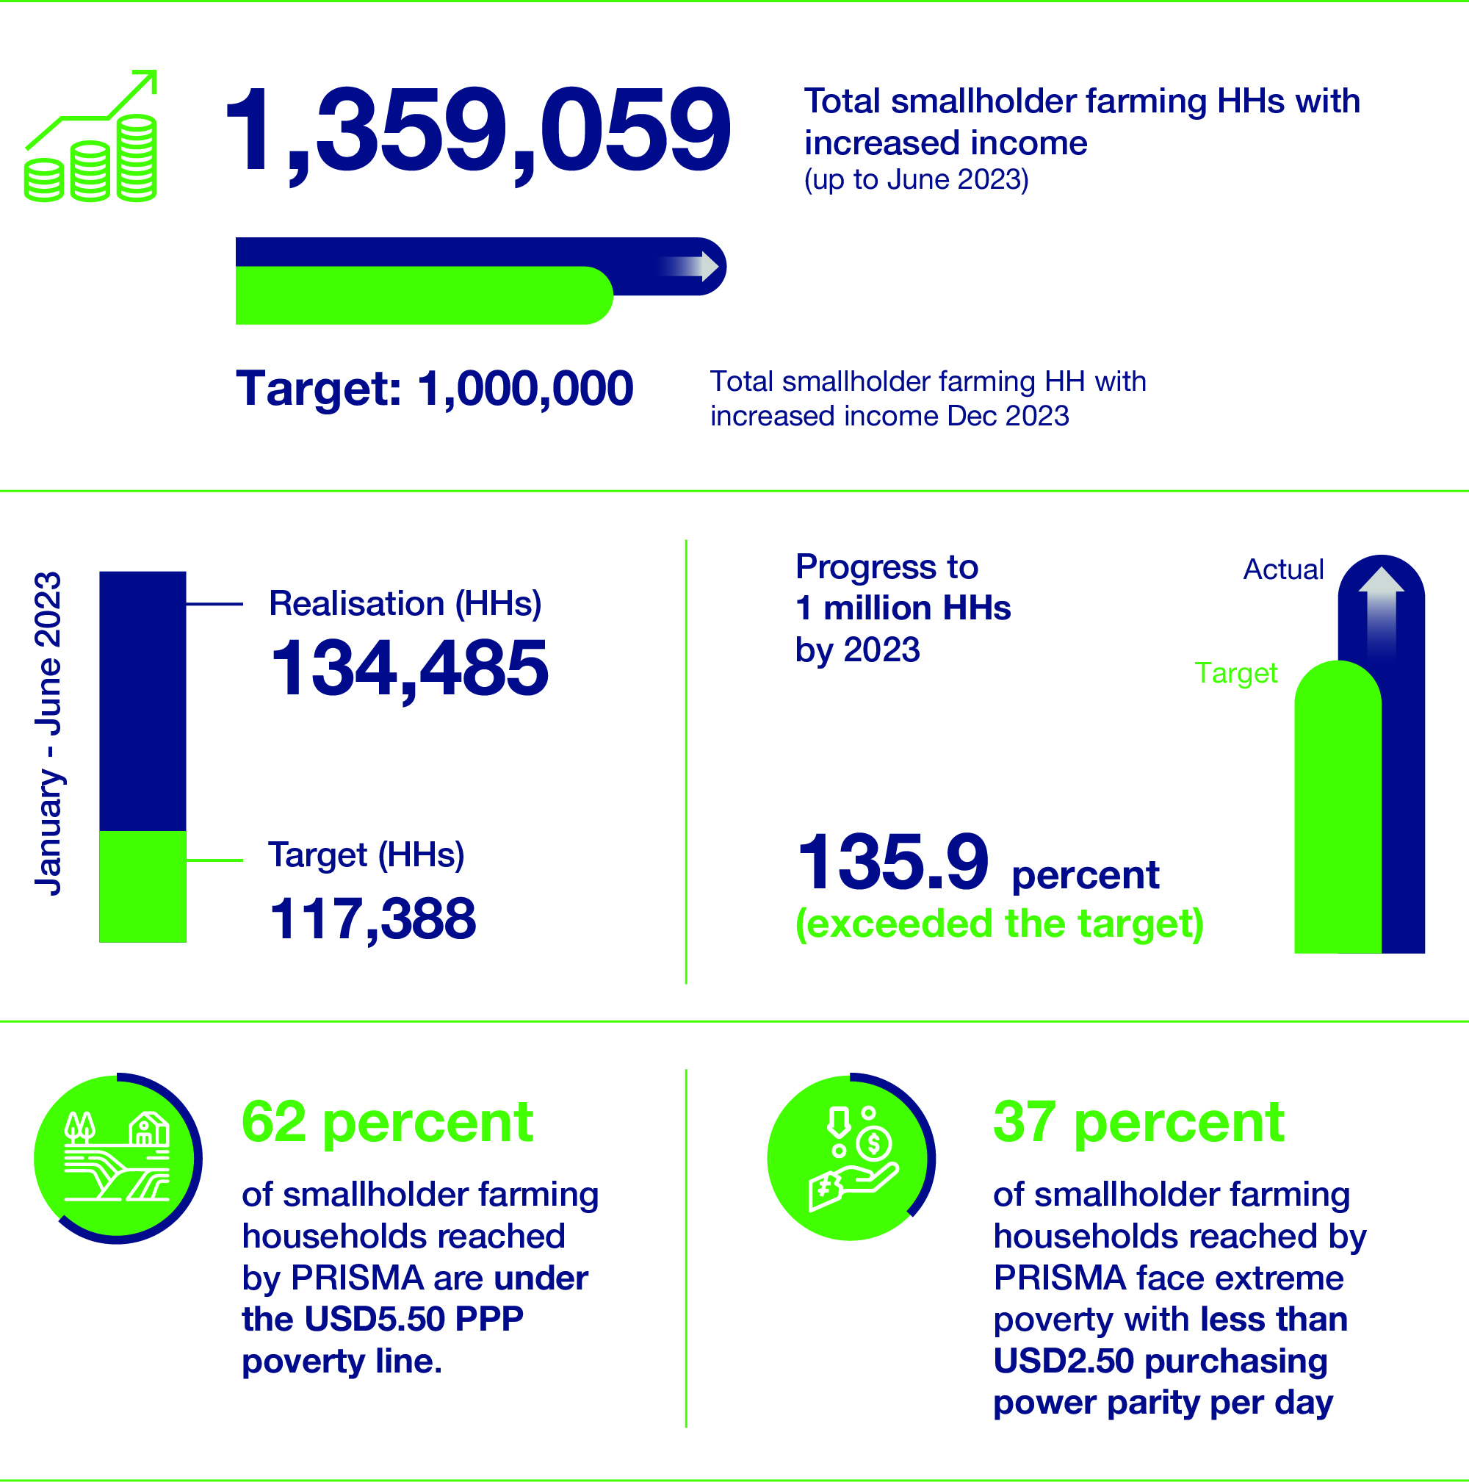
- IDR8.33 trillion (AUD833 million) in additional income for smallholder farming households up to June 2023.
- IDR4.99 million (AUD499) in additional income per smallholder farming households during semester 1 of 2023 (January to June 2023).
- 268 partners (up to June 2023). 74 active partners as of June 2023.
- During semester 1 (January to June 2023): 4 new partners, consisting of 0 public sector, 4 private sector; 68 crowding-in businesses/institutions; and one responding business/institution.
- Total value of additional turnover for SME up to June 2023 (for 13,494 SMEs) reached IDR2.02 trillion or AUD202 Million.
- Investment per HH from the total intervention cost (VFMINT) is AUD 63.90 and social return on investment (SROI) per HH (VFMSRT) is 9.59.
- Cumulative net attributable income change (NAIC) percent up to Y23S1: 168 per cent or an 8.8 per cent decrease from the previous semester at 184 per cent. Incremental (January - June 2023): 30 per cent or a 74.1 per cent decrease from the previous semester at 116 per cent.
- Incremental partner investment (Jan-Jun 2023): IDR33. 5 billion or a 14.1 per cent increase from the previous semester at IDR29.3 billion. Cumulative partner investment up to Y23S1: IDR292 billion or an increase of 13 per cent from the previous semester at IDR258 billion.

Social Impact
PRISMA surveyed 166 farmers (75 percent male and 25 percent female) from Central and East Java to understand the social impact of income increases. Future surveys will have a more even gender balance. The survey is complemented by other large scale quantitative data collection undertaken routinely by the RML team, such as impact assessments. The farmers interviewed were impacted by interventions in PRISMA’s beef, rice, fertiliser and maize sectors.
The survey gathered information on household spending over the year to understand what areas of the farmers’ lives were impacted and what needs they met first. Figure 3 provides a breakdown list of farmer expenditure frequencies based on their increased income.
Among the respondents, a significant portion of farmers identified investing/reinvesting in economic activities as their highest priority. This finding underscores the crucial role income increases can bring to expanding economic activities in the household and improving well-being. The full survey results will be published next semester.
The figure below outlines farmers’ responses on using the additional income. The percentage shows the most frequently mentioned areas where farmers invest or spend their additional incomes. For example, from all responses, agriculture investment, such as seeds and fertiliser, was mentioned 31.8 percent of the time, and staple food was cited 22.5 percent. Disaggregated data shows women prioritised spending money on daily food (49 per cent) compared to men (14 percent) and men prioritised agriculture investment (44 percent) compared to women (22 percent).
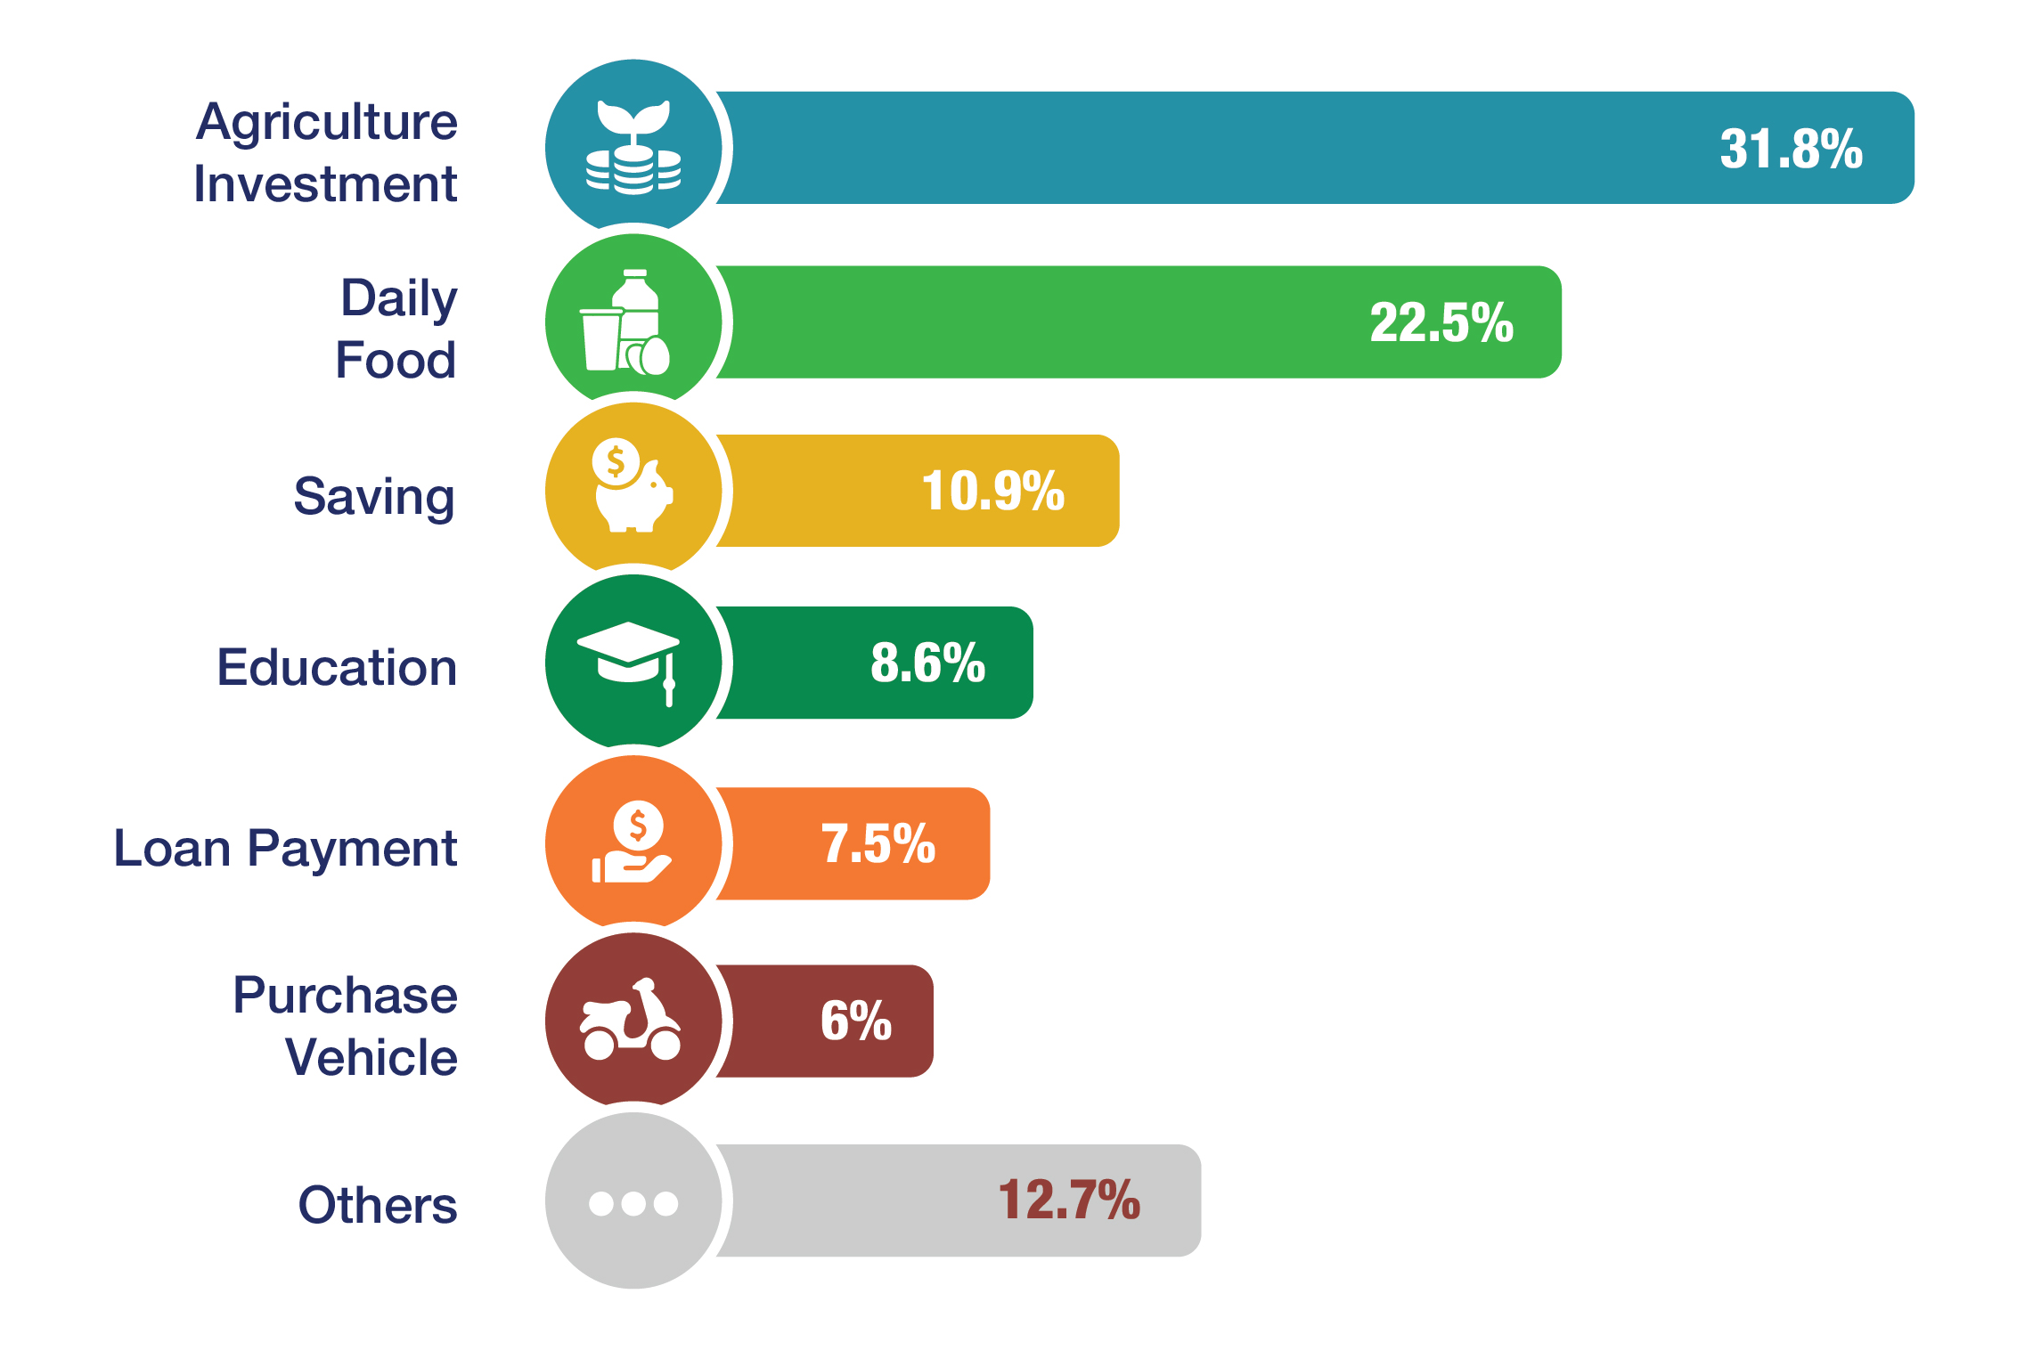
- Use of additional income

Smallholder farmer additional income spending by gender
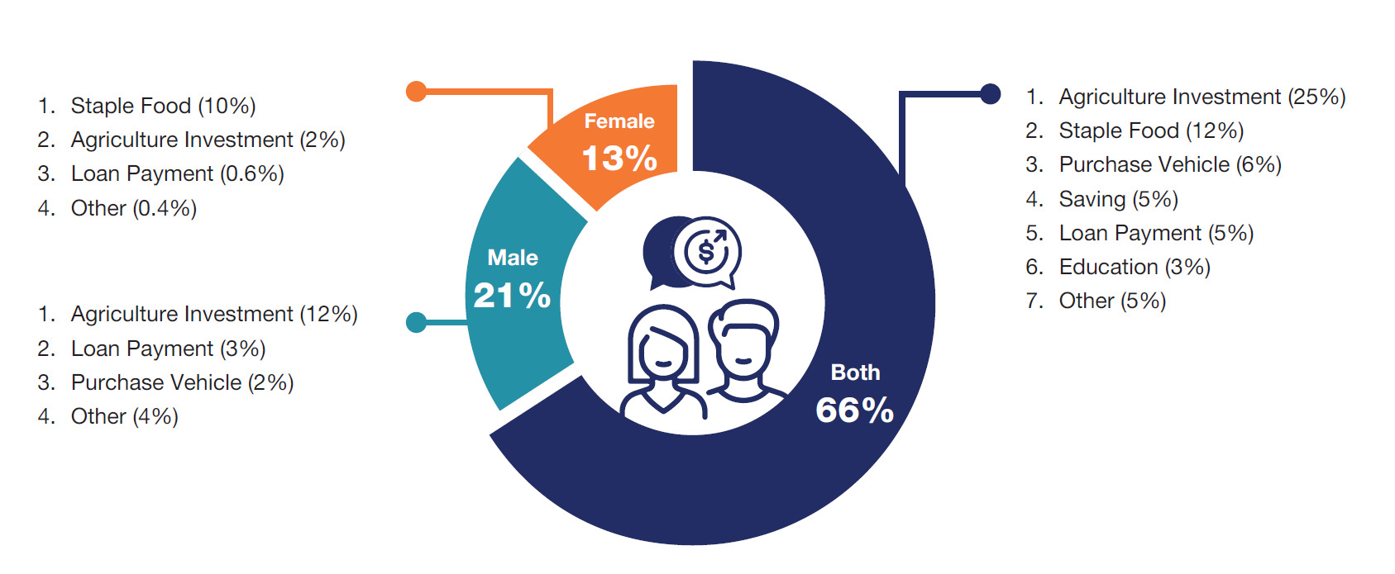
- Spending habits of women and men for additional income (from PRISMA’s social impact study)

Progress in Cross-cutting Areas
Good progress was made in the cross-cutting areas this semester, as outlined below.

Policy engagement
Policy engagement continued to gain momentum this reporting period, with further progress in improving the business enabling environment in the beef, dairy and maize sectors. At the national level, PRISMA supported the MoA in revising the overarching feed standards for all livestock animals, which will enable more businesses to enter the feed sector and produce quality feed at 3 different price points.
PRISMA continues to support the MoA in determining the efficacy of the Jersey breed for smallholder farmers and expand the dairy industry to the lowlands. The 2 studies commissioned last semester on a repopulation study and a Jersey roadmap were presented to MoA this semester.
At the sub-national level, PRISMA concluded its work in cost benefit analysis (CBA) training for the Central Java provincial government. This training enables the government to better plan budgeting for animal disease prevention in the future. PRISMA also supported sub-national level work in soil treatment in East Java to educate farmers on mineral-based fertilisers, and in NTT supported the government in developing plans managing and in NTT supported the government in developing plans managing and maintaining the African swine fever (ASF) diagnostic tools. The loop-mediated isothermal amplification (LAMP) is placed on three islands (i.e., Timor, Sumba, Flores). Farmers and market actors in these areas now have access to quick, reliable and cost-effective testing facilities. Currently, PRISMA is supporting the provincial government in developing standard operating procedures and establishing a reagent supply chain for operating the LAMP.
PRISMA continued its influencing work with Bappenas by developing 4 learning case studies on maize, finance, treecrops and seaweed, for the national government. PRISMA also progressed in developing a background paper on agricultural modernisation to influence the GOI’s 5-year development plan (RPJMN).

Strategic communications
This semester, PRISMA reached a significant milestone, bedding down the exit strategy and the supporting communications strategy. The strategic aims are crowding in, knowledge sharing and expanding PRISMA’s contribution to the national discussion on agriculture and rural development. PRISMA is now planning events to support the sustainability and legacy of the program.
The strategy includes harvesting and sharing knowledge through events and activities, a new media strategy to disseminate inclusive business models, practices and innovations, a Q&A series with private sector partners to share insights on what and how impact has been sustained, the continuation of the learning series for the development community, the gathering hand distribution of market intelligence through Indonesia Market Watch for market actors and government counterparts, and continuing to raise the visibility of the program and program outcomes through systemic change films and contributions to webinars, national and international media, and forums.
The strategy builds on the foundations from last semester when PRISMA opened the program to wider audiences. The result was a 1200 per cent increase in website traffic and a reach of 2.7 million people through the Economist Impact web portal and social media campaign.
Early achievements for the new strategy include an increase in media coverage (64 media mentions),2 PRISMA-led webinars on the Building Effective and Accessible Markets (BEAM) Exchange, the finalisation of 3 learning papers, 2 Indonesia Market Watches, a film on PRISMA’s work growing vegetable markets in Papua, a PRISMA brief on climate-smart agriculture and continued growth across PRISMA’s digital channel. Support for sector teams on communications behaviour change messaging continued throughout the semester.

Gender equality disability and social inclusion
PRISMA continues to yield positive results in women’s economic empowerment (WEE) advancement with a positive impact across all 6 WEE dimensions that PRISMA measures. Of 1600 women surveyed 56 per cent of women are receiving an economic advantage from the interventions supported by PRISMA, and 44 per cent are getting access to better services and products to enable them to increase agricultural productivity.
There has been further progress in mainstreaming WEE in PRISMA partners with 17 new interventions incorporating gender-specific activities. As of this semester, 81 out of 124 (or 65 percent) of ongoing interventions have progressed toward WEE mainstreaming.
PRISMA continues to target farmers living with disabilities. This semester, 105 beneficiaries were identified as having a disability, comprising primarily of visual impairment and then mobility, hearing and cognitive impairment. This semester, 3 partners adopted universal design (UD) principles in the crop protection and mechanisation sectors, bringing a total of 6 private sector companies adopting UD principles in packaging and information.
This semester, PRISMA conducted a stock-take of its partnerships to assess opportunities for engaging youth as agricultural entrepreneurs. PRISMA helped identify youth opportunities with a feed partner and a rice partner by establishing agri-preneur opportunities through a youth business incubator in NTB for beef feed and an apprenticeship program for rice seed nurseries. Both youth initiatives started this semester.
In indigenous inclusion, PRISMA continues supporting vegetable seed partners in Papua to recruit local field staff and engage with tribal heads to increase the number of indigenous farmers accessing innovations in the vegetable sector.

Environment and climate change
In environment and climate change, PRISMA conducted 15 environmental desk assessments (EDAs) with only moderate environmental risks being identified. Standard risk mitigation measures are already in place as part of the intervention design in these sectors.
This semester, PRISMA began to measure its climate-smart agriculture impact with
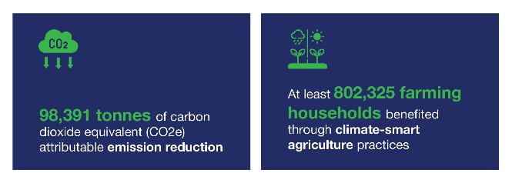
- Climate impact graphic
These figures come from the reduced and efficient use of nitrogen-based fertiliser in maize, rice, and other crops and improved feeding practices in the beef sector. The emission reduction in farming activities comes from farmers who have adopted innovations introduced by PRISMA’s partners relative to emissions emitted from farmers who have not adopted better farming practices.

Lessons Learned
Maize Madura
PRISMA chose to work in the maize sector because maize is one of Indonesia’s primary food crops, and demand far exceeds the domestic supply. Adoption of hybrid seed and good agricultural practices (GAP) are two key approaches in increasing maize supply. PRISMA has supported private seed companies to enter the commercial market, which has led to increased productivity.
The key lessons PRISMA learned in this process are as follows:
- More effective and wider uptake of public sector innovations requires engagement at the national level.
- Government subsidies can be an entry point for developing a commercial market for seeds but may still pose a threat to commercial growth.
- Demonstrating that the government and the private sector have a common vision is critical for successful public-private collaboration, and a neutral facilitator can be key to bridging the views of both sides.
Mungbeans
PRISMA chose to work in the mungbean sector because domestic production cannot meet the increasing demand, and mungbeans can provide additional income for smallholder farmers. The adoption of high-yielding seed and GAP are essential strategies in increasing low domestic productivity. PRISMA has supported seed producers to enter the commercial market and made linkages between relevant mungbean market players, leading to improved productivity.
The key lessons PRISMA learned in this process are as follows:
- The value addition of a Market System Development program to a large company is often less about the funds that the program brings to the table and more about the market insights and technical support it can provide.
- Although the quickest route to scale is often through a large market actor, it is important not to rule out diversifying with medium-sized players.
- Even after entering a partnership, it is important to continuously and proactively identify the risks and constraints that may arise for partners, particularly when developing a market for a new product.
- Policy advocacy is not the only way to solve government-related bottlenecks. In some instances, private solutions may be equally or more effective in alleviating a bottleneck.
Pigs
PRISMA chose to work in the pig sector in NTT because the market is underdeveloped despite being one of Indonesia’s largest producers and consumers of pork. Pig rearing is a culturally significant tradition in NTT, and women are very involved in the sector. Adoption of good animal husbandry practices and pig health products are key approaches in building sector resilience in preventing and recovering from the ongoing African swine fever outbreaks. PRISMA has supported feed companies to enter the NTT market, leading to improved breed genetics, farm management and biosecurity measures. PRISMA also supported a disease prevention, detection, and surveillance strategy implemented by the NTT Provincial Animal Husbandry Office.
The key lessons PRISMA learned in this process are as follows:
- Thin markets may require a more hands-on approach initially, but an exit strategy and upfront and clear boundaries on how far the program is willing to go with its support are necessary.
- It is important to identify a network of interested agents when trying to attract companies to enter the market, especially in thin markets like NTT.
- Despite having a common national language, customised and contextualised materials and influencing strategies are important for more effective information and marketing campaigns.
- When there is a health emergency that needs urgent action, local media coverage can be used to kick-start a government response.

Ririn Handayani of CV Argo Jaya, a PT Kubota Machinery Indonesia dealer in Banyuwangi, East Java demonstrates the use of combine harvesters, a faster, more cost-effective and climate-friendly approach to rice harvesting.

Program Relevance
PRISMA is a market systems development (MSD) program working in agriculture in 6 provinces in Eastern Indonesia: East Java, Central Java, East Nusa Tenggara (NTT), West Nusa Tenggara (NTB), Papua and West Papua.
The program is funded by the Australian Government’s (GOA) aid program through the Department of Foreign Affairs and Trade (DFAT) and implemented in cooperation with the Government of Indonesia (GOI) through the National Development Planning Agency (Bappenas). PRISMA is an AUD165 million investment that began in 2013.
PRISMA’s governance structure includes a Project Coordination Committee (PCC), with representatives from Bappenas (Directorate for Food and Agriculture) and DFAT. The PCC meets at least once a year to review program updates, provide recommendations, and approve the annual work plan. PRISMA and DFAT also hold regular meetings to discuss program progress and challenges. PRISMA shares a monthly update report based on these discussions, which DFAT uses to communicate with Bappenas. Meanwhile, the internal governance structure includes a Management Team with members from all portfolios, Chief Operations Officer, Chief Technical Officers, and the Chief Executive Officer. The Management Team meets weekly and discusses the program’s progress, implementation plans, challenges, and risks.
Achieving rural growth through the private sector will alleviate poverty for smallholder farmers and put Indonesia in a better position to improve its food security. The program's investments seek to change how the private sector does business in rural Indonesia so that smallholder farmers can increase their farm productivity.
PRISMA does this by:

Relevance to the GOI Strategy
PRISMA is aligned with the GOI’s National Medium Term Development Plan (RPJMN) 2020-2024. Bappenas openly supports the program’s efforts to ensure smallholder farmers have access to critical inputs in line with the MoA’s strategic plan for 2020-2024. PRISMA is also aligned with the GOI’s plans for post-COVID-19 economic recovery.
Indonesia’s Long-Term National Development Plan (RPJPN) 2005–2025 prioritises rural development and agricultural reform to achieve food security, enhance equity, and drive economic growth – all of these strategic goals align with the program. President Widodo’s administration continues to prioritise economic growth in the rural sector by transforming the agriculture sector, nutrition, reducing regional disparities, and ensuring climate resilience.

Relevance to the GOA Strategy
The Partnerships for Recovery: Australia’s COVID-19 Development Response Plan 2020-2022 guides Australian development programs’ approach to supporting Indonesia’s COVID-19 response and recovery. PRISMA contributes to the stability and economic recovery pillars by strengthening agricultural markets and food security while improving poor farmers' livelihoods. PRISMA remains well-placed to help reduce economic hardship and ensure that women and vulnerable groups play a critical role in Indonesia’s recovery.
PRISMA’s focus on systemic change aligns well with DFAT’s COVID-19 Development Response Plan by building more resilient agricultural markets in eastern Indonesia. The impacts of COVID-19 and the ongoing conflict between Russia and Ukraine have resulted in stresses on agricultural value chains and the price of agricultural inputs, leading more rural poor into poverty. PRISMA’s work with the private sector helps markets recover and build resilience against future shocks. It does this by simultaneously tackling the underlying causes of market failures, such as limited access to agricultural products and information and addressing inclusion and resilience. Therefore, PRISMA is well placed as part of DFAT’s recovery portfolio.

Relevance to Sustainable Development Goals
PRISMA is designed to support economic recovery, address inclusion, and build partnerships with the private sector to support agricultural growth in eastern Indonesia.
PRISMA’s key performance indicators (KPI) are aligned with Sustainable Development Goals (SDGs) 1 and 2: ending poverty and ending hunger. PRISMA also captures data on women’s economic empowerment (WEE), which goes some way to contributing to SDG 5 - gender equality.
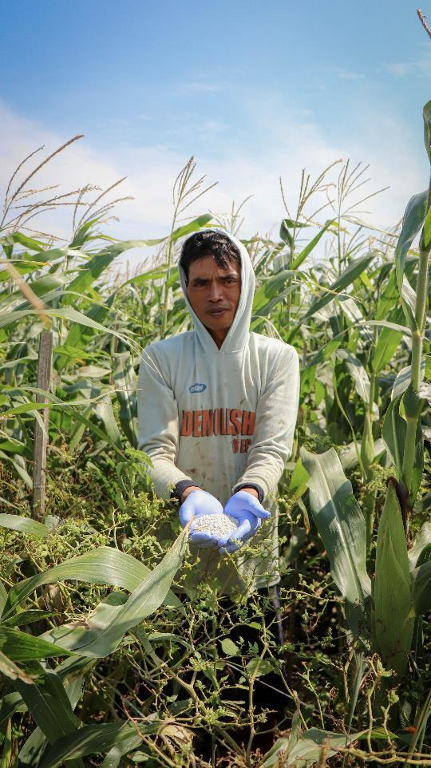
Antok, a maize farmer in Plemahan, Kediri district, uses a climate-friendly fertiliser in his maize field.

Portfolio Overview and Progress

Program Context
PRISMA uses an MSD approach working with the private and public sectors to introduce innovation into the market to address the underlying underperformance of that market. In other words, PRISMA attempts to permanently change how the private sector does business in agriculture to make it more inclusive.
PRISMA will end in December 2024, and this semester has been used to assess, monitor, and evaluate each of the 12 target sectors to determine an effective exit strategy. Each market system exit strategy identifies activities and actions that need to be undertaken to induce crowding in (more competing companies copying the business model) and nudging a response from complementary service providers (non-competing companies). These actions will ensure greater sector resilience and further progress towards systemic change. Actions will also include phasing out of market functions that are performing independently, such as the feed function in the beef, dairy and pig sectors, maize seed in Madura, and product marketing for mechanisation in East and Central Java. Some market functions have been dropped due to lack of progress, including small and medium enterprise (SME) financing consulting services and SME financial services. The digital agricultural ecosystem function in information and communications technology (ICT) that deals with livestock health services has been discontinued.
The exit strategies were collated and presented to DFAT during the semester, and changes to the market system strategies (MSS) have been included in the sector updates (refer to Annex 1).

Progress Toward Systemic Change
This report is the fourth Progress Report and Implementation Plan (PRIP) since the program strategy refresh in 2021. The program has progressively highlighted sector progress in batches in each PRIP, starting with those sectors showing the greatest progress towards systemic change (refer to Figure 5). Progress is evaluated for the sectors every 6 months with a sector review undertaken by the senior management team. This comprehensive review evaluates progress using a format designed by the Donor Committee for Enterprise Development (DCED) and also industry principles and methodologies for assessing progress towards systemic change. The sector review is done with a one-day workshop with the sector team and supplemented with a field trip to test assumptions through interviews with partners, intermediary service providers (ISP), and user and non-user farmers.
This PRIP highlights the finance and ICT sectors, which had a major strategy overhaul in September 2021. Both the ICT and finance sectors are showing the least progress towards systemic change compared to other more mature sectors. This is because of historical factors leading up to the revised strategy (outlined in the sections below); this shorter timeline limits change to the partner level. This PRIP also comes back full circle to highlight the beef and soil treatment sectors featured in the first post-refresh PRIP. Both sectors are showing expected progress towards systemic change.
- Portfolio progress towards systemic change
How is systemic change measured
Systemic change is measured in a range of ways, including through the program key performance indicators (KPI) (refer to Annex 2). Indicators such as farmer outreach (KPI1) and income increase (KPI2) tell if a sufficient scale and benefit has been achieved that farmers will autonomously adopt the innovation.2F The partner investment leverage (KPI8) and increased partner and ISP turnover (KPI5,7,8) tell how much investment the partners are making towards adopting and adapting the business models. Indicators such as the number of businesses crowding in and the number of responding organisations or institutions (KPI 9,10) indicate if innovations are being copied independently and if other market actors are responding to this change, providing greater depth and breadth to the change in the system. These KPIs are all quantitative indicators of systemic change.
The most important tool to measure systemic change is the systemic change narrative, as acknowledged by the independent strategic review team. These stories illustrate the starting and end points of the change to the market system and capture qualitative data. The program supplements the systemic change story with an easy-to-follow flow diagram showing the change through time. And finally, the program supplements the systemic change story with a partner and farmer perspective in narrative form, highlighting the significant changes from their perspective.

Sector highlights - systemic change stories
Finance (progress against MSS)
The finance sector strategy focuses primarily on strengthening agri-SME access (especially agri-kiosks) to more flexible credit such as overdrafts, revolving loans, and terms of payment to fit with their seasonal demands for capital. More flexible working capital will help agri-kiosks better manage their cash flow, stock sufficient products for the agricultural season, and potentially offer flexible payment options to farmers. In tandem with the ICT sector and in support of other areas of PRISMA, the finance sector aims to ensure that kiosks are better managed, stocked, and informed so that they can provide affordable, quality products and services on time to smallholders.
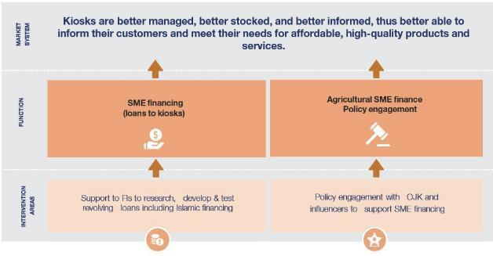

Indicator
Actual cumulative outreach to June 2023 (HHs) 3F: 23,646 (Male: 39,535, Female: 20,780)
Cumulative outreach projected to Dec 2024 (HHs): 26,491
Total NAIC to June 2023 (%)4F: 32%
Total NAIC up to Jun 2023 (IDR): 104.9 billion
Total projected NAIC to Dec 2024 (IDR): 110.4 billion
Value for money (VFM)
Investment leverage: 5.67
Investment per HH: 71.09
Social return: 6.24

Constraints
On the demand side, unlike mainstay non-agricultural businesses, agri-kiosks are seasonal and often lack sufficient working capital to stock high-quality products at peak periods and diversify into other areas, such as mechanisation services and commodity trading. Kiosks are constrained by inappropriate loan products (inflexible monthly repayment loans over 1 or more years), uncertain business conditions, a lack of financial literacy to choose the right product, and a lack of financial product information.
On the supply side, FIs have low incentives to lend to agri-kiosks due to perceived risks associated with agriculture and a lack of knowledge regarding the potential agri-SME market. In addition, FI sales agents may lack the product knowledge and ability to sell more flexible loans and may lack the incentive to diversify their portfolio, preferring to sell more standard loans instead.

Vision
By 2024, at least 3 banks will have increased their commercial interest in disbursing agricultural financing products to agri-kiosks in Central and East Java. PRISMA will do this by engaging with FIs to offer novel conventional and Islamic financing products for SME financing.

Market function 1: SME financing
Bank Mandiri’s Central Java regional branch has provided 21 loans to agri-SMEs because of the kiosk landscaping survey supported by PRISMA. These loans are a mix of the government’s subsidised smallholder loan product (KUR) and commercial loans, with a total value of IDR4.4 billion (AUD441,000) each.
Responding to Bank Mandiri headquarters’ recent strategy and interest in improving their targeting of agricultural SMEs, PRISMA supported them to expand the kiosk landscaping survey to a further 500 samples in 4 provinces (East Java, West Java, Lampung, and South Sulawesi), which they will use to develop suitable loan products for agri-kiosks.
PRISMA has facilitated conversations between Mandiri, and its ICT partners, Semaai and Bayer, to explore potential finance provision to their agri-kiosk network, and non-disclosure agreements have been signed. Bank Sinarmas Syariah is exploring potential financing for Semaai and Nadi agri-kiosk networks. The finance team supported the mechanisation sector to link Bank Sinarmas Syariah to Kubota Machinery Indonesia and its distributors to explore financing options.

Market function 2: agricultural SME finance policy engagement
Preliminary focus group discussions (FGD) were conducted as part of an agri-SME financing policy study conducted by the Institute for Development and Economics and Finance (INDEF) and attended by representatives from the Financial Service Authority (OJK), the Coordinating Ministry for Economic Affairs, the Ministry of Agriculture (MoA), the Ministry of Cooperatives and SMEs, Central Bank, Bank Sinarmas, and microfinance practitioners from the Bogor Agricultural University (IPB) and the University of Indonesia. These FDGs contributed to a broader policy landscaping study that will inform policy around agri-SME financing to be made available next semester. A key area of focus is the KUR scheme, which currently does not allow for more flexible products.

Challenges and learning
The strategy for the finance sector is only 18 months old, and following the sector review this semester, a lot has been learned from early interventions that is feeding into improved partnerships being designed for Semester 2. Part of the learning is that the finance strategy may have been too ambitious in initially incorporating a light-touch function on SME financing consulting services. This has now been dropped. Although there was hope that PRISMA could support consulting firms to develop kiosk landscaping studies for other banks to facilitate crowding in, the quality of end products was below expectation, and too much hand-holding was required.
In addition, all legacy interventions related to SME financing services to farmers via kiosks have also been closed. Most models were not replicable or scalable, although there may have been good impact at a micro-scale.
The current minimum loan amount for revolving loans offered by PRISMA’s FI partners is IDR500 million (around AUD50,000), much higher than the IDR300 million (AUD30,000) that most agri-kiosks require. Persuading FIs to lower this will require a combination of instruments, product design, and testing to address risk perceptions while ensuring that the commercial returns make it attractive enough. It will be a challenge for PRISMA to convince banks to design and test products in the remaining period, so more achievable options are already being explored.
Financial literacy is a constraint to the uptake of short-term, flexible loans by agri-kiosks. This may, in turn, limit the products offered by the banks as their agents are more likely to offer products that they are likely to sell to get their commission rather than spend time educating their customers. Kiosks tend to make their choice based solely on the interest rate rather than thinking about how much the loan will ultimately cost them. Some banks have a large network of branchless banking agents (e.g., Bank Mandiri) that could be trained and incentivised to collect the agri-kiosk and other rural SME data for potential borrowers using a modified survey methodology. Finding the right incentives for these agents will be an important factor in their success. To address this, PRISMA will explore incentive model options for bank sales agents.
Whilst agri-kiosks’ financing needs and turnover make them attractive to FIs, this could be a good springboard to service other agricultural SMEs such as off-takers and processors since they are likely to have similar profiles to agri-kiosks in terms of turnover and cashflow but are less likely to need flexible financing. PRISMA will explore this further next semester as it can be implemented without needing to change the loan product.

Finance systemic change story
A journey fraught with roadblocks
The finance sector story is not a story of systemic change. Instead, it is a journey of learning what works and what does not in improving smallholder farmers' access to finance. In its 9-year history, PRISMA has tried a range of models to give farmers greater access to finance at scale but with limited success.
Growth in farmer financing is constrained by a lack of commercial interest from FIs due to high transaction costs, limited availability of credit history data, and limited information or technical skills in agriculture finance.
Finance is a critical barrier to smallholder farmers' access to quality inputs and services needed to increase agricultural productivity. In Indonesia, FIs provide limited suitable loan products for smallholder farmers that fit the seasonal needs of farmers, for example, flexible loans or lines of credit at peak planting times. In addition, farmers are not comfortable with borrowing from FIs due to their limited financial literacy. As a result, around 71 per cent of smallholder farmers and kiosks rely on informal credit sources.5F
In the first phase of PRISMA (2013-2018), its sister program, SAFIRA, used value chain financing (VCF) to reach farmers by focusing on credit for agri-inputs. The VCF approach relied on third parties, such as off-takers, facilitating loans by repaying the FIs on the farmers’ behalf. However, the approach required intensive capacity development of FIs and smallholder farmers, which impeded SAFIRA from reaching scale or resulting in sustainable business models. The approach also required tailor-made rather than generic deals to be developed, which meant scale was hard to achieve. Most of the models established with the FIs under SAFIRA were not replicable, and few FIs developed new commercial loan products, relying instead on KUR, the government’s subsidised loan product.
In Phase 2 of PRISMA, access to finance expanded beyond VCF to other forms of agricultural finance. Financial technologies (Fintechs) were explored as a source of direct farmer financing because they had a higher risk appetite and were quicker at developing new products. However, the Fintech environment was risky. Due to ongoing limited scale potential and a contracting financial market due to COVID-19, PRISMA moved the focus away from direct farmer financing towards financing agriculture SMEs. When it comes to financing kiosks, they are less risky due to their ability to provide collateral.
A smoother road but still some speed bumps
In 2021, as part of the PRISMA strategy refresh, PRISMA launched a new finance strategy focusing on SME financing, mainly revolving loans6F for agri-kiosks. Agri-kiosks are a primary source of information for farmers, and input companies are increasingly targeting agri-kiosks to reach farmers. Increased flows of funds to kiosks can translate into better management of inventory, stocking of complete product lines, and even provision of flexible payment options or branchless banking to farmers. Kiosks’ need for working capital (capital for day-to-day operation) increases during the peak agriculture season. Hence, they prefer short-term loans that allow them to repay at the end of the season.
However, implementing this approach in 2021 was challenging as PRISMA and the rest of Indonesia had to work from home for 18 months due to the pandemic. In November 2021, PRISMA returned to the office, and field travel recommenced, and by mid-2022, the team began to achieve some progress. A series of agri-kiosks studies commissioned by PRISMA provided vital insights to convince 3 banks: Mandiri, BNI, and Bank Sinarmas, to partner with PRISMA to explore opportunities for financing agri-kiosks. For Bank Sinarmas, PRISMA commissioned a kiosk landscaping study in NTB to explore opportunities for Islamic financing to agri-kiosks.
Progress has been slower than expected with the bank partners because PRISMA has found it challenging to convince the banks to broaden their loan types, which has been compounded by bank staff needing to fully understand the existing products on offer and how to tailor them to agricultural SMEs. The finance strategy initially focused mainly on agri-kiosks and has now widened to agri-SMEs to encompass traders, nurseries, and machinery operators, which all have similar seasonal working capital requirements. This makes the market larger and hence more appealing to Fis.
In tandem with the SME financing work, PRISMA, in early 2023, engaged the INDEF to review the SME financing policy landscape to identify challenges or opportunities in the business-enabling environment. If barriers are identified (e.g., a lack of flexibility in KUR) in the policy landscape as part of this study, PRISMA will present these findings to the OJK. Since the program will end in 2024, PRISMA will share the study findings with other industry stakeholders and relevant DFAT programs to develop a policy brief and advocate any possible changes to the OJK.
The road forward
The revised strategy for the finance sector is about 18 months old. PRISMA learned a lot from the early interventions and research on agriculture SME financing. This learning will feed into improved partnerships for the upcoming semester. The partner banks now have a deeper understanding of agri-kiosks and improved capacity and information on what works and does not work in financing agri-kiosks. The next semester will focus on developing short-term, revolving loan products for kiosks and other related SMEs. The goal is to assess the systemic change potential for SME financing by this year and document results for continuation.
GEDSI Spotlight
Capital for green growth: financing women’s groups to invest in high-value organic agriculture
PRISMA supported former partner, financial institution PT Permodalan Nasional Madani (PNM) to increase financing for smallholder farmers and medium and small enterprises (MSME) with a specific strategy for engaging women farmers. PNM developed a model that attaches training to loans for women farmer’s groups to increase productivity, while for PNM, this helps with customer acquisition and retention.

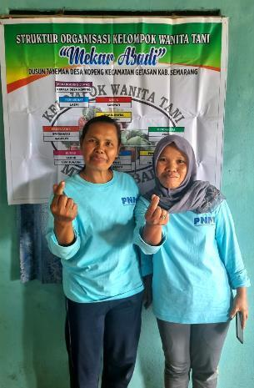
Ibu Lasmi and Ibu Sumiyati, leaders of the Kelompok Wanita Tani Mekaar Abadi women’s farmer groups
‘I like the togetherness of the group; we are a community. We don’t only meet to talk about farming but other important issues we’re all going through,’ explains Ibu Lasmi. Ibu Lasmi is a vegetable farmer in Kopeng, a village perched on a hillside in the foothills of Mt Marbabu. Mt Merbabu is not far from Mt Merapi and sits in the chain of volcanoes that cuts through Java. The soil is fertile, and Kopeng is not far from the capital of Central Java, Semarang and the connections to traders that a city presents.
Ibu Lasmi has been living in the area all her life. Her mother is 88 years old and continues to work as a farmer on her plot, as does her son. Her daughter is in Jakarta studying theology, when she finishes, she will return and work as a farmer. ‘If you’re not a farmer, you’re a labourer building houses or maybe a driver,’ says Ibu Lasmi.
Going up a level
Ibu Lasmi is one of the leaders of a women farmers group, Kelompok Wanita Tani, that uses a loan to grow organic vegetables in a greenhouse jointly owned by the group. Each woman has their own plot and takes turns tending to the communal plot.
As Ibu Lasmi describes the group, she repeats that the “spirit of togetherness and working together on a project” is what stands out. The group’s progress is also perhaps a result of this camaraderie. To start the women’s farmer’s group organic farming project, the group received a loan from the non-bank financial institution, PT Permodalan Nasional Madani (PNM).
‘PNM supported us with the capital and the financing. We started with IDR2 million (AUD200) and have increased to IDR7 million (AUD700). What I found helpful was the support from PNM to strengthen communication in the group and define the roles, our business knowledge and ways to improve our farming, like making our own organic fertiliser,’ explains Ibu Lasmi.
As a result, the group has now broken even in organic farming. The group decided to go organic for their communal plot, as the produce has a higher selling price.
‘We’ve improved our productivity. With the mekaar loan (PNM product name) we could make weekly instalments for up to 50 weeks. Agriculture is seasonal and we needed a loan, which we can now get.’
A cluster approach
PNM was established in 1999 and has developed an extensive business across Indonesia lending money to ultra-micro and medium and small enterprises (MSMEs). In 2021, PRISMA approached PNM to strengthen its business model by engaging more smallholder farmers and MSMEs. The PRISMA team also encouraged PNM to consider how their businesses could benefit women farmers.
For businesses, women farmers present a largely untapped opportunity for market growth – be it for high-yielding seeds, fertiliser products or, in this case, microfinance loans. To help PNM develop its offering to women farmers, PRISMA looked at how to support customer retention for PNM by engaging women farmers beyond loans.
PNM’s Capacity Development Officer, Ibu Devi explains, ‘We introduced a cluster approach to support our customer retention strategy – where we run a 6-month program with women farmers groups, training women in agriculture to improve productivity while also strengthening the group’s way of working together with communication, organisational development, financial management, and business skills training.’
At the end of the 6-month period, the aim is for women farmers’ groups to conduct their own meetings, independently contact off-takers, and increase their investments. Through this process, women are building their agricultural knowledge and skills, using the experience of the communal plot on their own plots.
Business development
For PNM, the clusters have been a source of learning about what is possible in agriculture. ‘We are actively looking for other potential agriculture areas to support and actors to collaborate with, such as input companies, off-takers or organisations engaged in agriculture.
We will continue to support the women farmer groups for organic farming so that they can reach a wider market and better selling prices.’ Ibu Lasmi explains what she has learnt. ‘Before we just bought fertiliser and used it. Now we know the dosage and even make it ourselves from household waste and our animals.’
This is not only improving productivity but farmer incomes in the process. ‘We can see that organic farming has a higher value and we aim for organic certification. It takes 2-3 years for the chemicals to work their way through the soil, but we’ll get there.’

ICT (progress against MSS)
PRISMA’s ICT and finance sectors share the same overall aim to improve the ecosystem around agri-kiosks so that they become better managed, stocked, and informed. This will enable agri-kiosks to provide affordable, quality products and services on time and provide accurate information and advice to smallholders so that they can make informed input purchases. PRISMA is achieving this by engaging input and agri-e-commerce companies to improve their kiosk platforms and distribute product–related information.
PRISMA’s ICT sector is also contributing to other sector constraints, such as soil treatment, by engaging with tech companies to develop fertiliser applications to provide accurate fertiliser recommendations to kiosks and farmers. PRISMA is also supporting the beef and pig sector in innovation in online veterinary services and the rice sector through smart irrigation.
Support input companies/agri- tech/government to develop improved GAP content and channels
Input supply chain
Agriculture information
dissemination & marketing
MARKET
SYSTEM
FUNCTION
INTERVENTION
AREAS
Kiosks are better managed, better stocked, and better informed, thus better able to inform their customers and meet their needs for affordable, high-quality products and services.
Support research and development of new/improved agri- services for smallholder farmers through kiosks of other channels
Support agri-input providers to deliver improved kiosk management

Indicator
Actual cumulative outreach to June 2023 (HHs): 2,349 (Male: 2,963, Female: 4,018)
Cumulative outreach projected to Dec 2024 (HHs): 2,740
Total NAIC to June 2023 (%): 64%
Total NAIC up to Jun 2023 (IDR): 9.8 billion
Total projected NAIC to Dec 2024 (IDR): 10.6 billion

Value for money (VFM)
Investment leverage: 0.04
Investment per HH: 703.96
Social return: 0.59

Constraints
Smallholder farmers lack access to quality information on good agricultural practices (GAP) and other agricultural services (e.g., crop protection input usage and fertiliser dosage), and the public sector extension services cannot provide universal coverage. Input and service suppliers are constrained in supplying GAP information and services via kiosks because they are largely unaware of the opportunity, and economies of scale are perceived to be low. Although smallholders perceive kiosks as credible information sources, they lack complete product lines and sufficient stock to meet demand at the right time due to supply-chain constraints and lack access to credible and accessible product information.

Vision
Through ICT interventions, agri-kiosks are better managed, stocked appropriately with products in a timely fashion, and can respond to farmer demand. Kiosks have access to and offer an increased range of agricultural services. Kiosks and agri-input companies offer relevant and quality advice and promote products and services responsibly.

Market function 1: input supply chain
PRISMA and Semaai initiated discussions to develop a transaction dashboard in their kiosk app to help kiosks predict sales trends based on purchasing history and equip them with a digital transaction record to support bank loan applications. In addition, PRISMA facilitated meetings between Semaai, Bank Sinarmas Syariah and Bank Mandiri to incorporate buy-now-pay-later (BNPL) facilities in their kiosk app as an alternative payment in stock procurement.

Market function 2: agriculture information dissemination and marketing
Semaai launched a clinic feature in its kiosk app, which provides accessible advice to kiosks on its products so that it can better advise its farmer customers. The feature has already been accessed by 876 unique users.
No progress has been made this semester with the Bayar app, as the head office is waiting for approval from the parent company to use the application programming interface. In the meantime, Bayer conducted 4 women-specific training programs in GAP, attended by 88 women farmers and kiosk owners. The research on gender roles and dynamics in kiosks, which began last semester, has been completed. Information is being collected from various sources, including women and men kiosk managers, farmers, distributors, and customer traffic data during the planting season.
PRISMA initiated support to MSMB and SIPINDO to develop fertiliser calculator applications as tools to disseminate improved fertiliser recommendations to farmers, kiosks, and extension services. Research commenced in Blora to test 3 smart irrigation sensor types and explore the social and economic parameters for their wider adoption. This trial will be finished in July.
Based on the results of the sector review, there will be no further work in exploring early-stage technical innovation, and this intervention area has been removed from the MSS.

Market function 3: digital agriculture ecosystem
The results of market research on the demand for digital livestock health services were disseminated in collaboration with the Indonesian Veterinary Medical Association (PDHI) through a workshop attended by veterinarians, paramedics/paravets, digital animal health service providers, AIHSP, and the MoA. This semester, PRISMA has assisted PDHI in developing guidelines and a code of conduct for digital health service provision that will pave the way for investment in service provision.
No further work will be undertaken in this market function going forward, and it has been removed from the MSS.

Challenges and learning
Digital and financial literacy remain a constraint to developing more advanced management features. Whilst SMEs are adopting more digital tools such as Semaai’s platform, low digital and financial literacy holds them back in adopting more advanced features that could help them manage their kiosks better, such as inventory management and bookkeeping. PRIMSA and Semaai explored developing such features, but Semaai is not developing this functionality due to low demand during the user research.
Introducing technological innovations is challenging. The dynamic and rapidly changing sector, combined with insufficient infrastructure and low digital literacy, make investment in the sector challenging to reach economic feasibility. This underscores the need for development and blended finance to help overcome these barriers.

ICT systemic change story
Opportunism is a necessary starting point
ICT innovation in agriculture in Indonesia is very new and is fertile ground for innovation. However, digital agriculture faces numerous challenges in eastern Indonesia, including limited infrastructure, farmers’ lack of technological knowledge, and a poor understanding of agriculture among ICT actors who have demonstrated a willingness to tap into the sector. The ICT sector started in Phase 1 and focussed on the shortage of extension services to farmers and identifying how ICT solutions could close this gap.
During Phase 1, PRISMA had 6 partnerships, mainly with input providers and tech companies, including startups with limited experience in the agriculture sector. PRISMA partnered with the crop protection company, BASF, to expand their existing call centre for crop disease consultation for farmers. PRISMA also supported several input partners (including EWINDO and PT Natural Nusantara) to develop, test, and promote new mobile apps to provide GAP information directly to farmers. The program partnered with 2 startups (8 villages and HARA) to develop applications for market linkages.
Most of the pilots had limited success because of lack of scale and sustainability due to the high investment needed for data collection and the low financial returns. Most of the companies were not prepared to shoulder this cost alone when there was a low return on investment. While some of the larger companies could shoulder the cost of the applications, most found the uninstall rate of farmers as high as the install rate, except for EWINDO. None of the interventions in ICT were continued into Phase 2.
Going off on a tangent
PRISMA’s support at the beginning of Phase 2 moved from farmer data collection to a multi-stakeholder partnership involving a credit union, off-taker, and input company (BISI), which used WhatsApp groups as the platform to facilitate communications and information sharing among partners and with key farmers involved in the pilot. However, the pilot was unsuccessful, and PRISMA reverted to its previous partner, HARA, to support another round of farmer data collection through agri-kiosks to sell to FIs. However, due to COVID-19, HARA could not monetise the data, and instead, it pivoted to a new off-taking business model in rice and maize. While the business model failed for these staple crops, HARA found some success in the ginger sector, but again at a small scale.
With the failure of HARA, and without a strong overarching strategy to guide the ICT sector, PRISMA worked on digital off-taking services with companies such as Viamo, Panen.ID, Tukang Sayur and SiKumis during the pandemic years. None of these interventions succeeded due to lack of scalability, issues around traceability, and the inability of the program to assess if the platforms were benefiting poor farmers.
Improving the ICT sector strategy with a shift towards agri-kiosks
The PRISMA strategy refresh in 2021 provided an opportune time to revisit and consolidate the ICT strategy. Up to that point, the strategy had been retrofitted around assumed solutions and intervention development was not aligned with the sector vision. It was agreed that the digital off-taking service partnerships would be closed, and the HARA ginger intervention would be phased out.
The ICT strategy focused on bringing ICT solutions to known constraints in other sectors. The mandate given by the Strategic Review Panel (SRP) was for some blue-sky thinking and “bounded creativity” to test innovation within the parameters of sector constraints analysis and the change agenda of the sector MSS.
Given the close link between the finance strategy and opportunities for the digitisation of kiosks, the ICT strategy focussed on supporting agri-kiosks to become better stocked, better managed, and better informed so they could provide high-quality agri-inputs and information to farmers. Digitising the agri-kiosks makes sense because, compared to farmers, kiosk owners have better connectivity and higher digital literacy. There was an opportunity to capitalise on the scale afforded by the kiosks at the village level with their connectedness, as well as the momentum generated by input companies that had largely digitised because of COVID-19.
Implementing a new strategy and piloting of blue-sky thinking takes time
In late 2022, PRISMA signed a partnership with an emerging startup, Semaai, to provide an e-commerce platform for agri-kiosks. This partnership is well underway, with the company adopting the business model. To support information dissemination and marketing, PRISMA partnered with Bayer, a large agrochemical company, to develop an additional function on its existing platform to disseminate GAP and explore a partnership with finance partner Bank Mandiri for a closed-loop model for rice farmers. This work is waiting for sign-off from headquarters but is poised for take-off.
In May and June of 2023, PRISMA partnered with the agricultural startups, MSMB and YBTS, to develop fertiliser calculators to assist farmers in applying the correct dosage. This work is being done in collaboration with the soil treatment sector and will be incorporated into EWINDO’s existing platform (the contract was just signed with YBTS), and MSMB will spend the next 6 months pitching their calculator app to fertiliser companies. This work is in its infancy but provides complementary support to the soil treatment sector.
PRISMA is working with the PDHI to digitise animal health services for livestock as part of information dissemination and marketing. While similar services exist for pets in urban areas, there is no such service for livestock. PRISMA is currently finishing work with PDHI on an overarching code of conduct that would govern the development of such an application. While there are some companies prepared to develop and market the application to avoid the duplication of work with other DFAT programs, no further work will be done from PRISMA in this space. Instead, PDHI will be linked with other DFAT programs with the specific mandate of working with animal health issues.
PRISMA is currently trialling the use of soil water sensors which can be marketed to irrigation service providers. The sensors will be able to give accurate information on water needs for paddy fields. Most farmers overwater and overuse urea, which decreases productivity and increases greenhouse gas emissions. This is a potential win-win solution where irrigators save on electricity costs, and farmers increase productivity by using less water, making better use of soil nutrients and fertiliser, and the environment has less greenhouse gas emissions and water pollution. However, farmer acceptance remains a big question and anecdotal evidence from the field is that neither irrigation service providers nor farmers are quite ready for this change, given the cultural norms such as the expectation that paddy should be flooded, and the social pressure to plant and manage the crop in certain culturally accepted ways. The trial results are expected next semester but no further work is planned in this area.
Going forward
While the SRP was correct that ICT is a fertile ground for rapid innovation, PRISMA has found that partners and kiosks need more time for adoption than originally envisaged. With only 12 months left for pushing partner and farmer adoption, the team is reflecting on what is possible and what needs to be dropped.
The ICT team will continue to scale up the supply chain applications and successful models for agricultural information dissemination as this work supplements the work being done by other crop sectors. The senior management team will undertake quarterly sector reviews to assess progress.

ICT partner story
Farmer-first ICT solutions – a story from Semaai
Semaai was established 2.5 years ago in Central Java. The company’s aim, explains Ayu Semara Sandrasari, the area manager of the greater Solo area, is to revolutionise agriculture through technology by ensuring that agri-kiosks can stock quality inputs for farmers. ‘We see ourselves as a one-stop-shop for the full crop cycle. This includes planting, fertilising, treating pests and diseases, and even off-taking,’ says Ayu.
Ayu says that when PRISMA met with the chief executive officer (CEO) of Semaai, Yoga Anindito, in 2022, the team gave good suggestions on how Semaai could improve its application and services. ‘PRISMA told us that the best way for farmers to buy products is if their productivity increases due to using those products,’ says Ayu. ‘But selling isn’t enough. PRISMA explained that agri-kiosks owners need readily accessible information on what products address what problem and how farmers should best apply those products. We had not thought of that up to now,’ explains Ayu.
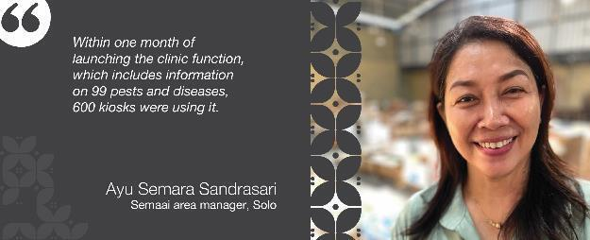
Semaai partnered with PRISMA in August 2022 and invested in improving their application to include an agricultural clinic function that is intuitive and easy to use. Kiosks or farmers can access the clinic to look for stress signs or symptoms in crops and get information on how to treat them. Ayu explains, ‘Within one month of launching the clinic function, which includes information on 99 pests and diseases, 600 kiosks were using it. The kiosks like it because we organised the information in a simple way, and it takes you directly to the product you need and provides information on the correct dosage.’
Semaai offers 570 agricultural products from more than 100 companies through the app and offers instant delivery. PRISMA has supported Semaai with additional functionality by introducing the startup to Bank Mandiri to provide credit facilities to pre-approved agri-kiosk. Semaai is now also offering BNPL services to its kiosk customers.
Next, Semaai will discuss with PRISMA’s other ICT partner, MSMB, to look at adding their fertiliser calculation app to Semaai’s platform.
Since working with PRISMA, Ayu says Semaai has 6,000 agri-kiosks ordering products from them monthly. ‘My hope going forward is that we continue to expand to become a household name for agri-kiosks and farmers alike.’

ICT kiosk story
How to become an instant plant doctor
A farmer arrives at Gunawan’s agri-kiosk, Toko Anugerah, and asks for a product to kill sundep, the Indonesian term for rice stem borer. Gunawan suggests a few products to the elderly farmer and reminds him of the correct dosage for the treatment he eventually chooses.
Gunawan is not a farmer, but his parents are. ‘I took over my parent’s agri-kiosk 2 years ago because they are getting very old. I come from the finance sector and am used to technology, but I know less about farming,’ admits Gunawan. Because he lacked knowledge, Gunawan relied on Google for all his product information. ‘It’s a bit hard to reply on Google when someone comes into the store asking what they should do when the leaves on their chilli plants have gone yellow. Google can be a bit of a rabbit hole,’ laughs Gunawan.
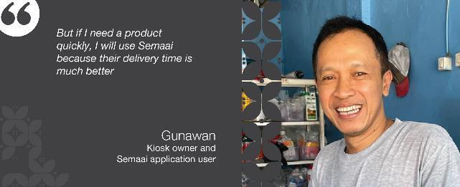
Gunawan joined Semaai in 2021 to order his products. He orders 4 times a month with an average order size of IDR3.5 million. ‘I don’t always buy from Semaai because sometimes AgriAku has the same product for cheaper,’ says Gunawan. ‘But if I need a product quickly, I will use Semaai because their delivery time is much better,’ he states.
However, the most significant value Gunawan sees in the Semaai application is the clinic function. ‘I am much better now at referring my customers to the correct products. If they have time and are not in a rush, I can also access videos and show the farmer how to use the product and how much they need. Most people overuse pesticides, and that’s not good because it doesn’t kill the pest, and the farmer goes to a different agri-kiosk because he is unsatisfied,’ explains Gunawan.
Gunawan says that he will remain a loyal Semaai customer. ‘Anything that turns me into a plant doctor overnight, I like,’ he says with a laugh as he turns his attention to another customer.

Beef (progress against MSS)
Domestic beef consumption in Indonesia continues to exceed supply, so beef must be imported. East and Central Java and NTB are the largest cattle-producing provinces, representing 45 per cent of the country’s cattle population, comprising about 2.5 million small-scale beef producers. Yet, cattle production and productivity are low.
Small scale beef producers increase cattle productivity through improved livestock management practices in Central and East Java and NTB
Advocating for changes to feed SNI
Policy
Improving cattle trading system and supply chain networks
Supply Chain
Access to affordable good quality veterinarian products and services
Animal Health
Promotion of quality concentrate feed and good cattle rearing practices
Feed
MARKET
SYSTEM
FUNCTION
INTERVENTION
AREAS

Indicator
Actual cumulative outreach to June 2023 (HHs)7F: 638,649 (Male: 584,352, Female: 269,842)
Cumulative outreach projected to Dec 2024 (HHs): 662,397
Total NAIC to June 2023 (%)8F: 145%
Total NAIC up to Jun 2023 (IDR): 3.63 trillion
Total projected NAIC to Dec 2024 (IDR): 3.79 trillion

Value for money (VFM)
Investment leverage: 3.04
Investment per HH: AUD10.35
Social return: 54.86

Constraints
The cattle sector in East and Central Java, and NTB operates under a low input-output production system resulting in suboptimal weight gain (approximately 0.3kg/day), long intervals between calving (18 to 20 months), and poor health conditions. This is because smallholder farmers 1) rely on native grass and fodder rather than commercial feed; 2) have limited access to affordable feed, pharmaceuticals, and veterinary services; and 3) have poor knowledge of livestock management practices. This is compounded by an ineffective cattle trading system.

Sector vision
PRISMA will address the market constraints and improve cattle production and productivity for smallholder farmers in East and Central Java, and NTB. This will be achieved by introducing good quality and affordable cattle feed and pharmaceutical services. This will be supported by enhancing the feed standards (SNI) from the Government of Indonesia (GOI) and a better trading system for live cattle.

Sector status
After 8 years, around 64 per cent of farmers in East Java and 33 per cent of farmers in Central Java are using high-quality feed. Over 640,000 of these farmers have increased their incomes by 145 per cent. Before PRISMA, only 2 per cent of farmers in Indonesia used high-quality feed. From a baseline of 2 feed companies, there are now 62 feed companies selling concentrate feed through 1,097 agents. PRISMA’s partner companies have invested AUD4.83 million in feed production and distribution systems and continue to expand to new provinces, such as NTB. In response, the government changed the SNI to enable more companies to enter the feed market and produce good-quality feed at the price point that smallholder farmers can afford. In addition, 5 pharmaceuticals now actively promote pharma products and educate farmers in good livestock management.
Most smallholder beef cattle farmers are using commercial feed (64 per cent East Java, 33 per cent Central Java). From the baseline of 2 companies, there are now 62 feed companies producing and selling affordable commercial feed through at least 1,097 distribution channels to smallholder farmers. PRISMA supported the SNI changes through the quality grading system, meaning even more feed producers can enter the market to produce affordable and certified feed throughout Indonesia. Five pharmaceutical companies have responded to the growing feed industry and the foot-and-mouth disease (FMD) outbreak. As a result, 5 per cent of farmers are regularly applying biosecurity.

Market function 1: feed
PRISMA currently partners with 5 feed companies to promote high-quality commercial feed and educate farmers on good rearing practices across 63 districts in the target provinces. Substantial progress has been made with partner feed sales that have gradually rebounded from a 50 per cent decline due to FMD and lumpy skin disease (LSD) outbreaks in 2022. Farmers are gaining confidence in reinvesting in cattle and actively purchasing feed from partners.
Partners conducted 54 educational and promotional activities this semester, engaging 3,642 farmers and agents. Sreeya expanded to NTB and collaborated with a local university, feed agents, and a pharmaceutical company (PT CTSI) to promote feed products and educate farmers in NTB (see partner story below). Munir Jaya passed feed lab tests and has applied for a feed registration number. As a result of these efforts, feed sales for partners increased by nearly 20 per cent in the first half of 2023. Additionally, PRISMA assisted PT AgCoTech in conducting a molasses lick block trial to reduce methane emissions from cattle, with the final report expected next semester. The trial encouraged the company to consider establishing a factory in Indonesia.
Because the feed market is well established and partners and non-partners have reached scale, PRISMA will exit the feed market next semester.

Market function 2: animal health
PRISMA collaborates with 3 pharmaceutical companies to promote animal health products, proper animal health management, and biosecurity practices to farmers across 39 districts in Central and East Java and NTB. In response to the government's request, PRISMA commissioned CENTRAS-IPB to conduct a cost benefit analysis for FMD prevention and control, which was well received by the GOI. Using information produced by the MoA, PRISMA partners developed products (63 new products, 65 per cent for FMD prevention) and marketing messages for the prevention and control of FMD, which has contributed to farmers adopting biosecurity and treatment measures. While the efficacy of the long-term modelling in the cost benefit analysis was debated, the report helped to influence Bappenas to allocate an additional IDR3 trillion for FMD control and prevention in 2023.
As a follow-up, PRISMA was requested to conduct training sessions for 25 government officials in Central Java to assist them in budget planning for disease control. The cost benefit analysis report was presented to the MoA and livestock agencies across Indonesia. AIHSP, will take forward any future initiatives related to cost-benefit analysis forward.
In addressing the FMD and LSD challenges in cattle, PRISMA’s partners worked closely with government vets, feed companies, and universities to implement control strategies, educate farmers on biosecurity practices and promote proper animal health management. The strategies used information developed by the MoA in collaboration with the DFAT animal health program, AIHSP, and in line with Department of Agriculture, Fisheries and Forestry (DAFF) recommendations. This semester, 1,534 farmers took part in 33 educational campaigns, training programs and awareness initiatives conducted by PRISMA partners.
Significant changes have taken place in the pharmaceutical industry because of PRISMA interventions. There are now 5 pharmaceutical companies that have expanded their business focus from poultry to include cattle, specifically targeting FMD and LSD. PRISMA's exit strategy is to help these partners increase farmer adoption rates of biosecurity measures.

Market function 3: supply chain
The supply chain function was to be undertaken in NTT. No progress was made this semester due to the outbreak of FMD.

Market function 4: policy
Following the success of revising the SNI feed policy last semester, PRISMA continued to support the MoA to develop a regulatory impact assessment to support the overarching regulatory review process. Additionally, PRISMA experts assisted the MoA draft 3 overarching regulations for wider industry change in the feed sector, which are expected to be published by the end of 2023.

Challenges and learning
FMD and LSD outbreaks continue to pose a threat to the cattle sector. While FMD cases have decreased and the beef industry is recovering, LSD cases have grown exponentially. Low adherence to biosecurity practices by farmers and increased cattle movement before Eid al-Adha at the end of June have heightened the risk of disease transmission. To mitigate the risk, PRISMA continues to support private partners to develop adaptive mitigation strategies, informing farmers about preventive measures, and fostering collaboration between business to business (B2B) and private-public sectors to minimise the impact of FMD and LSD on the cattle industry.
The new SNI standards for native chickens, broiler chickens, pigs, ducks, and quail are already in force, but the beef and dairy cattle feed standards are on hold pending the availability of a nonprotein nitrogen (NPN) analysis tool in the laboratories. The NPN requirement was not part of the original SNI supported by PRISMA. The program is now advocating for NPN to be on the ‘optional criteria’ list. This approach will be regulated in the new MoA overarching regulation.

Beef systemic change infographic
Beefing up sales – how PRISMA is supporting small-scale beef producers to increase cattle productivity through improved livestock management practices in Central and East Java and NTB.
2014 – present
- [2014 - 2015] The starting point. Only 2 per cent of beef farmers use concentrate feed, with cattle averaging a daily gain (ADG) of 0.3kg.

- [2015-2016] Proof of concept PRISMA partners with 2 small feed producers to establish distribution channels for commercial concentrate feed and educate farmers on livestock management practices.
- [2017 – Dec 2018] Nudging change. The business model is successful. Cattle fattening times improve from 24 to 11 months, but the scale remains limited.
- [2019 – 2020] Reaching scale. PRISMA supports 5 more feed producers to enter the feed market, and distribution grows to more than 1000 agents. Farmers can sell 2-3 cattle per year with an income increase of 131%.
- [Jul 2020] A barrier to growth. Despite 26 feed producers crowding in, PRISMA identifies the SNI as a barrier to growth. Feed mills cannot produce registered feed within the purchasing price of smallholder farmers.
[2021 –2022] Broadening the scope of change. PRISMA commissions reports and technical assistance to advocate the MoA to revise the cattle feed SNI. The MoA commissions a review to verify PRISMA’s studies. PRISMA broadens support to the cattle sector by including animal health, supply chain, and policy functions for improved resilience.

- [2022–2023] FMD and LSD hit 27 Provinces in Indonesia. PRISMA leverages its private sector networks to deliver animal health messages from the MoA. PRISMA supports the government in budget planning for animal disease prevention through a cost-benefit analysis. PRISMA partners with 3 large pharmaceutical companies to improve farmers' access to veterinary products, biosecurity measures, and animal health services.

- [Dec 2022] The doors to the feed market open. New feed standards are released for all livestock feed allowing more feed producers to enter the market and produce good quality certified feed at affordable prices. Due to government restrictions importing products such as feed and medicine for cattle to NTT, FMD closes the door to supply chain interventions in NTT.
- [2023 – ongoing ] Expanding into thin markets. PRISMA is supporting feed partners to expand feed and animal health interventions in underserved markets while phasing out from the mature Java market. PRISMA also pilots a youth business incubator model with one feed partner in NTB.
- To date: PRISMA continues to support the SNI policy change with a change to the overarching MoA livestock feed regulations. This could benefit up to 13.6 million farming households (HH) in Indonesia. Sixty-two feed producers are producing feed for cattle in East and Central Java. Sixty-four per cent of farmers use concentrate feed in East Java and 33 per cent in Central Java. Cattle ADG has increased to between 0.9kg-1.4kg; cattle fattening time has decreased to 4-6 months; and PRISMA interventions have added 143,157 tonnes to the national beef production. To date, 641,316 smallholder farmers are benefitting with an income increase of 145 per cent.
- [2024] Exit Strategy. Expanding to thin markets and exploring climate-smart feed options.

Beef systemic change story
Things will never be the same again, and that’s a good thing

Beef sector snapshot – the starting line
The beef sector was seen as a good opportunity in Phase 1 because there are 4.4 million smallholder cattle farmers in Indonesia, and 2.6 million live in East and Central Java. Cattle are the primary income for around 20 per cent of these farmers and the secondary income for 30 per cent of them. Approximately 66 per cent of these smallholders in 2015 lived under USD5.5 a day.
Cattle productivity in Indonesia could be higher, but most farmers use traditional feeding and animal husbandry practices. As a result of poor nutrition, cattle had an average daily weight gain of less than 0.3kg and a calving interval of up to 20 months (more than double the global average). Farmers take up to 2 years to fatten their cattle with an average weight sale price of IDR11-15 million (AUD1,100).
When PRISMA started in the cattle sector, 2 per cent of cattle farmers Indonesia-wide used concentrate feed. In Central and East Java, only 3 SMEs produced unlicensed and untested concentrate feed, catering to 8 per cent of farmers. Farmers were not regularly treating cattle for common medical problems, such as worms, and few pharmaceutical companies produced cattle products. The beef sector had good growth potential. Following is how PRISMA contributed to it.

A slow grinding start
PRISMA’s biggest problem was convincing feed companies that smallholder farmers were a profitable market segment. All large feed companies prioritised the poultry sector and were not interested in beef. PRISMA had to start small in the feed function with 2 SMEs (PKM and UD Wahyu Utama) producing cattle feed using agricultural by-products and help from Google.
For 2 years (2016-2018), PRISMA supported the SMEs with feed experts to help the SMEs develop a better feed mix. PRISMA supported the partners in developing distribution channels, promotional and marketing campaigns for farmers, and staff capacity in business management. By 2018, PRISMA needed a scale agent, and based on the success of PRISMA’s SME partners, 2 larger companies (Japfa Comfeed and KJUB Puspetasari) agreed to pilot the business model.
The gears begin to turn
By 2021, PRISMA had persuaded 5 more companies (Sreeya, Munir Jaya, Fermen Hipro, Sinta Prima, Sumber Rejeki) to enter the cattle feed market. PRISMA partners had expanded their distribution channels to 1,097 agents, and the feed market was taking hold. However, PRISMA was aware that one barrier to reaching wider systemic change was the high specifications of the SNI. The SNI meant that only large companies could afford the base ingredients to meet the standard, and the resultant price of the feed put it outside the purchasing power of smallholder farmers. Although PRISMA’s partner’s cattle feed achieved a good Average Daily Gain, the feed could not pass the SNI, thereby preventing the SMEs from licensing the feed to sell it legally and exporting it to other provinces.
To address this barrier, in 2021, PRISMA engaged well-known feed experts, industry lobby groups, and associations, such as PISAgro, Gabungan Perusahaan Makanan Ternak (GPMT) or Feedmills Association., Ganungan Koperasi Susu Indonesia (Indonesian Dairy Cooperative Association) GKSI, and leading universities, including Brawijaya, Gadjah Mada University (UGM) and Bogor Agricultural University (IPB), to conduct multi-stakeholder workshops with the MoA, market research, and academic studies that led to a policy brief for consideration by the MoA and the National Standardisation Bureau (BSN) in 2022. The MoA agreed to the findings in the policy brief and undertook a technical review. The MoA’s study confirmed the results, and MoA and BSN signed the new standards at the end of 2022.
The new beef feed standards allow for 3 grades of feed, including premium, middle and standard feed, with the required nutrients for weight gain but with different core ingredients and price points. This change allows more SMEs to enter and effectively compete at an affordable price point for smallholder farmers.
In 2021, PRISMA also began to work in animal health and did a market study to convince pharmaceutical companies to extend their focus on cattle, with a specific focus on addressing intestinal worms. In 2022, PRISMA partnered with 3 companies (CTSI, USFA and Medion) to develop marketing and promotional strategies focused on smallholder farmers.
Enough speed to avoid the roadblock
In 2022, FMD and LSD hit the sector, leading to a reduction in feed sales. PRISMA partners supported the fight against FMD by including biosecurity messages in their marketing and promotional materials. PRISMA coordinated with the DFAT animal health program, AIHSP, and the MoA, ensuring that messaging was consistent with the government’s approach.
While feed sales slowed momentarily, it provided momentum for PRISMA’s animal health innovations to take off. PRISMA partnered with an additional pharmaceutical company, CTSI, and all partners started to develop medications, food supplements, and biosecurity products specific to the cattle industry in addition to worming products. PRISMA facilitated multi-stakeholder collaboration with government vets, feed companies, and pharmaceutical companies to deliver bundles of services and educate farmers on good feeding, health and rearing practices.
Hitting the highway
In 2023, the MoA agreed to review the overarching feed guidelines for all livestock feed, and the draft regulation (Peraturan Menteri Pertanian) is under review. In parallel, the MoA agreed to streamline the licensing process and contributed IDR111 billion (AUD111 million) to improve and build laboratory facilities.
Now, 62 feed producers including 7 partners supply and distribute commercial feed to smallholder farmers in 26 provinces throughout Indonesia. PRISMA partners (7) have invested more than AUD4.77 million in the feed industry to continue to deliver services to smallholder farmers.
Three pharmaceutical companies now carry a range of 33 products specifically for cattle and are experiencing a 15 per cent sales increase annually.
PRISMA leaves behind a cohort of universities, research firms, trainers, and digital marketing companies that can now deliver services to the cattle industry and government.
More than 1.15 million farming households have used concentrate feed, and 641,316 farmers are using it continuously, with an income increase of 145 per cent (64 per cent in East Java and 33 per cent in Central Java). The average daily weight gain for cattle has increased from less than 0.3kg to 0.95 to 1.4kg (depending on the dose). The fattening time has decreased to 4-6 months, meaning that farmers can sell 2-3 cattle annually at an average price of IDR25-30 million/head (AUD2,500). To date, PRISMA beneficiary farmers have contributed 143,157 tonnes to the national beef production, equivalent to IDR15.7 trillion (AUD15 billion) since it began. PRISMA has significantly contributed to a total transformation of the beef sector in Indonesia.

Beef partner story
Empowering youth in agribusiness in NTB
NTB is a thin market, meaning few private sector companies are engaged in agriculture and even fewer in new markets. Cattle feed is a very new market in NTB, and PRISMA is supporting a feed company, Sreeya, to expand to the area. To nudge growth in the feed sector, a local university is leveraging its work experience program to encourage youth to enter the livestock market with some help from Sreeya.
Yuni, Reza, Ruslan, and Mario are all animal science students at the University of Nahdlatul Wathan in Mataram, NTB. They are part of a new business incubator initiative of the university to give entrepreneurial training to students wanting to establish themselves in the livestock sector. The Feterna Business Incubator (FBI) was created by the Dean of Animal Science at the university, Alimuddin, following a business model suggested by PRISMA. FBI is halfway through its first intake of 25 students.
‘The FBI gives training in business management, digital marketing, and hands-on skills to birth entrepreneurs who are ready to open agribusinesses when they graduate,’ says Alimuddin. ‘The work they do here, which is guided by the university professors and technical experts, is credited to their degree, so it is a win-win outcome,’ he explains.
Mario, a 22-year-old student, is very excited about his prospects of opening an agribusiness. My father died in 2014, and my mother had to work as a cleaner in Malaysia to support my sister and me,’ says Mario. ‘So, I am motivated to do something that can support my family and other families like mine in West Lombok.’
Mario’s uncle has 28 heads of cattle. He explains that this does not make him wealthy as they use traditional farming practices. ‘My uncle’s cattle are swum over to a small island 1 kilometre from the shoreline where they stay and graze. But because West Lombok gets very dry, there is only a short window when my uncle can sell them before their condition drops. It takes nearly 2 years to fatten them, but my uncle rarely makes much profit when he does sell them,’ explains Mario. Mario wants to raise cattle and teach his uncle to fatten cattle using concentrate feed.
Reza is from East Lombok from a farming family. His father owns a few heads of cattle and has already convinced him to feed his cattle concentrate feed and to stall them. ‘My father listens to me because I am the eldest and the only one with a university education,’ he says. ‘My father has put aside one cow for me, and I plan to increase that to 50 head of cattle.’ Reza and his fellow students are already active sub-agents for a local feed distributor, Purwadi. Previously a distributor for poultry feed, Purwadi started distributing cattle feed for Sreeya a month ago when they entered NTB.
Yuni is more interested in opening an agri-kiosk and selling cattle feed and medicine. The FBI is already collaborating with PRISMA feed partner, Sreeya and pharmaceutical company CTSI to provide products in sampler packets for the NTB market. Both companies are now doing this, and sales have increased. From zero sales in cattle feed last month, Purwardi has sold 40 tonnes in June and expects this to double in July.
Ruslan is one of 5 kids. His father died when he was 16, and his mother supported them by selling snacks at the market. Through the FBI, Ruslan has developed a business plan to work directly with local beef butchers as an agent. He has submitted a proposal to the local livestock department to access micro-credit to get his business off the ground. ‘The business incubator has built my confidence that I can succeed and given me the skills to do that,’ says Ruslan.
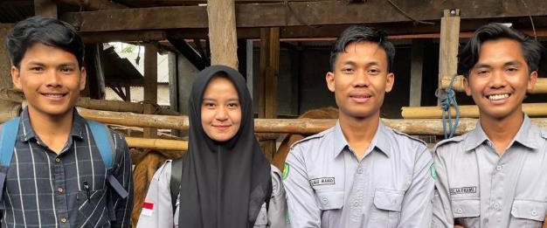
By supporting youth in opening agribusiness and partnering with input companies such as Sreeya and CTSI, the FBI will contribute to the changing farmer behaviour in NTB. ‘With 25 students gaining experience through the FBI per semester, we hope to increase farmer productivity and ensure the working prospects of NTB youth,’ says Dean Alimuddin. ‘This is something the university is behind 100 per cent.’

Beef farmer story
Building back better – life after foot and mouth disease
Warsiyem is from a long line of rice farmers who have kept cows as a source of income. Warsiyem’s parents used to keep water buffalo, but as land sizes have decreased and hand tractors have taken over the work of water buffalo, Warsiyem and her husband reverted to beef cattle. She kept one cow to complement the family income. Warsiyem’s husband spent many hours a day searching for fodder for the cow, and they supplemented the grass with rice straw. It took Warsiyem over a year to sufficiently fatten her cow for sale. She sold her cow aged 1.5 years, with a purchase price of IDR14.5 million, for IDR23 million after one year of feeding.
In 2020, Warsiyem met a farmer from a neighbouring village at the local agri-kiosk. ‘This farmer was buying Nutrifeed concentrate feed for his cattle, and so I asked him whether it works,’ says Warsiyem. ‘He told me the proof was in his cattle and that I could come and see them before he sold them to the market for the big Eid al-Adha festival.’ Warsiyem took up the invitation and was so impressed by what she saw that she started buying feed directly from the farmer, who was a distributor for Nutrifeed.
Within 4 months, Warsiyem saw a considerable difference in the weight gain of her cow, even though she was only giving 2 kilograms of feed rather than the full recommended daily dose of 8kg. When Warsiyem and her husband saw the potential of the cattle business, they decided to invest in another cow. ‘We see it as revolving our capital,’ explains Warsiyem, ‘We sell our cows to buy rice seed, and then we sell our rice harvest to buy more cows,’ she explains with a laugh.
By 2021, Warsiyem and her husband had 5 head of cattle, all fed with Nutrifeed. After discussions at a farmers’ gathering in Klaten with Nila, the marketing manager for Nutrifeed, Warsiyem and her husband upgraded their cattle pen with concrete floors and concrete washable feed and water troughs. That year at the Eid al-Adha festival, they sold their cattle for around IDR48 million a head, experiencing a 943 per cent income increase from cattle sales compared to 2020.
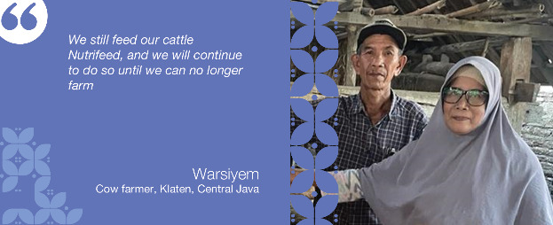
In July 2022, FMD struck, and Warsiyem’s village was in the red zone. All of Warsiyem’s 6 cattle contracted FMD, but they survived. Warsiyem puts this down to their feeding regime but admits she also had her cattle vaccinated. In comparison, her neighbour’s cows were fodder fed, and all 3 died. Because the FMD outbreak was close to Eid al-Adha, Warsiyem could sell 5 of her cows at the market rate, but one she kept because it was still limping. Warsiyem said she got information from Nutrifeed on disinfecting her cattle pens and other biosecurity measures. ‘Because I was paid a deposit for my cows for the Eid al-Adha festival, I worked extra hard to ensure they stayed alive,’ said Warsiyem. ‘My neighbour had to pay back his deposit because all his cows died. That was a huge burden for many farmers at that time.’
Warsiyem used the profit from the sale of her cows to grow back her herd. She is still using biosecurity measures, but only once a week. It is now close to the Eid al-Adha festival once more, and Warsiyem is informing her 1,500 TikTok followers on how to keep their cattle fat and healthy. While she admits she spent a year being a Nutrifeed agent, she stopped doing it because there are so many more agents now that it no longer made it profitable. ‘Plus, I am getting older,’ she explains, laughing, ‘I can still do TikTok for my fellow farmers on how to get your cows fat, but the feed sales I now leave to the younger generation.’
Warsiyem and her husband have no plans to stop raising cattle. ‘We still feed our cattle Nutrifeed, and we will continue to do so until we can no longer farm,’ says Warsiyem.

Soil treatment (progress against MSS)
Indonesia’s fertiliser market consists of both subsidised and non-subsidised (commercial) fertiliser. There is an estimated 11.9 million tonne supply gap to meet optimal crop requirements. Because of the over-use of nitrogen-based fertilisers, such as urea, there is poor soil quality in many intensively farmed areas. As a result, 77 per cent of the fertiliser needed by farmers is organic.
MARKET
SYSTEM
FUNCTION
INTERVENTION
AREAS
Marketing & promotion
Distribution
Support innovative promotional and marketing activities with a customer-centric focus
Facilitate the collaboration of fertiliser companies and other inputs/ service providers for opportunistic and integrated marketing and promotion
Support the expansion of distribution channels and capacity building for fertiliser companies
Staple, horticulture, and estate crop farmers in Central Java, East Java, and NTB have access to and use quality fertiliser in a safe way

Indicator
Actual cumulative outreach to June 2023 (HHs): 223,010 (Male: 364,527, Female: 197,108)9F
Cumulative outreach projected to Dec 2024 (HHs): 292,821
Total NAIC to June 2023 (%): 54%
Total NAIC up to Jun 2023 (IDR): 1.66 trillion
Total projected NAIC to Dec 2024 (IDR): 2.07 trillion

Value for money (VFM)
Investment leverage: 27.71
Investment per HH: 9.92
Social return: 74.95

Constraints
Major constraints in the sector include 1) limited and untimely supply of subsidised fertiliser, 2) limited supply of good quality commercial fertiliser (especially organic as fertiliser producers are hesitant to invest in market expansion due to a lack of reliable market intelligence and the prevalence of subsidised fertiliser), and 3) farmers’ lack of awareness of the benefits and correct application of quality fertiliser. These constraints have been exacerbated by increasing global fertiliser prices due to the ongoing Russia-Ukraine war.

Vision
PRISMA’s vision is to increase the availability and use of high-quality commercial fertilisers in Central and East Java and NTB by working through private and state-owned fertiliser producers. Fertiliser producers and retailers will offer a variety of fertilisers (both organic and chemical) through innovative marketing and promotional strategies incorporating accessible information on good fertiliser practices (GFP).

Sector status
In 4 years, more than 223,000 farming households have benefitted from using good quality fertilisers and applying GFP. Now, farmers can access commercial fertilisers through 290 kiosks in Central Java, East Java, and NTB. This was achieved by working with 6 companies that invested AUD1.97 million in developing the commercial markets. Now, 9 companies actively promote commercial fertilisers and educate farmers on good fertiliser practices. Before PRISMA’s work, most companies, including 5 state-owned enterprises (SOEs), focused on the government’s subsidy market but not on farmers’ education.

Market function 1: marketing and promotion
This semester, PRISMA’s partners further invested in expanding into the commercial market. ITN conducted marketing strategy training for its core staff to improve and strengthen its penetration and expansion. ATS is exploring a collaboration model with district governments in Sampang, Pamekasan and Sumenep, designing demo plots and embedded GFP promotion activities for mineral-based fertilisers.
ITN conducted market research jointly with PRISMA for bio-fertiliser products and customer behaviour in East and Central Java to identify marketing opportunities. Using these insights, they conducted similar research independently for Lampung and West Java. Saprotan Utama conducted market research for their new NPK (nitrogen, phosphate, potassium) and phosphorus-based products in East and Central Java. Saprotan Utama identified market opportunities amid high fertiliser prices and the changes in subsidised fertiliser policy. Based on the study, 60 per cent of respondents replaced SP-36 with other commercial fertilisers since the government no longer subsidises it. This shows the willingness of farmers to adopt and pay for commercial fertiliser.
PRISMA partners continued to provide GFP as part of their marketing activities, typically through farmers’ meetings and field days. Two companies hired additional resources to provide technical assistance to farmers. PT Petrokimia hired 2 new agronomists and 38 new ‘Taruna Makmur’ youth apprenticeship staff as part of their Makmur program in Central, East, and West Java and NTB. ITN hired 2 field staff for Central Java to promote the benefit of using liquid organic biofertilisers.
PRISMA conducted an impact assessment of Saprotan Utama, ATS and ITN interventions this semester. The assessment showed that 63,236 farming HHs benefited, with a 23 per cent income increase equal to IDR7.43 million per HH.

Market function 2: distribution
This semester, PRISMA partners continued to expand their sales and distribution networks. ATS engaged 2 new main distributors in East and Central Java and expanded to 3 districts in East Java. Prior to the partnership, the company had 4 distributors and 42 kiosks, which has expanded to 8 distributors and 70 kiosks. PT Petrokimia also continued to build new distribution channels for their commercial products throughout East and Central Java and NTB by acquiring 40 new distributors.
Saprotan Utama trained 22 of its area managers and 70 agronomists in territory management and account planning to improve staff capacity and expand its distribution channels.

Challenges and learning
The GOI has revised the fertiliser subsidy policy and is planning to include organic fertiliser again. This may present both opportunities and challenges for fertiliser companies. The presence of subsidised organic fertilisers will compete with commercial products, but it may also provide a boost if they are used wisely. With the right social marketing and the increasing popularity and use of organic fertilisers, market demand can be expected to grow to create business opportunities for fertiliser companies.

Soil treatment systemic change infographic
Buying better crops – how PRISMA supports the private sector to get farmers to invest in appropriate fertilisers at the correct dosage for increased productivity.
2018 – present
- [2018] Reliance on subsidies. The fertiliser supply-demand gap is 14.4 million tonnes, with most supply aimed at the subsidy market.
- Business model is trialled. PRISMA develops and trials a business model with 3 fertiliser companies to market commercial fertiliser using GFP. The model is proven with 1,500 farmers increasing their income by 23 per cent.
- [2019] The business model is expanded. PRISMA facilitates a multi-stakeholder partnership model between non-competing companies and the largest SOE, PT Pupuk Kalimantan Timur (PKT), for joint marketing and logistics to broaden services to farmers.
- [2020] Further validation of the model is achieved. The multistakeholder partnership program with PKT is branded as AgroSolution and formally launched. The GFP model is pitched to other private companies to improve distribution to underserved areas. The overall result is an income increase of 75 per cent for more than 138,549 farmers.
- [2021] Strategy broadened to climate-smart fertilisers. PRISMA forms new partnerships to expand the use of coated fertilisers (slower release), organic and mineral fertilisers
- [2021] Education is the key. PRISMA encourages partners to focus more narrowly on education-based marketing and improving distribution to underserved areas.
- [2021] SOEs increase focus on the commercial market. AgroSolution, Pupuk Indonesia’s flagship commercial program is rebranded as Program Makmur and expands into 19 new provinces.
- [2023] To date. 5 partners benefit 223,010 farmers with an income increase of 54 per cent. The fertiliser supply-demand gap has reduced to 11.9 million tonnes. Three partners have moved from business to government (B2G) to business to consumer (B2C) models, and a 134 per cent increase in sales.
- [2023-2024] The exit strategy: Supporting crowding in and innovations to leverage impact and reach at least 16 per cent of the fertiliser market with improved education-based marketing methodologies.

Soil treatment systemic change story

Buying better crops- supporting farmers invest in appropriate fertilisers
Soil treatment sector snapshot – the starting line
Smallholder agricultural productivity in Indonesia is low compared to neighbouring countries. Fertiliser at the correct dosage has a significant influence on increasing productivity. The type of fertiliser farmers use also matters to soil health and productivity. When PRISMA first entered the soil treatment sector in 2019, there was a 14.4 million tonne gap (42 per cent) between supply and latent demand.10F Most of the supply was aimed at the government subsidy market, which supplied 22 per cent of the total market. The fertiliser subsidy program was inefficient because:
It used generic nutrient content, making it a one-size fits all approach rather than being tailored to a specific commodity, location and soil type.
There was a mistargeting of recipient farmers.
Farmers did not have sufficient technical assistance leading to an overuse of nitrogen-based fertiliser and an under-use of other macro and micro-nutrients.
The highly subsidised market discouraged private investment towards smallholder farming and focussed more on estate crops and large agribusiness. Eighty per cent of the commercial products focused on the B2B and not the B2C market. SOEs and the private sector were unwilling to embed farmer education services or GAP information because they believed it did not increase sales. Then PRISMA came in - this is the story.

A sceptical start
During Phase 1 of PRISMA (2013-218), fertiliser was not a stand-alone sector with a specific strategy and interventions to influence the fertiliser market system. Given the visible hand of the government in the fertiliser market, PRISMA was sceptical about the overall market opportunity. Towards the end of Phase 1, the door opened for a more focused fertiliser strategy.
From March to May 2018, PRISMA initiated 3 pilots with PKT, the largest SOE serving both the subsidy and commercial fertiliser market, CV Saprotan Utama (SUN) in the coconut sector, and PT Behn Meyer in the vegetable sector. These partnerships focussed on piloting marketing and promotion of commercial fertilisers.
Pushing for new thinking
The fertiliser strategy (refer to MSS) focussed on models that would have fertiliser companies conduct customer-centric, education-based marketing strategies embedding GFP information. In 2019, nearly all fertiliser companies sold products through the agri-kiosks using demonstration plots. The main issue was that kiosk owners did not have sufficient technical knowledge of products and correct dosage. This lack of knowledge led to a perverse incentive for agri-kiosks, as owners pushed for more sales rather than GFP. As a result, farm productivity continued to decrease due to the overuse of the wrong fertilisers.
As well as changing how companies promoted their products, PRISMA wanted smallholder farmers to buy and use commercial products more optimally using GAP and GFP. By optimally, PRISMA meant farmers using a balance of chemical, organic, and mineral fertilisers in a way that considered the farmers’ purchasing power, geography, labour availability, and seasonality, as well as whatever they were growing.
Early interventions focussed on supporting partners to become more customer-centric and developing the skills of its field staff in marketing and promotion—this included conducting more field activities directly with farmers and expanding distribution networks.
Using SOEs as a scale-agent
In 2019, PRISMA pitched an innovation to PKT to use a multi-stakeholder partnership approach which would bring together non-competing partners to promote a range of services and products at the same time using the education, farmer-centric approach. This innovation was named ‘agro-solution’ by PKT. This approach was so successful that in 2021, the parent company, PT Pupuk Indonesia (which has over 40 per cent of the commercial fertiliser market share), adopted the approach and rebranded it as the Makmur program and made it mandatory for its 5 subsidiary companies throughout Indonesia. By the end of 2022, Makmur had already reached 128,000 smallholder farmers reaching 271,000 hectares (ha) of land from their target of 250,000 ha. There are now 30 agri-service providers (finance, seed producers, insurance, traders, and off-takers) working under the Makmur umbrella with these fertiliser companies.
While working with SOEs is good as a scaling agent, adopting innovation takes longer due to the additional bureaucracy. So, PRISMA looked at bringing other partners on board to reach scale.
Changing the way companies and farmers do business
In 2021, PRISMA convinced another 3 fertiliser companies to adopt the education-based business model (ATS, BAI, and ITN). PRISMA recognised that businesses and distributors also needed to provide regular information to farmers on GFP. PRISMA supported its partners in conducting educational activities in the field and using digital platforms, including platforms for agri-kiosks, to reach more farmers with proper product knowledge.
Towards the finish line
The fertiliser supply-demand gap has reduced from 42 per cent in 2019 to 34 per cent (11.9 million tonnes). In 2019, subsidised fertiliser covered 6 products; in 2023, this is down to 2 products (urea and NPK). Private producers and imports now cover the reduction through the commercial market.
Six of PRISMA’s partners have now diversified their market activities, and 2 of them (PKT and Behn Meyer) are doing it without further support from PRISMA. Six of PRISMA’s 7 partners have expanded their businesses to service smallholder farmers in new areas, including NTB, NTT, and Sumatra. Three of PRISMA’s partners (ATS, BAI, ITN) have moved from a B2G to a B2B model and now a B2C model. The new way of doing business has resulted in a 95 per cent repeat order from farmers, a 4 out of 5 satisfaction rating for the kiosk information service, and a 134 per cent increase in fertiliser sales.
A critical component of the business model has been convincing farmers that an important part of the fertiliser dressing regime needs to include liquid organic fertiliser. Only the private sector can fill this niche. PRISMA partners are now providing free soil testing to educate farmers on what their land needs in terms of fertilisers.
To date, 223,010 farmers have benefitted, with an income increase of 54 per cent. PRISMA partners have invested AUD1.97 million to change how they do business.
The exit strategy
Changing the soil treatment market system in East Java, Central Java, and NTB requires sufficient scale. To reach the tipping point where enough companies and enough farmers are adopting the innovations, PRISMA needs to reach a few more companies. With only 1 or 2 agricultural seasons remaining, PRISMA will do some facilitated crowding in to convince other companies to adopt education-based marketing. PRISMA is doing a study to measure the conversion to sales of education-based marketing to develop material to nudge other companies to copy the model.
The soil treatment team will work with the ICT team to link businesses to the fertiliser calculation service (refer to section 4.2.1 ICT Partner Story on technology company, Semaai). The team will also work with the result, measurement and learning (RML) team to measure the impact of the Makmur program.

Soil treatment partner story
Creating demand by providing better service – the story of PKG
Sahran, the area coordinator for Petrokimia Gresik (PKG), a subsidiary of Pupuk Indonesia, is visiting one of his distributors in Sragen, Central Java. Sri Muryanti and her son Shodiq run PT Murni Sri Jaya, an agri-kiosk and leading distributor of PKG products in the greater Solo area.
Today, Sahran is bringing along an agronomist and an apprentice from one of the local agricultural colleges. The technicians will be helping Sahran at a farmer event, demonstrating soil testing and showing farmers what their soils need.
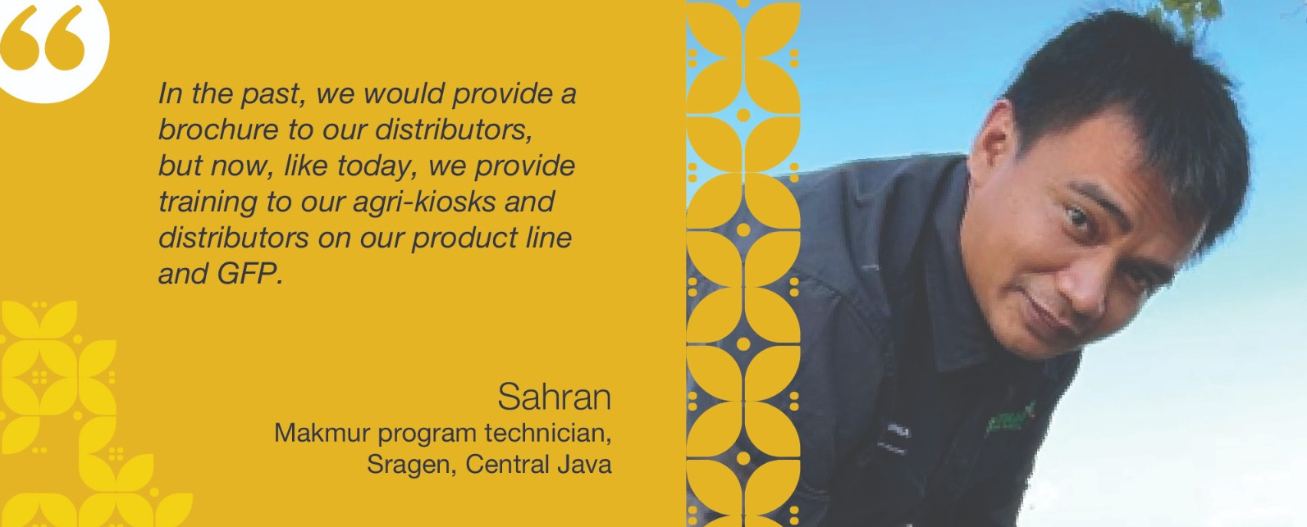
The technicians are part of the Makmur program, an innovative multi-stakeholder partnership approach to marketing introduced by PRISMA. Sahran explains that before this program, he worked in a small office with a few staff, but now has 11 agronomists and 38 apprentices that join PKG for 6 months at a time helping to deliver education-based training to farmers at events like the one being held today. In Sahran’s area, he does these events with farmers’ groups, agri-kiosks, and major distributors and partners with FIs (BRI, BNI, Bank Mandiri, and Bank Syariah Indonesia), government extension workers, Jasindo (an agri-insurer), and off-takers (ID food, PTPN, Syngenta, and BISI).
‘We all synergise with the other companies we invite to these farmer days, but PKG prioritises extension services,’ explains Sahran. ‘In the past, we would provide a brochure to our distributors, but now, like today, we provide training to our agri-kiosks and distributors on our product line and GFP,’ says Saharan.
Sri Muryanti is a strong Javanese woman with 5 adult children. ‘I want all my children to have their own distributor branches eventually,’ says Sri proudly. ‘I got this kiosk from my parents, who established it in the 80s. I only graduated from primary school, so I have to ask my son to help me with all the computer work,’ says Sri.
Before working as a distributor for PKG, Sri needed help to make ends meet. ‘I had to go out to all the small kiosks and drop off my product to them. Sometimes the kiosks could not pay for the product, so I gave loans. Kiosks often didn’t pay back the loans, and at times, it was difficult to feed my children,’ she admits. The lack of capital for kiosks is one of the reasons why Sri likes being a distributor for PKG and part of the Makmur program. ‘Since I became a distributor for PKG, I now give training to my agri-kiosks on how to provide information to farmers. And now, with the Makmur program, I no longer have to give loans.’
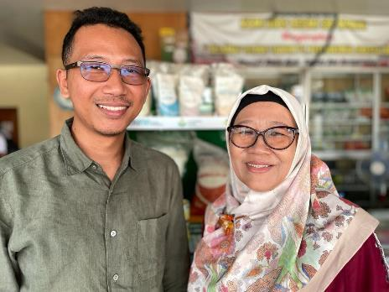
Sri and her son now serve 8 districts, but she is unhappy with more distributors established in the area. ‘I used to be the only major agri-kiosk on this main road. I wanted PKG to protect me, but they said this was business and competition was good.’
Shodiq is more positive than his mother. ‘Farmers in this area are a little old-fashioned, and most will choose subsidised fertiliser because it is free. But we have seen a significant decrease in subsidised fertiliser, so selling non-subsidised fertiliser makes good business sense,’ explains Shodiq. ‘We are grateful to have had the training from the Makmur program because when we pass this on to our kiosks, they are more comfortable convincing the more stubborn farmers to try new things,’ says Shodiq with a laugh.
Shahan says that since starting Makmur in 2021, they have seen a significant increase in the sale of non-subsidy fertiliser. In 2021, his area sold 16,000 tonnes, and in 2023, this has risen to 95,000 tonnes, despite the increase in fertiliser costs. ‘I put this down to the fact we are now closer to the farmer by training the kiosks and providing the information they need to make good farming choices.’

Soil treatment farmer story
Seeing is believing
Supomo and his wife are rice farmers from Sragen, Central Java. They have a small 3,400-metre plot of land and rent a further hectare with his parents, who are also rice farmers. ‘We’re just average farmers like everyone else in the area,’ says Supomo. In 2020, Supomo and his wife joined a farmers’ gathering supported by PTG as part of the Makmur program. ‘They taught us the importance of choosing the right fertiliser and started the discussion with a soil test. After that, they asked if anyone would like to offer their land for a demonstration plot. I was interested, so I volunteered a small piece of my land,’ says Supomo.
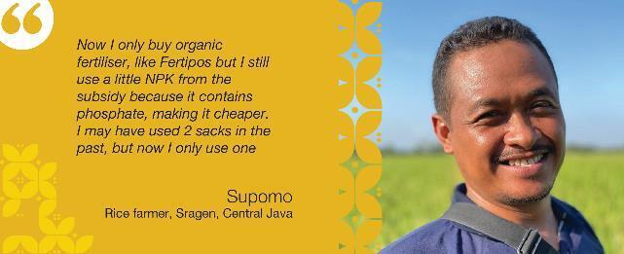
PKG used a drone to map out the land and get the correct coordinates, and then they took a core soil sample of Supomo’s land. Based on the results of the test, which were instantaneous, they were able to show the farmer groups what the land needed in terms of fertiliser.
‘They told me my land needed phosphate and organic matter, which the subsidised fertiliser couldn’t provide. They gave me free fertiliser for the demonstration plot and showed the farmers how to apply it properly and at what dose,’ explains Supomo.
Supomo’s demonstration plot yielded 200 kg more rice compared to the rest of his land, which equates to an extra half a tonne per hectare. ‘Now I only buy organic fertiliser, like Fertipos but I still use a little NPK from the subsidy because it contains phosphate, making it cheaper. I may have used 2 sacks in the past, but now I only use one,’ explains Supomo.
Even though Supomo cannot afford to use the full commercial regime of fertiliser suggested by the agronomist from PKG, he says that he can now get the organic liquid fertiliser and the zinc fertiliser with a loan from the kiosk. ‘At the farmers’ meeting, we were introduced to BNI, which said it could give us access to capital through the agri-kiosks. The kiosk gets the land, and we get the fertiliser directly from the agri-kiosk,’ explains Supomo. ‘I only have to pay the kiosks back when I have sold my harvest.’
Another advantage for Supomo and his farmer group is that there was also an off-taker at the Makmur farmer gathering that guaranteed to take their harvest. ‘We don’t get more for our rice because the government sets the floor price, but knowing your rice will be sold at the end of the harvest is a huge weight off our shoulders,’ says Supomo.
Supomo says he will continue to use commercial fertiliser because it benefits his yield. ‘Now that I have additional cash coming into the household, I can reinvest in more fertiliser, and we can buy what we need for school for our 2 children,’ says Supomo. ‘We are not rich, but we certainly have fewer worries.’

Other sector progress
Progress against the MSS for all other sectors can be found in Annex 1 and summarised in the table below:
Table 2: Sector progress Semester 1 2023.
Sector | Vision | Sector status
Crop Protection | Smallholder women and men rice and maize farmers in East and Central Java use safer crop protection products in an appropriate way. | After 4 years of PRISMA’s engagement, more than 110,000 rice and maize farmers in East and Central Java have reduced harvest loss by 22.5 per cent, equivalent to a saving of IDR1 million per season (AUD100). This result was achieved through working with 4 crop protection companies. These companies continue serving 12 per cent of the total crop protection market and educating smallholder farmers on good crop protection practices. Before PRISMA, 74 per cent of rice farmers and 51 per cent of maize farmers experienced harvest loss even after using pesticides.
Dairy | Small-scale women and men dairy farmers have improved milk quality and productivity by adopting good practices in rearing, feeding and health management in East Java and Central Java. | To date, over 6,518 farmers have increased their incomes by 74 per cent, using high-quality feed, good management, and milking practices. Now, 26 companies sell affordable feed to farmers in East Java and Central Java, compared to only 12 feed companies in 2019. PRISMA also induced pharmaceutical companies to target dairy farmers and educate them on disease prevention and treatment. With PRISMA’s support, the MoA is developing a roadmap for increasing cattle population and milk production in Indonesia.
Maize Madura | Women and men maize farmers in Madura use quality seed and good agricultural practices (GAP) to improve productivity. | More than 126,000 farmers (around 30 per cent of the total farmers) in Madura have increased their income from increased maize yield. Smallholder farmers in Madura use hybrid maize seeds and apply GAP. Now, 8 companies sell hybrid seeds through 95 kiosks and educate farmers on GAP. This is because the local government revised its geographic targets for subsidy distribution. Before PRISMA’s intervention, access to hybrid seeds was limited, with only 2 companies struggling to develop seed businesses in Madura.
Maize NTT | Smallholder women and men farmers in NTT use certified maize seeds and apply GAP properly. | Over 40,000 smallholder farmers in NTT benefitted from using certified maize seeds and applying GAP. Certified seeds are available in the main maize-producing areas, although the supply fluctuates every year. While only 3 local seed producers actively promote certified seeds, another 5 companies are ready to enter the market. Before PRISMA’s work, the availability of certified seeds in the commercial market was negligible, as no seed producers actively promoted and built a distribution network. With PRISMA’s support, the provincial government has strengthened the GAP service in its seed assistance programs and improved its seed certification capacity. However, the growth of the maize sector in NTT is still constrained by the limited availability of parent seeds and large-scale off-takers.
Mechanisation – Rice | Women and men rice farmers increasingly use agriculture machinery (combine harvesters and drone sprayers) services resulting in reduced production cost and harvest loss.​ | After 3 years, more than 42,000 farmers have used mechanisation services and increased their incomes by 17 per cent. Over 80 service providers now offer mechanisation services to these farmers. This was achieved by working with 5 companies promoting machinery services across 6 provinces. Companies also provide after-sales services for machine owners to ensure the durability and optimum lifetime of the machines. Before PRISMA, companies did not offer after-sales services or marketing strategies, leading to a low penetration rate and low durability of machines.
Mechanisation – Maize | Women and men rice and maize farmers have increased access to and use of agriculture machinery services to reduce labour costs. | In 3 years, more than 1,000 farmers have saved on labour costs and reduced their workload by using maize planters. Two companies in 2 provinces continue improving their capacity to better capture demand. Companies also offer after-sales services to machine owners to ensure the durability and optimum lifetime of the machines.
Mungbeans | Improved quality, competitiveness, and continuity of local mungbean supply. | After 6 years, more than 48,000 mungbean farming households have used quality seeds. The government reported11F that 24.8 per cent of planted mungbeans now use quality seeds. Before PRISMA, there was no commercial market for high-yielding seeds. Currently, 6 seed producers have entered the commercial market and sell quality seeds. Government research institutes have commercialised parent seeds to increase seed propagation.
Pigs | Women and men farmers and market players in the pig industry gain benefit from increased availability and appropriate use of quality inputs, use improved husbandry practices, and have access to the downstream market supported by a conducive regulatory environment. | More than 130,000 smallholder farmers increased their incomes by 405 per cent from pig rearing. These farmers continue to restock their farms with high-quality piglets, use concentrated feed, and apply biosecurity measures, leading to low mortality and increased productivity of pigs. This is because 13 breeding farms invested in improved breed genetics, farm management, and biosecurity measures. Thirteen feed companies sell affordable pig feed and educate farmers on good rearing practices. Before PRISMA, farmers followed traditional feeding practices, with only 2 feed companies having indirect operations in NTT.
Rice | Women and men rice farmers in East and Central Java adopt high-yield rice seeds and have increased productivity. | In 4 years, more than 90,000 farming households have adopted high-yielding rice seeds and increased their yield. This was achieved by working with 5 seed companies that continued to promote high-yielding varieties and have produced over 1,500 tonnes of seeds to date. Companies expanded into new districts in Central and East Java, even to new provinces. All partners have implemented inclusive business models and reached people with minor visual impairments through improved packaging.
Soil Treatment | Staple, horticulture, and estate crop farmers in Central Java, East Java, and NTB have access to and safely use quality fertiliser. | In 4 years, more than 223,000 farming households have benefitted from using good quality fertilisers and applying GFP. Now, farmers can access commercial fertilisers through 290 kiosks in Central Java, East Java, and NTB. This was achieved by working with 6 companies that invested AUD1.97 million in developing the commercial markets. Now, 9 companies actively promote commercial fertilisers and educate farmers on GFPs. Before PRISMA’s work, most companies, including 5 state-owned enterprises (SOE), focused on the government’s subsidy market but not on farmers’ education.
Vegetables | Women and men farmers' income increases from producing and selling more vegetables. | From having no direct distribution channel in Tanah Papua, 3 seed companies now sell quality vegetable seeds and provide GAP information. Companies have hired local-based field staff, including indigenous Papuans, modified marketing tools to fit the local context, and continued implementing inclusive business strategies. With a gradual increase in sales through 5 active distributors, more than 7,000 farmers have benefitted from these interventions.

Challenges, risks and management response
The high levels challenges and risks facing the program are as follows:
- Continued reliance on the subsidy market impacts the willingness of partners to contribute to the commercial market. Where the subsidy allocation is declining, such as in the fertiliser sector, partners are willing to take more risks and see the incentive of serving the smallholder market segment. However, in sectors with a high reliance on subsidies, such as rice and mungbeans, partners need more convincing to increase production for the open market rather than serving the government market. The impact on the program is the pace of scale. In the maize NTT sector, the fluctuation in the subsidy allocation pushed back the behaviour changes of market actors, and the progress towards systemic change has reduced significantly.
- Animal disease outbreaks continue to impact the program’s progress in the livestock sectors. While the ASF outbreak has only had localised flare-ups this semester, and the rate of FMD has reduced significantly, the LSD cases have risen exponentially.
- Political tension in Papua and localised violence continues to restrict activities in Papua, particularly in the highland areas. PRISMA has overcome some of this with partners recruiting locally-based field staff. However, PRISMA activities, such as impact assessments and monitoring made more difficult with travel restrictions. PRISMA will continue to monitor tensions in the area and plan travel accordingly.
- The heightened security risks in highland Papua hampered the implementation and monitoring of activities. While partners have restarted their business operations, the progress remained slower than expected. PRISMA closely monitors the security situation and, when the situation subsides, advises partners to resume their operations.
- Financial institutions remained risk-averse and took more convincing to design new loan products, such as flexible loans for agri-kiosks. The partner banks (i.e., Bank Mandiri, Sinarmas and BNI) required detailed market assessments, feasibility checks, and internal capacity building before introducing new loan products. The detailed market assessment was time-consuming and required going back and forth; hence, progress in implementing the revised finance strategy was slower than expected. PRISMA plans to try a few solutions (e.g., first loss sharing, seconding resources, knowledge transfer to headquarters staff) to reduce the risk of promoting new loan products.
- Retaining key experienced staff will continue to be challenging as the program approaches its end phase. The revised incentive structure has been implemented this semester to minimise turnover.
Ermalinda Abi (32) poses with drying maize from using high-quality maize seeds in Motadik village, Biboki Anleu subdistrict, Timur Tengah Utara, East Nusa Tenggara.

Cross-cutting Area Progress

Policy Engagement
PRISMA's policy engagement strategy has 4 pillars, 3 of which relate to program implementation. The fourth is the bilateral engagement with Bappenas, which DFAT manages. Policy engagement initiatives aim to improve the business-enabling environment so the private sector can undertake more inclusive business at the national and sub-national levels. Semester progress against each of the 4 pillars is outlined below:

National Level
Key progress this sector on national-level policy initiatives has been in the dairy and beef sector, as outlined below:
Indonesian national feed standards
PRISMA is supporting GOI with the implementation of the new feed standards. The publication of the new animal feed standards (including beef and dairy cattle) in December 2022, the MoA requested support to review the overarching regulations to enhance the legal basis for sustainable changes in the animal feed industry in Indonesia. With PRISMA's support, the Feed Directorate under the MoA, conducted a series of internal workshops to draft a new set of regulations (Ranpermentan). For further details, see the beef sector update at Section 2.4.1.
Cost-benefit analysis (CBA) in LSD and FMD
PRISMA is supporting GOI to respond to market shocks such as animal disease outbreaks. This semester, the IPB presented the final report on the CBA for LSD and FMD to representatives of Bappenas and the MoA. PRISMA has wrapped up its support in this area after organising a training event on CBA for relevant provincial and district government officials from the livestock departments of Central Java. The training better equips government to budget for animal disease prevention. Any further work on CBA will be undertaken by DFAT’s animal health program, AIHSP.
Dairy cattle repopulation strategy and roadmap for Jersey breeds
PRISMA is supporting GOI to explore the introduction of new jersey cattle varieties to increase the production of smallholder dairy farmers. During this semester, the repopulation strategy for the dairy sector and the roadmap for the Jersey cattle breed conducted by UGM and IPB were shared with the Directorate of Livestock and Animal Health Services and other government stakeholders.

Sub-national level
At the sub-national level, PRISMA engaged in 4 critical policy engagement initiatives to improve the enabling environment by advocating greater take-up of more inclusive business practices:
Maize: PRISMA supported the Central Java Agriculture and Plantation Office develop a smart-seed subsidy guideline for maize, which was completed this semester. In April, the new guideline was enacted.12F By implementing these guidelines, there is expected to be less overlap between areas serviced by the free seed program and the commercial market. For the guidelines’ implications, refer to the maize update in Annex 1.
Soil Treatment: PRISMA facilitated discussions between its partner, PT ATS, and 6 district governments in East Java for better soil management through mineral-based fertiliser application. Following the discussions, PT ATS and the 6 district governments agreed to educate farmers on mineral-based fertiliser through demonstration plot activities. This initiative will leverage government networks to deliver quality products and information to smallholder farmers.
Pigs: PRISMA has worked with 3 district-level animal husbandry offices (Kupang, East Sumba, and Sikka) in NTT province, assisting them in designing and allocating budget mechanisms. This will assist the government in improving ASF testing kit maintenance, piloting, and promoting mobile diagnostics in NTT.
Beef and Dairy: PRISMA completed the CBA for cattle FMD and LSD for the Central Java provincial government (refer to national-level update).

Influencing the influencers
PRISMA continued informing and disseminating its learnings with key stakeholders this semester. This included:
National guideline on MSD for Bappenas: PRISMA finalised the guideline on public-private partnerships for the agricultural sector based on MSD requested by the Food and Agriculture Directorate of Bappenas. The guideline will inform and support Bappenas to roll out and manage MSD-like programs for sustainable agriculture sector development. Bappenas plans to endorse the guidelines then socialise the guidelines.
Knowledge management documents: As part of knowledge harvesting and influencing Bappenas, PRISMA developed 4 case studies in the maize, finance, seaweed, and tree-crops sectors. PRISMA plans to share these case studies with Bappenas next semester and develop a further 3 case studies in the mungbean, soil treatment, and ICT sectors.
Support to the National Medium Term Development Plan (RPJMN): PRISMA is supporting Bappenas develop a background paper on agriculture modernisation and resilience. The program is supporting Bappenas organise 2 provincial and one national-level multi-stakeholder consultative workshops to complement the report. The findings from these workshops and the background paper will help inform the national 5-year plan (RPJMN 2025 – 2029).
PRISMA continues to engage with and inform various government stakeholders at the sub-national level on PRISMA’s learning and best practices. PRISMA also actively strives to match the private sector with relevant government agencies where collaboration would support the intervention idea.
PRISMA has actively participated in events conducted by the local governments in all 6 provinces. These events include coordination meetings with development partners, where PRISMA shared progress and learnings of its work in each province.
PRISMA provided support to DFAT for regular administration reporting to Bappenas, including for VAT restitution and monitoring and evaluation sessions.

Strategic Communications

Vision
The current vision for PRISMA’s strategic communications is to support PRISMA’s exit strategy; building the scale, sustainability, and resilience of interventions, sharing knowledge, lessons learned and market intelligence, increasing the visibility of the program and recognition of the Indonesian and Australian government’s role in increasing productivity for smallholder farmers.

Strategy highlights
This semester, PRISMA reached a milestone, bedding down the sector exit strategies and the supporting communications strategy. The strategic aims are crowding in, knowledge sharing and expanding PRISMA’s contribution to the national discussion on agriculture and rural development. PRISMA is now planning events and activities to share program insights and support the sustainability of program benefits and legacy of the program.
Strategy highlights:
- Harvesting and sharing knowledge and insights through events and activities.
- A refreshed media strategy to disseminate inclusive business models, practices and innovations.
- A Q&A series with past partners to share insights on what and how impact has been sustained.
- The continuation of the learning series for the development community.
- Gathering and distributing market intelligence through the Indonesia Market Watch.
- Continuing to raise the visibility of the program and program outcomes.
The strategy builds on the foundations from last semester opening the program to wider audiences through a revived brand, website, new channels partnership with the Economist Impact. The result was a 1200 per cent increase in website traffic and a reach of 2.7 million people through the Economist Impact social media campaign.

Early achievements
Early achievements for the new strategy include an increase in media coverage (64 media mentions), high profile knowledge sharing activities, including presentations at 2 PRISMA-led webinars with knowledge sharing platform, Building Effective and Accessible Markets (BEAM) Exchange. The complete list of products published, events and activities are below:

PRISMA  Website | Total | PRISMA  LinkedIn | Total | PRISMA Publications & Films | Total
Average users per month | 1,066 | Followers | 1056 | Indonesia Market Watch | 2
News users | 4889 | Impressions | 69,434 | PRISMA Brief | 1
Average session duration | 1.47 | Engagement rate | 10.783 | Research & Studies | 1
 |  | Posts | 64 | Film | 2

PRISMA  Media | Total | DFAT Social Media | total | PRISMA @ Webinars | Total
Media mentions | 65 | Jakarta and Consulate-General Posts | 8 | BEAM Exchange | 2
 |  |  |  | Others | 3

Activities

Harvesting and sharing program knowledge and insights
The new strategy supports events and activities that elevate PRISMA’s knowledge and insights to the national level with sector stakeholders, government, and other market actors. A workplan for events is in development and will be implemented next semester.

Backing intervention impact
PRISMA supports our partners to share evidence from the latest innovations in agriculture The communications team supports sector teams to amplify messages for wider audiences. This semester, PRISMA supported sector teams with photography, design and reporting editing for farmer field days, market storms, market research and studies.

Behaviour change communications
This semester, communications provided support to sector teams on behaviour change messaging and communications products in the maize and pig sectors, enhancing behaviour change messaging for improved use of high-yielding seed varieties, good agriculture practices and biosecurity measures for smallholder pig farmers.

Media strategy
This semester, PRISMA updated its media guidelines, developed media release templates, and held training for staff on local media engagement. The local media strategy supports the exit strategy, promoting business models and farming innovations through local media channels. This semester, the pigs and vegetable teams supported partners to develop and distribute media releases resulting in coverage in local newspapers. The coverage contributes PRISMA insights and learning to the local and regional discussions on agriculture and rural development.

Market intelligence
PRISMA continued to share market intelligence through the Indonesia Market Watch publication and outreach with the market systems and broader development community. The Indonesia Market Watch supports sharing knowledge, lessons learned and market intelligence with the private sector, government and other stakeholders. This semester 2 reports were published, both second editions of previous Indonesia Market Watches – an update of the food price inflations survey and an update on fertiliser prices. Both had first editions in 2022. PRISMA’s CEO and management team contributed to 2 webinars for the BEAM Exchange sharing program learnings and insights.

Digital channels
PRISMA continues to build and engage its online audience through its website, LinkedIn and partner channels (both government and private sector partners). This semester, PRISMA developed social media campaigns, marketed content and fostered engagement with its varied stakeholders in GOI, GOA, the private sector, academia and media organisations. PRISMA’s web audience averages more than 1,000 per month, and its 64 LinkedIn posts reaches an audience of close to 70,000.

Gender Equality, Disability and Social Inclusion
PRISMA supports business partners to adopt inclusive and sustainable models. Inclusive business models create opportunities for women, people with disabilities, youth, indigenous people, and other community members.

Women’s economic empowerment
Impact on WEE dimensions
PRISMA’s ongoing efforts to mainstream WEE internally within PRISMA and with its partners’ business practices continue to yield positive results. Cumulative findings from 1600 women respondents across 54 interventions show that women have experienced a positive impact across all 6 WEE dimensions that PRISMA measures. The 6 WEE dimensions include access to products, services, skills and knowledge, decision-making, a manageable workload, greater agency to leadership and social network, and economic advancement.
During this semester, 44 per cent of women experienced better access to agricultural products, including quality rice, vegetable seed, and mechanisation services. Thirty-five per cent of the women thought that the knowledge gained from PRISMA’s gender-targeted and inclusive activities improved their agricultural skills. Fifty-six per cent of the women respondents experienced more opportunities to increase savings and investments and fulfil other household needs through increased income from higher yield and better-quality crops. A positive impact on manageable workload was also reported by 30 per cent of the women respondents. Thirty-three per cent of the women have experienced improved decision-making abilities as they are more informed and knowledgeable about quality inputs and good farming practices. Meanwhile, 26 per cent of the women experienced a wider social network within their communities.
The cumulative percentage of the positive impact on WEE dimensions this semester is lower than the previous semester as most of the data points acquired this semester were from sectors with low women’s involvement, including mechanisation, beef, dairy, and crop protection. To put things in perspective, less than 5 per cent of women respondents from cattle farming households have noticed any increase in access to quality feed as they are typically not involved in purchasing and feeding their cattle. On the other hand, 57 per cent of the women from maize farming households experienced improved access to quality seeds due to their significant involvement in maize cultivation.
PRISMA also identifies potential risks to women by analysing negative perceptions from both women and men due to their involvement in improved farming practices. While less than 15 per cent of the women and men respondents felt an increase in women’s workload, women found it manageable. Overall, 30 percent of women reported more manageable workloads, 58 percent no change and 12 percent experienced increased workload but no complaints.
Women felt the economic benefits outweighed the slightly increased workload. Moreover, there were no alarming indications in other WEE dimensions that could put women at risk. The WEE assessment is a perception-based survey on the 6 dimensions, which do not cover gender-based violence GBV related questions directly. But these perception-based questions provide proxy indication of any strong likelihood of risks (e.g.: abuse from other household members due to increased income, restriction on participating in social events, limitation or decreased role in decision making, etc.) The WEE assessment also covers perceptions of men regarding the changes in women’s empowerment and no discontent was observed.
PRISMA will continue to monitor its interventions’ positive and negative implications on women.

Progress toward WEE mainstreaming13F
There has been further progress, with 17 new interventions progressing towards WEE mainstreaming this semester. For instance, PT UPL in the crop protection sector is conducting an assessment to identify opportunities for improving the performance of their women sales agents. PT Pilar Putra Teknik from the mechanisation sector has conducted a study and adjusted its promotional style to reach and engage more women farmers. PT Bayer in crop protection, PT Botani in rice seed, and PT Sinar Madani Group in the dairy sector have piloted women-inclusive field activities for example farmer trainings, harvest days and other field level promotional and educational activities where women are intentionally engaged to inform them about quality inputs and GAP. As of this semester, 81 of the 124 ongoing interventions have progressed toward WEE mainstreaming. There are 3 levels for measuring WEE sustainability including pre-implementation stage, implementation stage and sustainability/continuity stage. PRISMA provides more detailed breakdown for the stage each intervention is at in separate reporting during the semester. The remaining interventions that are yet to exhibit adequate progress are either newly developed or have little or no business cases for gender-targeted activities due to the low involvement of women.
WEE dimension | Remarks
Access to products and services | 44%  Women adopted the innovation more easily due to the increased availability and accessibility of products and services in the neighbourhood.
Access to skills and knowledge | 35%  Women found knowledge from participating in gender-inclusive and women-targeted activities to be beneficial in improving their agricultural skills.
Economic advancement | 56%  Women experienced more opportunities to increase savings, investments and fulfil family needs due to higher yields and better-quality crops.
Manageable workload | 30%  Women experienced a more manageable workload due to adopting innovations induced by PRISMA.
Decision-making | 33%  Women were more involved in agriculture decision-making as they gained better access to information on better-quality inputs, services and good agricultural practices.
Leadership and social networks | 26%  Women were able to expand their social network within their communities.

Interesting findings and notable quotes:

On economic advancement:
Women reported that using fertiliser has resulted in an increase in yield and improved quality of crops. The additional income generated was then utilised for daily expenses, children's education, and capital for the upcoming planting season.
‘Due to the additional income from increased rice harvests [through the proper application of fertiliser], I am now better able to meet my family's daily needs and provide for my children's education.’- A woman farmer in Ngawi, East Java.

On manageable workload:
Due to the significant reduction in harvesting time, women no longer need to spend as much time in the fields. Women used the additional time to rest, take care of their families and businesses.
‘[After using the mechanisation services] it's great to see that harvesting has become much easier and less stressful these days.’ - A woman rice farmer in Banyuwangi, East Java

Disability inclusion
Analysis of the prevalence of disability
PRISMA has continued its efforts to capture disability prevalence as part of its regular impact assessments. This semester, 105 farmers with disabilities14F were identified who have benefited through PRISMA’s interventions. Eighty-one of these farmers experienced visual impairment, 37 were mobility impaired, 25 had a hearing impairment, and another 11 had difficulties in communication and cognitive aspects. This information helps guide private sector interventions to reach more farmers with a disability.
Disability inclusion workshop
PRISMA acknowledges that to encourage its partners to be disability-inclusive, it must first enhance understanding and internalise disability inclusion within the project. With this aim, PRISMA organised a 2.5 days workshop on 06-08 February on disability inclusion for its staff. Pusat Rehabilitasi YAKKUM, an organisation working for people with disabilities, facilitated the workshop, and over 40 participants from PRISMA and 2 DFAT staff members attended. Following the workshop, the gender equality, disabilities and social inclusion (GEDSI) team started working closely with different sector teams to design pilot initiatives for disability inclusion as part of their interventions. These pilot initiatives are expected to take place in the coming semester.
Updating disability strategy for PRISMA
Following the learning from the workshop, PRISMA has updated its disability inclusion strategy. The new strategy is based on two strands - (a) accessibility improvement and (b) participation improvement. The emphasis on accessibility improvement is centred on applying universal design (UD) principles across the business activities of PRISMA’s private sector partners. For example, PRISMA has supported its partners to create more accessible information materials and videos for farmers with hearing or vision disabilities. On the other hand, participation improvement aims to enhance the involvement of farmers with disabilities as a target demographic in partners’ marketing and educational events. PRISMA will support interested partners to identify, invite, and engage farmers with disabilities in their on-field activities, such as farmers’ meetings.
Progress on disability inclusion - improved accessibility
PRISMA has been advocating for its partners to apply UD principles and make their educational and promotional tools more accessible. PRISMA supported E-Tong from the crop protection sector to collect feedback from farmers, following which E-Tong agreed to redesign its materials for improved visualisation. In the mechanisation sector, PT. Rutan and PT. Angkasa Mulya Trading have also adopted PRISMA’s recommendations to improve accessibility to their marketing videos through subtitles. So far, 6 private sector companies have adopted UD principles for improving accessibility. Prisma is developing a framework to measure changes from disability inclusion activities to better understand the impact of improvements in UD and other interventions to improve accessibility on farmers.
Progress on disability inclusion – increased participation
PRISMA began identifying partners interested in piloting more disability-inclusive field activities in line with its updated strategy. Nutrifeed, a cattle feed producer, has engaged experts and conducted workshops on creating an inclusive working environment. It also plans to conduct inclusive farmer’s meetings by engaging farmers with disabilities. A pig feed company, Panca Patriot, and a local government agency in the Manggarai district in NTT have expressed interest in including pig farmers with disabilities in their educational campaigns. PRISMA has also approached a few local organisations of people with disabilities (OPDs). But opportunities for collaboration with the private sector remain challenging as the local OPDs lack the skills to connect the needs of farmers with disabilities with private sector business activities.
Progress in this pillar has been slow, as expected, due to the lack of a clear business case for the private sector. PRISMA will continue its efforts to conduct pilots with its interested partners and capture the learning.

Youth inclusion
Reviewing potential youth inclusion activities
This semester, PRISMA conducted a stock-take of its partnerships, which could potentially engage youth as farmers or kiosk, off-taker or agronomist agri-preneurs. The findings reveal that while most agri-business companies view youth farmers as early adopters of innovations and long-term potential customers, very few have targeted youth inclusion activities. This is mainly due to the lack of a deep understanding of youth's distinct characteristics, needs, and preferences, and the absence of real-life good practices on youth inclusion. For example, out of 14 partners with digital marketing and promotional activities, only 3 have materials or online events designed to target youth. Only 5 partners have conducted youth-targeted farmers' meetings, a common field event for PRISMA's partners. PRISMA will use this information to identify opportunities to support its business partners in developing specific youth-targeted activities.
Progress towards youth inclusion
Recognising an opportunity to engage young graduates in the livestock sector, PRISMA supported its partners Sreeya and PT Cipta Ternak Sehat Indonesia to collaborate with the University of Nahdlatul Wathan in NTB to develop a business incubator program. The Feterna Business Incubator is providing training to its first batch of 25 students on business development and marketing skills and knowledge of cattle feed and animal health. The training aims to prepare the students as entrepreneurs in the livestock sector. A few students have already become sub-agents of Sreeya for promoting its cattle feed and educating farmers on good cattle feeding practices.
PRISMA also supported CV Fiona Benih Mandiri in conducting an apprenticeship program for emerging and aspiring young nursery owners from West and Central Java. The participants gained insights into high-yielding seed varieties, the seed certification process, and business financing opportunities through a 2-day event. Following this event, CV Fiona will continue to mentor these young nursery owners either to supply seeds to CV Fiona or sell extension seeds to rice farmers.

Indigenous inclusion
Progress update
The private sector partners working in Tanah Papua have continued engaging with the indigenous community, which has grown consistently over the past semesters. These initiatives include recruiting local field staff, involving heads of local groups or tribes, and using local dialects to better connect with the indigenous farming communities. In line with the vegetable sector’s strategy to improve off-taking opportunities for indigenous farmers, PRISMA developed a plan to partner with Anggi Mart, an indigenous-owned greengrocer.
For more comprehensive information and updates regarding efforts to reach the indigenous community, refer to section 8.1.10. The GEDSI team will continue providing support as required by the vegetable sector team, particularly in consolidating insights and facilitating knowledge harvesting.

Results Measurement and Learning

Outreach
During the first semester of 2023, 134,48515F farming households benefitted from PRISMA interventions, bringing the accumulative outreach to 1,359,059 households. Rice and soil treatment sectors accounted for the most significant incremental outreach, benefiting 74,287 and 63,236 households, respectively. The rest of the outreach came from the mechanisation, pigs, finance, and vegetables sectors.
PRISMA conducted 9 field impact assessments this semester and 3 extrapolations for the mungbean and soil treatment sectors. Delayed reporting from the previous semester for crop protection, rice, and mechanisation sectors has also contributed to this semester’s outreach figures. The updated number from all completed and ongoing interventions are projected to reach 1,631,132 households by the end of 2024.

Figure 7 PRISMA outreach trajectory (cumulative total)

Partnership and wider market outreach
Twenty-nine per cent of the overall outreach this semester came from the wider market. The main contributors are partners from the rice, mungbean, pig, and mechanisation sectors, who have expanded their businesses beyond PRISMA’s intervention areas. For example, seed nurseries CV Annisa and CV Fiona Benih Mandiri started selling quality rice seed, benefitting rice farming households in Lampung, South Sumatra, North Sumatra, and West Java provinces. The pig sector partner, Sreeya, expanded and benefitted farmers in South Sulawesi and North Sulawesi through improved animal feed.
Although the cumulative percentage for the wider market decreased slightly from 53 per cent to 51 per cent this semester, incremental wider market outreach across multiple sectors demonstrates a promising trend toward systemic change. A positive trend is expected as PRISMA will continue to measure wider market outreach for sectors with significant systemic change.

Figure 8 PRISMA cumulative outreach – partnership and wider market outreach

Net attributable income change
This semester's average net annual income change (NAIC) was 30 per cent, resulting in an average cumulative NAIC/household of 168 per cent compared to 184 per cent in the previous semester. Twenty-three per cent NAIC from 63,236 beneficiary households in the soil treatment sector contributed to this low incremental NAIC. Most of these beneficiaries reported this semester are users of lower-priced fertiliser or mineral-based and organic fertiliser, which are not the major contributor to increased yield.
The average NAIC during this semester was IDR2.72 million per household. Consequently, there was a 4.95 per cent reduction in the average cumulative NAIC, bringing it down to IDR4.99 million per household from the previous IDR5.25 million. Meanwhile, the total incremental NAIC this semester from all PRISMA beneficiary farming households amounted to IDR471 billion, bringing the cumulative NAIC to IDR8.33 trillion or approximately AUD832.9 million. These figures demonstrate the continuous positive impact and progress generated by PRISMA’s interventions, despite a slight decrease in the percentage of income increase.

Other key performance indicators
Three hundred and thirty-two new ISPs are providing improved services to farming households. ISPs have experienced a 16 per cent increase in incremental turnover, showcasing a solid business performance. The number of businesses crowding in is also growing, reaching 99. The value of the attributable additional investment by all market actors increased by 9.6 per cent compared to the previous semester, reflecting growing confidence and support from stakeholders who recognise the value of PRISMA's interventions.
The details of the progress against KPIs can be found in Annex 2 and are summarised in the following table:

KPIs | Description | Actual Y23S1 | Actual up to June 2023
KPI1 | Number of farming HHs that increase their income due to PRISMA Interventions | 134,485 | 1,359,059
KPI1a | Number of farming HHs under extreme poverty (USD2.50 purchasing power parity [PPP] poverty line) with increased net-incomes | 39,682 | 498,955
KPI1b | Number of farming HHs under USD5.50 PPP poverty line with increased net-incomes | 69,711 | 845,102
KPI2 | Net attributable additional income for all targeted farming HH in IDR | 471,031,074,631 | 8,329,928,889,470
KPI2a | Net attributable additional incomes of farming HHs under extreme poverty (USD2.50 PPP poverty line) in IDR | 134,965,951,139 | 3,244,628,483,097
KPI2b | Net attributable additional incomes of farming HHs under USD5.50 PPP poverty line in IDR | 243,898,138,228 | 5,346,755,543,442
KPI3 | Number of ISPs providing additional/improved access to innovation to farmers | 332 | 13,494
KPI4 | WEE effectiveness within PRISMA innovations | 0.95 | 0.73
KPI5 | Value of additional turnover of ISPs in IDR | 177,339,093,170 | 2,016,162,675,579
KPI6 | Number of intervention partners (private sector and public sector) | 4 | 268
KPI7 | Value of additional turnover of private sector partners (PSPs) in IDR | 102,618,675,597 | 1,120,881,466,152
KPI8 | Value of attributable additional and/or more inclusive investment by public and private partners, ISPs, and farmers in IDR | 246,535,788,193 | 2,442,212,580,698
KPI8x | Value of attributable additional and/or more inclusive investment by public and private partners in IDR | 33,460,557,528 | 291,539,224,146
KPI8y | Value of attributable additional and/or more inclusive investment by ISPs in IDR | 103,927,446,129 | 450,311,623,111
KPI9 | Number of crowding in businesses/institutions induced by PRISMA-2 | 68 | 99
KPI10 | Number of responding businesses/institutions induced by PRISMA-2 | 1 | 96
KPI11 | Number of policy engagements | 7 | 100
Access | Number of farming HHs that get access or information about the innovation from AIP-Rural | 330,069 | 3,594,271
User | Number of farming HHs that adopt or use information about the innovation from AIP-Rural | 185,929 | 2,447,973

Value for Money
During this reporting semester, 2 VFM indicators (investment per household and investment leverage) showed a positive trend, while the third one (social return on investment) remained relatively constant (see Annex 5). Overall, PRISMA continues to deliver better value for money against program investment. Against total intervention cost, investment per household dropped to AUD63.90 from AUD66.80 last semester. Investment leverage by partners has increased from 0.32 to 0.34, with partners investing AUD1.77 for every dollar PRISMA invests (an increase from AUD1.64 last semester). Social return on investment declined slightly from 9.61 to 9.59, while investment leverage by sector increased from 2.68 to 3.03.

Environment and Climate Change

Environment desk assessments
PRISMA conducted 15 environmental desk assessments (EDAs) for interventions in soil treatment, finance, maize, vegetables, mechanisation, and rice sectors during this semester. These EDAs were carried out by independent environment experts and indicated moderate environmental risks. Standard risk mitigation measures are already in place as part of the intervention design in these sectors.

Climate-smart agriculture
As PRISMA works with its partners to bring sustainable and resilient changes in selected agriculture sectors, salient features of climate-smart agriculture are intrinsically embedded in most of its interventions. PRISMA has contributed to advancing climate mitigating and adaptive measures for smallholder farmers by supporting partners in promoting climate-resilient quality inputs and sustainable agriculture practices.
This semester, PRISMA, with the support of a climate change specialist, has set up a measurement system to capture climate change impact. PRISMA will continue its work in this area, including exploring opportunities to reinforce climate-smart agricultural practices and disseminate the learning as part of the exit strategy.
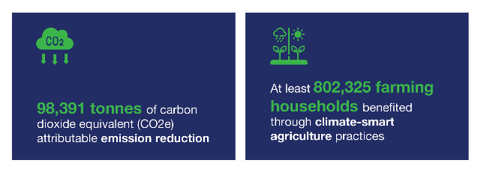

These figures on emission reduction are derived from 2 sources. The first is from reduced and efficient use of nitrogen-based fertiliser in maize, rice, and other crops. The other primary source comes from the cattle sector, where increased uptake of concentrate feed in cattle feeding practices leads to a shorter rearing cycle, reducing methane equivalent CO2 emissions. The emission reduction in farming activities comes from farmers who have adopted innovations introduced by PRISMA’s partners relative to emissions emitted from farmers who have not adopted better farming practices. Total reduction of emissions is a conservative representation as it captures emissions reduced by farmers for one season only.
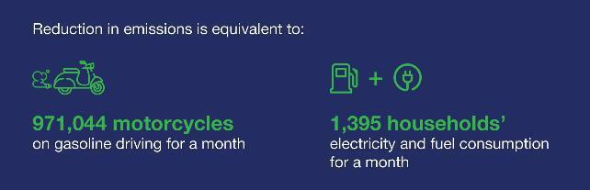

Sector | Attributable emission reduction | Total attributable emission reduction
MAIZE | 238.8 kg CO2e/farmer/season | 24,354.8 tonnes CO2e
RICE | Hybrid:  238.8 kg CO2e/farmer/season  New inbreed:  68.4 kg CO2e /farmer/season | 8,491.7 tonnes CO2e
BEEF | 100.8 kg CO2e/farmer/season | 46,980 tonnes CO2e
OTHER CROPS | 119.1 kg CO2e/farmer/season | 18,983.1 tonnes CO2e

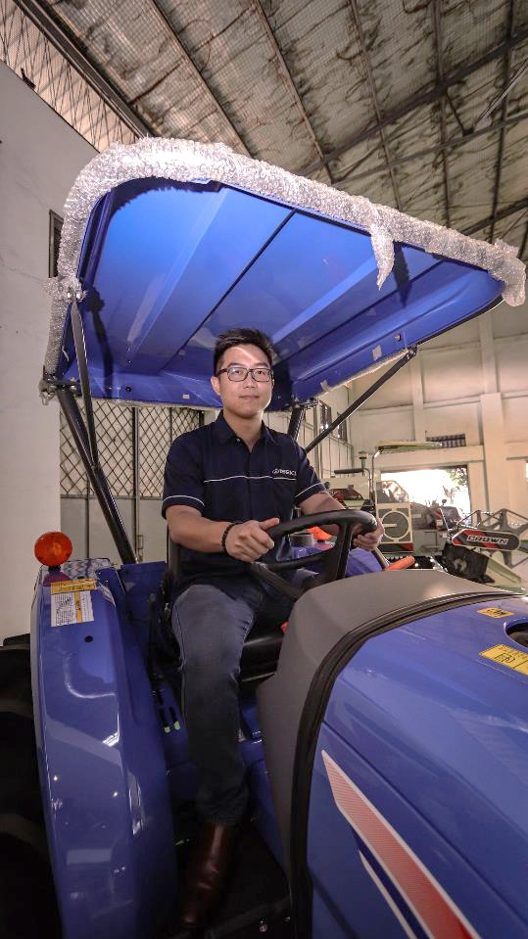
Clifford Iskandar, Director of PT Rutan, with a combine harvester his company is helping to boost access for smallholder farmers, in the PT Rutan showroom in Surabaya.

Operations and Finance

Human Resources
Human resources managed changes in the PRISMA team smoothly, including the recruitment of a new chief operating officer through an internal recruitment process and the introduction of a new mentoring program for operations team and plans to expand the mentoring program to principal business consultants.
During this period, PRISMA recruited a replacement provincial admin officer for NTT and a replacement chief operations officer.
Eleven staff resigned this period, mainly because staff received a better-paying offer and for scholarships. Three resigned for health and family-related issues.
Seventeen staff were promoted this semester. Nine staff were promoted from business consultants to senior business consultants, 7 from senior business consultants to principal business consultants, and one in operations.
Performance assessments were undertaken during this period, and staff were awarded revised salary increments in line with the PRISMA staff retention strategy.
During this period, a 10-week mentoring program was held for operations and contract and procurement staff by the CEO. The management team drafted a mentoring plan for the principal business consultants to better position them for future promotions and as part of the staff retention plan.

Operations
The number of partnerships decreased this semester as to be expected with the program winding back implementation. Two agreements were signed for the ICT sector, and a memorandum of understanding (MOU) with the livestock agency in East Sumba. The total number of active collaboration agreements to date is 73. Fifteen agreements were closed during the semester. Due to potential program extension, the implementation teams have started to submit amendment requests for existing partnerships. There were 11 amendment requests this semester.
During this period, operations conducted office safety checks and first aid training for designated first aid staff. The Palladium risk director undertook office safety audits during the semester and assisted the team update the Palladium safety plan, particularly in relation to Papua travel.
During the period, a series of internal audits were conducted, including for travel, procurement, partnerships, and assets, and Palladium conducted an audit for recruitment and promotions. A few minor issues were identified, which has led to some changes in the process for travel bookings, procurement and sole source applications.
During this period, the team prepared documents for the dip-test being conducted by DFAT.The DipTest is a Jakarta Post process that seeks to assess implementing partners systems and processes regarding procurement, contracting and budget management.
A workload assessment analysis was undertaken this period to determine the need for ongoing provincial level support. Based on the findings, the NTB Provincial Office was closed on 30 June, and all assets were handed over to the provincial government. Work will continue in NTB but without needing a fully staffed office.
Tri Wahyuni, with her sleeping daughter, inspects the vegetables in her field in Kopeng, Semarang district. Tri is one of the PT Permodalan Nasional Madani (PNM) customers, a PRISMA partner, who received agricultural business capital assistance.

Annexures

Annex 1: Progress against MSS

Crop protection
Farmers’ main challenge to increasing productivity is ineffective crop protection management practices. The majority of the 5.2 million women and men rice farmers in East and Central Java experience harvest loss due to pests and disease despite 86 per cent of them using pesticides. Over half of the 700,000 women and men maize farmers in East and Central Java experience harvest loss despite 54 per cent using pesticides.
Smallholder rice and maize farmers in East and Central Java use safer crop protection products in an appropriate way.
Marketing & Communication
Education and Training
Private sector (crop protection companies and distributors) educates farmers on the appropriate use of safer crop protection products
MARKET
SYSTEM
FUNCTION
INTERVENTION
AREAS
Crop protection companies strengthen marketing strategy in promoting safer pesticides and alternative methods

Indicator
Actual cumulative outreach to June 2023 (HHs): 116,572 (Male: 135,947, Female: 76,738)
Cumulative outreach projected to Dec 2024 (HHs): 138,525
Total NAIC to June 2023 (%): 36%
Total NAIC up to Jun 2023 (IDR): 595 billion
Total projected NAIC to Dec 2024 (IDR): 668.3 billion
Value for money (VFM)
Investment leverage: 11.12
Investment per HH: AUD28.79
Social return: 17.73

Constraints
Farmers in East and Central Java require sufficient knowledge of crop protection practices. Only a few crop protection companies offer such knowledge, and they prioritise hard selling over education. The government needs more resources to disseminate the required knowledge to farmers.
The main reason for the continued loss of crops is that farmers cannot effectively identify pests and diseases and do not apply the correct product or dose. Inadequate extension services exacerbate poor pest and disease management.
Sector vision
Smallholder rice and maize farmers in East and Central Java will reduce the harvest loss by adopting safer crop protection products and good crop protection practices (GCP) provided by the private sector. To improve farmers’ adoption of safer pesticides and GCP, PRISMA is working with 4 partners to improve their marketing and communication strategy.
Sector status
After 4 years of PRISMA’s engagement, rice and maize farmers in East and Central Java have reduced harvest loss by 22.5 per cent, equivalent to a saving of IDR1 million per season. This result was achieved through working with 4 crop protection companies. These companies continue serving 12 per cent of the total crop protection market and educating smallholder farmers on good crop protection practices.
Market function update 1: education and training
PRISMA has partnered with 3 private partners (PT Agricon, PT UPL, PT Etong) in East and Central Java to enhance their internal capacity in educating and training farmers to use safer pesticides and apply GCPs. During the reporting period, partners trained their field staff and mid-level managers to reach smallholder farmers more effectively. PT UPL upskilled its staff in market analysis and product strategy. PT Etong trained its staff on improved sales skills. PT Agricon has engaged a training provider, LIGHT Learning, to train its staff on strategic planning, management, and leadership.
PRISMA is looking into ways to further develop the education and training market system as part of the exit strategy. PRISMA has held initial discussions with training providers, such as LIGHT Learning, to strengthen its training modules to reach more private companies with a farmer education-based approach.
Market function update 2: marketing and communication
PRISMA partners have demonstrated a growing commitment to incorporating GCP into their marketing strategies. This period, Agricon revised its staff’s KPI and compensation scheme to motivate its field team to conduct more educational activities, resulting in a 37 per cent increase in field activities year-on-year. PT Etong has implemented UD principles to make its promotional materials accessible to people with disabilities. While many companies have shifted their focus to offline promotions, FMC Indonesia continues combining offline and online channels to educate farmers. This semester, FMC Indonesia garnered over 16,000 views on Facebook and YouTube.
PRISMA is conducting a comparison study to find evidence that education-based marketing gives better commercial outcomes than hard selling. PRISMA aims to compel crop protection companies to share knowledge with farmers, enabling them to utilise the products effectively and reduce harvest loss.
Challenges and learning
Partners’ internal restructuring continues to challenge progress. Significant alterations to management structure and field operations have caused delays in partnership activities and decreased sales performance. However, partners have re-engaged their new management, and the partnership activities are gradually regaining momentum.
As farmers prioritise fertiliser over crop protection, the high fertiliser price still affects farmers’ investment in crop protection. Partners have reported declining sales of safer pesticides, indicating underdosing as a primary means to reduce costs.
PRISMA will continue to help partners educate farmers on correctly applying safer pesticides.

Dairy
Context
Indonesia has experienced a large milk deficit for many years. Domestic milk production only meets about 20 per cent of demand, with significant supply coming from imports. East and Central Java account for almost 67 per cent of the local supply, with 115,000 small dairy producers. Nevertheless, milk productivity and quality are suboptimal.
Small scale dairy farmers have improved milk quality and productivity by adopting good practices in rearing, feeding and health management in East Java and Central Java
MARKET
SYSTEM
FUNCTION
INTERVENTION
AREAS
Feed
Animal Health
Policy
Off-taking
Promoting quality concentrate feed and good dairy management practices
Promoting good animal health management practices
Supporting advocacy from dairy companies, associations and co- operatives to improve guidelines for feed and breed.
Partnership(s) between dairy processing industry (DPI) and milk collectors to improve milk productivity and quality.
Indicator
Actual cumulative outreach to June 2023 (HHs)16F: 3,947 (Male: 4,197, Female: 3,606)
Cumulative outreach projected to Dec 2024 (HHs): 12,086
Total NAIC to June 2023 (%)17F: 67%
Total NAIC up to Jun 2023 (IDR): 51.4 billion
Total projected NAIC to Dec 2024 (IDR): 110 billion
Value for money (VFM)
Investment leverage: 6.64
Investment per HH: 263.77
Social return: 4.94

Constraints
The suboptimal performance in the dairy sector in East and Central Java is due to a lack of access to good-quality feed, pharmaceuticals, and veterinary services, as well as suitable dairy breeds for the tropical climate. In addition, farmers have poor knowledge of good dairy farming practices. On top of that, the recent FMD and LSD disease outbreaks have reduced the cattle population and milk productivity and increased farmers’ investment in animal health measures.
Sector vision
PRISMA will address the market constraints by improving management and business practices at the farm level for feed, animal health and enabling access to good dairy breeds through policy engagement. In addition, PRISMA will work with dairy processing Industries (DPI) to improve milk handling at collection points and expand distribution networks so farmers have better access to the DPI.
Sector status
To date, over 6,500 farmers increased their incomes by 74 per cent, using high-quality feed, good management, and milking practices. Now, 26 companies sell affordable feed to farmers in East Java and Central Java, compared to only 12 feed companies in 2019. PRISMA also induced pharma companies to target dairy farmers and educate them on disease prevention and treatment. With PRISMA’s support, the MoA is developing a roadmap for increasing cattle population and milk production in Indonesia.
Market function 1: feed
PRISMA works with 3 feed companies (i.e., PT Nufeed, PT SMG and PT Sinta Prima) to promote high-quality feed and educate farmers on good rearing and milking practices. The purpose is to increase milk productivity and quality across 8 milk-producing districts in East and Central Java. During the reporting period, dairy farmers increased milk production and showed improved resilience to disease outbreaks, attributed to the increased adoption of quality feed and application of biosecurity measures.
PRISMA’s partners organised 34 events this semester, reaching 1,348 farmers (52 women and 243 youth) with products, information and education services. All 3 partners expanded their distribution networks and added 17 agents across East, Central, and West Java. PT Nufeed organised a hybrid talk show sharing biosecurity and good feeding management in May 2023. The talk show gained traction, reaching 1,600 viewers on YouTube within a month. The impact assessment showed that Nufeed’s customers have improved feeding practices, resulting in increased milk production from 12 to 15 litres per cow daily.
Twenty-six feed producers now produce and sell high-quality feed to dairy farmers, compared to just 12 companies in 2019. Most of them initially focused on East Java but are now expanding to Central Java. PRISMA induced this change through feed interventions in the beef sector.
Market function 2: animal health
PRISMA partners with PT Medion to promote animal health products, proper animal health management and biosecurity practices to dairy farmers in 8 Central and East Java districts. This semester, PT Medion engaged dairy farmers to educate them on FMD and LSD prevention and treatment and good rearing practices. Farmers continue to buy Medion’s products and apply biosecurity measures.
PT Medion hired 23 new agents to promote pharma products for animal disease prevention and treatment, especially for FMD and LSD in East and Central Java. The company collaborated with various stakeholders (i.e., government vets, vet associations, dairy cooperatives, DPIs, feed companies, and agents) to educate farmers and promote animal health management and biosecurity practices. This semester, 3,285 farmers participated in 22 educational and awareness campaigns, resulting in a 46 per cent increase in sales of mastitis medication.
PRISMA’s interventions have induced substantial changes in the pharmaceutical industry. Five pharmaceutical companies have expanded their business focus from poultry to cattle to explicitly target FMD and LSD. Their contributions have significantly improved livestock health in Indonesia, safeguarded farmers' livelihoods, enhanced food security, and promoted sustainable growth in the livestock industry.
Market function 3: policy advocacy (new function)
PRISMA supports the MoA through the Directorate of Livestock Breeding and Production (or BitPro Directorate) in developing strategies and a roadmap for increasing the cattle population in Indonesia. The purpose is to promote the Jersey cows to lowland farmers. Jersey cows require less feed and water and have higher heat tolerance and shorter calving periods compared to the Holstein breed commonly reared in Indonesia. To achieve this, PRISMA completed 2 strategic studies, which the BitPro Directorate used to formulate policies, programs, and budgets.
The study led to the BitPro Directorate engaging the Coordinating Ministry for Economic Affairs and allocating budgets for importing 300 Jersey dairy cows in 2023. The BitPro Directorate will also explore the feasibility of importing Jersey cows from the USA, testing the Holstein-Jersey crossing, and launching Jersey straw production.
PRISMA’s research has also garnered the private sector’s interest in adopting the Jersey cattle breed. Three commercial breeding centres (i.e., PT Global Dairi Alami, PT Raffles Pacific Harvest, and PT Agrijaya Prima Sukses) have imported 400 Jersey cows from Australia for milk production. These breeding centres have improved capacity and facilities to rear Jersey cattle using good animal welfare standards.
Market function 4: milk off-taking (new function)
PRISMA supports PT Sarihusada Generasi Mahardhika (SGM-Danone), a dairy processing company and off-taker, to purchase milk from farmers based on quality. This partnership also facilitated a pilot project for selected lead farmers in dairy cooperatives to engage in Jersey cattle farming while improving milk handling practices. SGM-Danone has procured 10 pregnant Jersey cows from PT Greenfields, which will be transported to the trial farm in July.
Significant progress has been made in preparations for the Jersey trial, with 18 trained farmers (including 3 women) receiving guidance on rearing, reproductive management, and animal welfare practices specific to the Jersey breed. PT Nufeed, the PRISMA feed partner, is committed to supplying high-quality feed for the 6-month trial. The trial will commence in July 2023 across 3 cooperatives in Central Java. The trail will measure the technical and commercial feasibility of using the Jersey breed for smallholders in lowland areas. If the pilot is successful, the program will develop a scale-up strategy with more DPI and dairy cooperatives.
Challenges and learning
Despite a significant decline in FMD cases, the recovery process for dairy cattle remains challenging, impacting reproductive organ performance and pregnancy and lactation phases. Furthermore, the exponential growth of LSD in Java poses another major threat to the dairy sector. The disease outbreaks disincentivise farmers and businesses to invest in the dairy sector. To address these challenges, PRISMA actively supports public and private actors to implement mitigation strategies.
In early 2023, the DPI raised the farm gate price to IDR7,500 per litre (75 cents) due to competition for local milk procurement. However, in May 2023, world milk prices declined by 10 per cent, leading companies to reduce local milk prices by approximately 9 per cent and enforce stricter quality control measures. Although the impact on farmers has not been evident, it may discourage investments in high-quality production inputs.

Maize Madura
Context
There are more than 370,000 maize farmers in Madura Island, covering approximately 22 per cent (292,000 ha) of the cultivation area in East Java. The government has declared Madura, especially the Sumenep district, one of the maize-producing hubs of Indonesia. This has been on the back of a lot of the work PRISMA partners have been doing in the area. However, smallholder farmers’ main challenge is the low productivity at around 2.1 metric tonnes (MT) per ha.
MARKET
SYSTEM
FUNCTION
INTERVENTION
AREAS
Hybrid Seed Promotion
Policy Engagement
Facilitating public- private collaboration models to improve the government program
Inclusive marketing and data-driven approach to promote suitable seed and proper GAP application
Maize farmers in Madura use quality seed and GAP to improve productivity
Indicator
Actual cumulative outreach to June 2023 (HHs): 126,47218F (Male: 158,753, Female: 156,293)
Cumulative outreach projected to Dec 2024 (HHs): 126,472
Total NAIC to June 2023 (%): 401%
Total NAIC up to Jun 2023 (IDR): 398.8 billion
Total projected NAIC to Dec 2024 (IDR): 398.8 billion
Value for money (VFM)
Investment leverage: 2.83
Investment per HH: 27.52
Social return: 11.46

Constraints
Farmers in Madura lack access to commercial hybrid seed and knowledge about the benefits associated with using hybrid seed and GAP. While local governments have consistently promoted hybrid seed through subsidy programs, uptake has been slow as the availability of hybrid seed in the commercial market is limited. This is due to the prevalence of inferior quality seeds, the absence of extension services, and delays in distribution. The subsidy planning lacks efficiency, often resulting in high overlaps between the subsidy recipients and existing commercial seed users. As a result, seed companies are not incentivised to expand to Madura.
Vision
More than 16 per cent of smallholder maize farmers in Madura will increase production and productivity by adopting hybrid seeds and applying GAP through increased private sector investment in the seed market and improved delivery of government subsidy programs.
Sector status:
Farmers’ hybrid seed usage has increased significantly from 4 per cent to around 30 per cent. Initially, 2 seed companies struggled to build a market in Madura due to the high overlap of subsidies in the commercial market. The main district, with up to 85 per cent of all subsidy recipients, has implemented a smart subsidy plan. As a result, the commercial market has grown, and currently, 8 companies are actively promoting and expanding hybrid seed distribution in Madura. This has led to higher availability of hybrid seeds in 95 kiosks, enabling around 14 per cent of farmers to independently purchase hybrid seeds in the commercial market.
Market function 1: hybrid seed promotion
PRISMA had supported 4 companies to promote hybrid seeds to smallholder farmers in Madura. Since 2020, PRISMA no longer has active partnerships in Madura but continues to monitor the market to capture the changes.
The seed market in Madura continues to attract more investments from the private sector. After PT Jafran, PRISMA identified another hybrid seed company, PT Sage Mashlahat, that entered the commercial market in Madura. PT Sage appointed one local distributor in Madura. As of June 2023, 8 seed companies (5 companies entered independently) are actively serving the Madura market. This more competitive seed market is expected to be prominent in the upcoming primary planting season in October.
Market function 2: policy engagement
In Madura, PRISMA aims to maintain improved subsidy planning to support commercial market growth. The subsidy program has not significantly disrupted the market over the last 2 years, and there was no significant activity for this semester. PRISMA is focusing on advocating the adoption of improved subsidy planning at the province level in Central Java.
Challenges and learning
The inadequate supply of maize seeds remains a significant challenge in Madura. The primary planting season in Madura is from October until November. Companies’ seed distribution targets in Madura are generally low as they typically meet their sales targets by mid-year on other islands. The leading seed companies estimate seed availability will be further limited this year.
In some areas, another barrier to market growth is the limited window for planting. Hybrid maize varieties require 20 days more to mature than the local varieties, which deters farmers from adopting hybrid seeds. PRISMA plans to inform the private sector of farmers’ seed preferences and suitable cultivation methods to boost sales in these areas.

Maize Central Java
Following the sector review in 2021, it was decided that maize Central Java would be dropped as a separate sector. The maize sector in Central Java is performing well, but the growth potential is limited. However, some interventions are ongoing as they serve as a strategic fit for the maize sector.
Market function 1: policy engagement
The Central Java provincial government’s seed subsidy program aimed to achieve at least a 7 per cent productivity increase. However, productivity growth between 2014 to 2018 only reached 1.8 per cent due to the low suitability of the variety and limited GAP support. Also, this subsidy program disincentivised private seed producers by supplying free seeds to their existing customers. With PRISMA’s support, the provincial government aims to increase the effectiveness of this subsidy program.
This semester, the head of the Central Java Agriculture and Plantation Office issued a new operational guideline to improve delivery of the seed subsidy system. The new guideline addresses 3 main elements of the subsidy program:
- Seed selection: the selected variety must have a minimum level of productivity and suitability to the targeted areas.
- GAP assistance: all companies supplying seeds to the subsidy program must provide GAP information and training to the public extension service and/or seed recipients.
- Area selection: the proposed sub-districts for the subsidy program must be selected based on the strength of the commercial market.
Beyond the subsidy program, the goal is to increase farmers’ productivity and sustainable access to quality seed in the commercial market. This semester, the Agriculture Office conducted a socialisation event to enact the new guideline. Representatives of key provincial institutions and 18 district agriculture offices that oversee 90 per cent of the maize harvest areas in the province attended the event. PRISMA also supported the provincial government to develop a tool to compile and annually update sub-district level data to ascertain the strength of the commercial market. In the upcoming budget year, the provincial office will refer to this guideline and tool to decide the subsidy budget allocation and delivery mechanism.
Market function 2: hybrid seed promotion
During the sector review at the end of 2021, hybrid seed promotion was no longer a priority function for Central Java. One remaining partnership under this function was with PT BISI, which aimed to shift the company strategy from supplying subsidy programs to fully serving the commercial market.
Since the demand for maize seeds increased nationwide in 2022, BISI could achieve its sales target without updating its marketing strategy. This semester, PRISMA’s partnership with BISI ended.
Challenges and learning
The improved subsidy planning and distribution system is crucial for all staple commodities. During the socialisation of the new guideline, government officials acknowledged that the subsidy programs for other similar commodities need to improve to ensure their effectiveness. PRISMA will document and share the lessons and experiences with the provincial and national governments.

Maize NTT
Context
Maize NTT is a separate market system from Madura and Central Java because it presents a different set of market characteristics and constraints. Geographically dispersed farmers, poor infrastructure, fragmented supply chain, low private sector presence, and a high level of government interventions are common characteristics of NTT’s maize market system. Most of the grain in NTT is used for human consumption and feeding HHs’ livestock. Maize in Java and NTB mainly supplies livestock feed mills.
PRISMA Maise NTT Cumulative Outreach to Jun 2023 (HHs)
40,836
MARKET
SYSTEM
FUNCTION
INTERVENTION
AREAS
Supporting national seed companies to penetrate NTT market
Supporting local seed producers to produce and promote quality OPV seed in commercial market
Promotion of quality certified seed
Market supporting policies
Information on GAP
Supporting Provincial Government in Maize Development Strategy covering whole value chain
Supporting seed producers to share GAP information as an embedded service
Smallholder farmers in NTT have increased availability and properly use certified maize seeds and application of Good Agriculture Practice
Indicator
Actual cumulative outreach to June 2023 (HHs): 40,00619F (Male: 60,522, Female: 63,038)
Cumulative outreach projected to Dec 2024 (HHs): 40,006
Total NAIC to June 2023 (%): 115%
Total NAIC up to Jun 2023 (IDR): 69.4 billion
Total projected NAIC to Dec 2024 (IDR): 69.4 billion
Value for money (VFM)
Investment leverage: 3.01
Investment per HH: 91.23
Social return: 1.89

Constraints
Around 71 per cent of farmers (473,000 farming HH) in NTT are involved in maize production. However, maize productivity in the province is very low, with an average of 2.5 MT/ha, far below the national average of 5.23 MT/ha. Farmers have limited access to information and knowledge on GAP and certified seeds (open pollinated varieties [OPV] or hybrid varieties). Local seed-producing nurseries mainly serve the government subsidy programs rather than invest to reach commercial farmers. Meanwhile, the downstream maize market in NTT is limited to local off-takers supplying the traditional market and independent livestock farmers. Bigger off-takers struggle to procure local maize because of limited availability and poor quality.
Vision
PRISMA aims to increase the production and productivity of maize in NTT by 1) improving the capacity of OPV seed producers (nurseries) for quality seed production and developing the commercial seed market, 2) facilitating local governments in the development and implementation of their maize sector strategy, and 3) promoting GAP information for farmers. Following the feasibility analysis of off-taking business opportunities, PRISMA will drop this function and focus on 3 market function areas to improve (1) quality, certified seed, (2) market supporting policy, and (3) information on GAP.
Sector status
Over 40,000 smallholder farmers in NTT benefitted from using certified maize seeds and applying GAP. Certified seeds are available in the main maize-producing areas, although the supply fluctuates every year. While only 3 local seed producers actively promote certified seeds, another 5 companies are ready to enter the market. With PRISMA’s support, the provincial government strengthened the GAP service in its seed assistance program and improved its seed certification capacity. However, the growth of the maize sector in NTT is still constrained by the limited availability of parent seeds, private sector capacity and large-scale off-takers. In addition, the fluctuation in the subsidy allocation pushed back the behaviour changes of market actors in the last 2 years, and the progress towards systemic change has reduced. Because of this, PRISMA has downgraded the progress towards systemic change from significant to early progress.
Market function 1: quality certified seed
PRISMA works with 10 local seed producers to promote OPV seeds in the commercial market. Since this semester is an off-season for maize production in NTT, PRISMA focused on advising partners to develop their production and marketing plans. Partner companies mainly focused on producing seeds and establishing distribution channels.
This semester, 6 seed producers planted maize seeds for the upcoming season. CV Sehati Toka built a distribution network in Manggarai Raya and partnered with 3 agri-kiosks to sell seeds. CV Kakohari experienced production failure due to heavy rain, and the other 2 partners (Restu and Fini Faun) did not plant seeds because they could not obtain parent seeds.
Aside from producing seeds for the commercial market, 3 partners (Sehati, Sehati Toka, and TPM) also produced one tonne (equivalent to 20 per cent of the total parent seed availability in NTT) of parent seeds. They did this in response to parent seed unavailability, which has been a recurring problem since last year. PRISMA promotes the privatisation of parent seed production due to its significant impact on provincial food security.
Market function 2: market supporting policy
PRISMA works with the NTT Agriculture and Food Security Office to increase the availability of parent seeds and improve the certification services for seed producers. Both topics are important for local seed producers in developing their businesses and serving the commercial seed market.
This semester, the seed certification unit hired 13 additional certification field staff. This was induced by PRISMA’s analysis and insights on the need for additional field staff to replace a high number of expected retirees in the next 2 years. In March 2023, the NTT Agriculture and Food Security Office conducted in-house training for all field staff. PRISMA supported the training to enable the government field staff to advise seed producers on seed production practices.
PRISMA also facilitated a multistakeholder discussion on improved parent seed production planning to ensure local seed producers’ timely access to parent seed. Several key stakeholders attended the talks, including representatives from the seed production units and seed certification unit at the Food Crops Department and the Association of Seed Producers. The participants agreed to optimise parent seed production planning by mapping the seed demand and production area. A regular quarterly discussion will be conducted to update the production data and demand.
Market function 3: information on GAP
PRISMA works with the NTT Agriculture and Food Security Office and the Centre for Agricultural Instrument Standards to produce capacity-building materials for public extension workers, as they are the front-liners of GAP assistance. A digital GAP module (i.e., training video) was developed during the reporting period. The purpose is to ensure extension workers’ continuous access to learning materials amidst a limited training budget. The Agriculture and Food Security Office will disseminate the digital training content in the next semester.
Challenges and learning
The fluctuation in parent seed supply remains the main challenge this semester. A permanent solution is complex as it involves multiple government institutions, including the national government. In addition, the structural changes in the MoA have caused uncertainty and delays in parent seed production. PRISMA will continue advocating to the provincial government for a stable supply of parent seeds.
Previously, PRISMA supported PT Seger, a leading maize off-taker, to procure maize from NTT.20F This semester, PT Seger shifted its operational base from Timor to Sumba Island. The decision was taken as a response to the heavy rain in Timor, leading to harvest failure and limited maize supply in the area. PT Seger also adjusted its business model, emphasising stronger collaboration with selected local off-takers to increase sourcing efficiency.

Mechanisation: rice
Context
Indonesia has 7.4 million ha of rice fields,21F approximately 41 per cent spanning Java. Despite having a population of 270 million people, smallholder rice and maize farmers have significant problems with labour shortages. Manual harvesting is costly, time-consuming and results in crop loss, reducing crop yield and farmers’ incomes.
Women and men rice farmers increasingly use agriculture machinery (combine harvester and drone sprayer) services resulting in reduced production cost and harvest loss.
Product marketing
Machinery renting service
After sales services
- Machinery vendors establish new distribution networks and promote combine harvesters and drone sprayers
- Improved access to loans for machinery business (purchase)
Machine vendors introduce rental services to farmers
- Machinery vendors establish and expand service stations
- Machinery vendors expand spare parts distribution
MARKET
SYSTEM
FUNCTION
INTERVENTION
AREAS
Indicator
Actual cumulative outreach to June 2023 (HHs): 42,990 (Male: 48,346, Female: 34,580)
Cumulative outreach projected to Dec 2024 (HHs): 92,077
Total NAIC to June 2023 (%): 17%
Total NAIC up to Jun 2023 (IDR): 50 billion
Total projected NAIC to Dec 2024 (IDR): 73.9 billion
Value for money (VFM)
Investment leverage: 3.86
Investment per HH: 36.53
Social return: 3.65

Constraints
Smallholder farmers experience at least 14 per cent harvest loss due to manual harvesting. Using manual labour also increases production costs and often deteriorates the quality of rice and maize grains. There is no significant adoption of mechanised solutions by smallholder farmers because the machinery companies focus on the government market. Companies also provide limited or no after-sales support for machinery. The machinery businesses focus on sales to the government as they do not see a market in smallholder farming.
Vision
Smallholder farmers will have access to and use agricultural machinery services to increase income by reducing production costs and harvest loss. PRISMA will achieve this by supporting machinery companies to promote machinery access to smallholder farmers, introducing renting companies servicing directly to farmers, and improving after-sales services.
Sector status
After 3 years, more than 42,000 farmers have used mechanisation services and increased their incomes by 17 per cent. More than 80 service providers now offer mechanisation services to these farmers. This was achieved by working with 5 companies that continue promoting machinery services across 6 provinces. Companies also provide after-sales services for machine owners to ensure the durability and optimum lifetime of the machines.
Market function 1: product marketing
PRISMA works with 9 machinery companies in 4 provinces (i.e., East Java, Central Java, NTB, and NTT) to introduce agri machinery and tools. PRISMA supported the partner companies in implementing innovative marketing strategies to reach many farmers with mechanised services. Before PRISMA, companies did not have a product demonstration and promotion strategy.
This semester, PRISMA’s partners showed increased ownership of product marketing strategies and continued expanding to new areas. PT Rutan, PT Angkasa and CV Putra adopted product demonstrations as their core marketing activities. Using this strategy, Rutan promoted a new product (i.e., the crawler tractor), and Angkasa penetrated untapped areas with additional products, such as cultivators. CV Putra developed a permanent location to demonstrate its products. Rutan added new marketing staff to extend its promotion strategy nationwide. PT Angkasa and CV Putra intensified product marketing through websites and social media.
The machinery companies also experienced business growth this semester. After Sumba Island, Pilar Putra Teknik (PPT) scaled up its business to Timor Island, copying a similar strategy. Despite the declining trend of machinery sales in East Java, CV Argo Jaya managed to grow the market in new areas with a 30 per cent increase in sales to Bali.
PRISMA linked the partner companies with financial institutions. Bank Sinar Mas Syariah and Kubota Machinery Indonesia agreed to make financing available for Kubota’s dealers nationwide. Bank NTT and Kreditplus, a retail financing company, will offer financing products to promote agri machinery in Timor Island.
Market function 2: machinery renting service
PRISMA partnered with 2 companies to pilot a business model of machinery rental service for farmers. Although the business model is still in the piloting phase, renting companies have become more confident in the full-mechanisation strategy. This semester, Terra Agro Digital (TAD) scaled up its business through new investments in a drone and upgraded its mobile application to intensify the demand activation activities. TAD has also invested in a larger office to accommodate a bigger fleet of machines.
Another partner, Full Drone Solution (FDS), collaborated with a drone service company to expand its coverage to Central Java. PRISMA supported FDS in conducting demonstrations and linked them with potential machinery service providers. Former FDS employees have formed a new drone company named Drone One in Central Java. Drone One has used the learning and experiences from PRISMA’s partner, FDS.
Market function 3: aftersales
Before PRISMA’s engagement, after-sales services were rarely available. All the machinery companies assert that the after-sales service has contributed significantly to the sustainability of their machinery business and increases customers’ confidence in the products. PRISMA supported all the partner companies in developing their after-sales services.
This semester, PT Rutan developed its capacity for aftersales management. Rutan restructured its aftersales operation and offered attractive schemes for spare parts to its dealers across Indonesia. In addition, Rutan published a video showing the process of getting after-sales support, which further increased customers’ confidence. Another partner, PT Angkasa, also released a video guideline for machine operation and maintenance.
PRISMA also developed a training service to improve the resilience of after-sales services. United Tractor Training School (UTS), a leading technical training school for mining and construction equipment, developed a training curriculum on maintenance and spare parts management. PRISMA linked UTS with partners to gain knowledge about the agriculture machinery business. Later, UTS offered the training service to 2 of PRISMA’s partners.
Challenges and learnings
Access to finance for procuring machinery remains a significant challenge. Since Covid-19, banks and financial institutes have remained risk-averse and have yet to return to the pre-Covid-19 condition. As a result, many potential machine buyers are excluded from participating in the agri machinery markets. PRISMA supports several banks and leasing institutions with market information and links them with machinery companies.

Mechanisation: maize
Constraints
Maize farmers in Central Java, East Java, and NTB depend heavily on labour during the planting and harvesting seasons. With scarce rural labour, farmers experience increased production costs and harvest loss. However, machinery adoption is not widespread as machinery companies are not focused on this commodity segment. Also, private companies lack strategic insights into how to tap into this market segment.
Women and men maize farmers increasingly use agriculture machinery and tools resulting in reduced production cost and yield improvement.
FUNCTION
MARKET
SYSTEM
FUNCTION
INTERVENTION
AREAS
Product marketing
- Machinery vendors promote maize planters to farmers
- Machine vendors expand distribution networks
After sales services
- Machinery vendors establish service stations
- Machinery vendors establish spare parts distribution
Indicator
Actual cumulative outreach to June 2023 (HHs): 1,063 (Male: 1,195, Female: 855)
Cumulative outreach projected to Dec 2024 (HHs): 2,277
Total NAIC to June 2023 (%): 28%
Total NAIC up to Jun 2023 (IDR): 2.1 billion
Total projected NAIC to Dec 2024 (IDR): 3.1 billion
Value for money (VFM)22F
Investment leverage: 3.86
Investment per HH: 36.53
Social return: 3.65

Vision
PRISMA’s vision for smallholder maize farmers is to have access to and use machinery and tools (maize planters) to increase farmer incomes by reducing production costs and improving yield. PRISMA will achieve this by supporting machinery companies to promote machine access to smallholder farmers and improve after-sales services.
Sector status
In 3 years, more than 1,000 farmers have saved on labour costs and reduced their workload by using maize planters. Two companies in 2 provinces continue improving their capacity to better capture demand. Companies also offer after-sales services for machine owners to ensure the durability and optimum lifetime of the machines.
Market function 1: product marketing
PRISMA supports Rutan and PT Galaxy Partani Mas (GPM) to implement innovative marketing strategies to introduce maize planting tools to women farmers in East and Central Java and NTB. This semester, PRISMA built GPM’s capacity to conduct digital marketing. GPM responded by hiring 2 new staff for digital marketing and experienced increased sales due to the new marketing strategy.
Rutan further enhanced its promotional strategy this semester and released a video introducing land cultivators and maize planters to women and men farmers. The video has reached over 29,500 views on YouTube and is being promoted via Facebook to reach more potential customers. In addition, 3 companies (i.e., Kubota, Yanmar and Rutan) launched new dryland tractors and combine harvesters for maize. With PRISMA’s support, they conducted product demo activities for these new machines.
Market function 2: aftersales
GPM added 2 spare parts outlets this semester to extend its coverage, ensuring the sustainability of the machinery business. The number of outlets for spare parts has also increased significantly, from 5 to 20 stores in 2 years. Rutan restructured its after-sales operation and developed a new scheme for its dealers.
Challenges and learnings
Maize farmers take longer than rice farmers to adopt using machinery and tools. Therefore, key market actors, such as Kubota, Yanmar, and Rutan, still prioritise and focus on the rice sector. Companies also find it challenging to gather information and insights about the most viable products for each location. PRISMA will continue to support partners to increase their capacity for market research and data analysis.

Mungbeans in Central and East Java
Over 609,000 mungbean farmers in Central and East Java contribute 71 per cent of national production. Farmers plant mungbeans because it is a low-maintenance and low-cost crop that has beneficial properties for the soil. Despite its importance, mungbean farmers have low productivity of 0.8 MT/ha, well below the potential of 1.5 MT/ha. The leading cause of low production is the low use of inputs, especially quality seeds.
MARKET
SYSTEM
FUNCTION
INTERVENTION
AREAS
Smallholder mungbean farmers in Central and East Java have increased availability of and properly use quality seeds and improved off-taking services
Quality seed
Increasing availability of quality and certified seed
Off-taking
Promoting quality and certified seeds and GAP in Central Java, East Java
Supporting off-takers, exporters, food processors to improve sourcing strategies
Indicator
Actual cumulative outreach to June 2023 (HHs): 48,176 (Male: 42,368, Female: 34,912)
Cumulative outreach projected to Dec 2024 (HHs): 96,740
Total NAIC to June 2023 (%): 44%
Total NAIC up to Jun 2023 (IDR): 89.8 billion
Total projected NAIC to Dec 2024 (IDR): 209.1 billion
Value for money (VFM)
Investment leverage: 1.17
Investment per HH: 50.59
Social return: 3.68

Constraints
Mungbean farmers need commercialised quality seeds of different varieties and access to higher-value markets. While the government has subsidised seeds, the adoption of quality seeds remains low due to limited availability.
Private seed producers lack awareness of the market potential of mungbean seeds. Information mismatches between upstream and downstream actors limit access to higher-value markets.
Sector vision
The smallholder mungbean farmers in Central and East Java adopt certified quality seed and GAP, and additional mungbean seed producers enter the market. PRISMA aims to improve the downstream mungbean market development by connecting relevant market players.
Sector status
Before PRISMA, there was no commercial market for high-yielding mungbean seeds. With PRISMA’s support, 6 seed producers have entered the commercial market and sell quality seeds. Around 24.8 per cent of mungbean farmers now use quality seeds. The government research institutes, i.e., Balitkabi and BRIN, have commercialised parent seeds to increase seed propagation.
Market function 1: quality seed with GAP
PRISMA is working with 3 partners (CV Semi, CV Luwes, CV BTS) in 16 districts across Central and East Java to increase the availability of quality seeds in the market and promote GAP. As mungbeans entered their primary season, partners produced quality seeds and started promoting them to farmers.
CV Semi and BTS have improved their marketing strategies and expanded their coverage to the southern part of Central Java. These companies have invested over AUD23,200 in machinery and marketing activities. Based on the findings of a study commissioned by PRISMA, they plan to plant a seed variety with high demand in the export market. This initiative will improve farmers’ access to higher-value opportunities.
CV Luwes has expanded its business into parent seeds. This expansion will improve seed producers’ access to commercial parent seeds and supplement government research institutes.
Market function 2: off-taking (downstream market)
PRISMA is doing an off-taking study to understand the downstream market better. Based on the initial study findings, PRISMA has facilitated business discussions among off-takers, seed producers, and farmers this semester. These discussions aim to improve coordination in accessing a higher-value market.
Challenges and learning
Partners’ focus on the subsidy market has been a challenge. Some seed producers see a better business opportunity catering to the government rather than the free market. This will remain a challenge in any market where subsidy programs exist.
Ensuring contract farmers’ compliance with standard production procedures remains an issue for seed and parent seed production.
Learning shows that when introducing new varieties, it is crucial to meet market demand and specifications by understanding and matching the interest of seed producers and off-takers.
PRISMA will continue working with partners and other relevant actors to demonstrate the business potential, promote quality seeds, and improve market linkages.

Pigs
Pigs are an important economic commodity in NTT due to their significance in NTT culture, and the role pigs play in most cultural ceremonies, including marriage, deaths, births etc.
Promoting quality feed and feeding practices
Improving regulation for swine product movement
Strengthening and improving animal husbandry practices related to ASF detection, response, prevention, and recovery
Improving availability and access to live pigs and AI services
Breed
Animal health
Feed
Policy & Regulation
MARKET
SYSTEM
FUNCTION
INTERVENTION
AREAS
Women and men pig farmers benefit from restocking their farms with high-quality piglets, using quality inputs, and improved animal husbandry practices
Indicator
Actual cumulative outreach to June 2023 (HHs): 130,661 (Male: 217,693, Female: 186,356)
Cumulative outreach projected to Dec 2024 (HHs): 163,820
Total NAIC to June 2023 (%): 405%
Total NAIC up to Jun 2023 (IDR): 731.9 billion
Total projected NAIC to Dec 2024 (IDR): 748.9 billion
Value for money (VFM)
Investment leverage: 10.26
Investment per HH: 50.32
Social return: 11.13

Context
In late 2019, ASF hit NTT and decimated the pig population. The loss of pig stocks caused a significant decline in farmers’ income and demand for feed and pharmaceuticals – 2 of PRISMA’s main functional areas. PRISMA has refocused the pig strategy towards sector recovery by building and strengthening the breed and animal health management systems by partnering with the private and public sectors. This semester, a third wave of ASF had a minimum impact on NTT, and the farmers and breeding farms are starting to restock; hence the demand for piglets, feed, and pharma products is increasing.
Constraints
Pig farmers in NTT need better access to quality breeds and information on sound husbandry practices, including farm and breeding management. Pig health products are not readily available. If farmers do not adopt good animal health practices, the risk of ASF outbreaks will continue. Trade transactions for pigs and pork products are restricted due to government regulations, restricting options to re-stock. The primary constraint for farmers and the private sector is the need for pig stock.
Vision
PRISMA will work towards a 10 per cent recovery of the pig sector in NTT. The focus is on detection, response, prevention, and recovery from ASF by improving restocking, awareness, and information about animal husbandry practices. Sector resilience will focus on breed improvement by building the capacity of key market actors and strengthening the regulatory environment, feed, and pharma distribution networks.
Sector status
More than 130,716 smallholder farmers increased their incomes by 405 per cent from pig rearing. These farmers continue to restock their farms with high-quality piglets, use concentrated feed, and apply biosecurity measures, leading to low mortality and increased productivity of pigs. Now, high-quality piglets and quality inputs are widely available in NTT. This is because 13 breeding farms invested in improved breed genetics, farm management and biosecurity measures. Thirteen feed companies sell affordable pig feed and educate farmers on good rearing practices. With PRISMA’s support, the NTT Animal Husbandry Office is implementing a disease prevention, detection, and surveillance strategy. Before PRISMA, farmers followed traditional feeding practices, with only 2 feed companies having indirect operations in NTT.
Market function 1: breed
PRISMA supports 13 breeding farms in NTT to promote high-quality piglets and artificial insemination (AI) services to smallholder farmers. This semester, all breeding partners increased their investment in pig genetics improvement and on-farm biosecurity measures and supplied better seed stocks to smallholder farmers. With an additional investment of IDR908 million this semester, the total investment of breed partners reached IDR1.59 billion. The increased private sector investment indicates the progress towards recovery of the sector.
This semester, 9 breeding farms sold AI services to smallholder farmers. Among them, Aroma, Rio Farm and Tilong Farm have also changed their breeding practices from traditional mating to AI. During this reporting period, the partners produced over 3,195 piglets (a total of 9,015 piglets to date) and 5,120 semen straws (a total of 5,368 straws to date). In total, around 22,167 piglets have been born and reached 13,300 farmers. The AI services helped farmers to reduce costs (from IDR500,000 to IDR1 million per piglet - AUD50 to AUD100) for piglets and save more than IDR8.5 million (AUD850) per boar from not keeping a boar for mating.
Proper waste management is crucial for breeders to reduce pollution and the spread of disease. PRISMA advises and supports breeding partners to adopt environment-friendly practices. With PRISMA’s technical support, Tilong Farm established and fully funded a wastewater treatment plant and started reusing water this semester, leading to reduced operational expenses and an improved bio-secure environment.
Encouraged by Tilong Farm, another PRISMA partner, PT Aroma, is also building a water treatment facility by itself. Tilong and Aroma Farm are implementing a biogas management system to complement the waste wastewater treatment. The biogas management system will reduce the greenhouse gas produced, generate renewable energy, and produce cleaner and sustainable compost.
Market function 2: animal health
This semester, PRISMA continued supporting its private and public partners in disseminating ASF awareness information across NTT, helping farmers to improve their resilience towards the ASF outbreak. PRISMA supported church organisations and universities in the 3 major islands in NTT to build their capacity on ASF, biosecurity, feed management and pharmaceutical products. In addition, PRISMA supported the East Sumba district government and local radio to share information in the local language and Indonesian.
This semester, the provincial government of NTT acquired a diagnostic tool to identify ASF, the loop-mediated isothermal amplification (LAMP). Three LAMPs were placed on 3 islands (i.e., Timor, Sumba, Flores). Farmers and market actors in these areas now have access to quick, reliable and cost-effective testing facilities. Currently, PRISMA is supporting the provincial government in developing standard operating procedures and establishing a reagent supply chain for operating the LAMP.
To ensure LAMP operation sustainability, the NTT Animal Husbandry Office has committed to allocating budgets for LAMP maintenance, promotion, and reagent procurement.
All work in relation to animal health in NTT is coordinated with the DFAT animal health program, AIHSP.
Market function 3: feed
During the reporting period, feed companies continued expanding their business coverage to other areas in NTT, signalling a gradual sector recovery from ASF. PRISMA’s partner, Sreeya, increased its feed sales from 300 MT/month to an average of 500 MT/month between the last 2 semesters. Sreeya also started exporting pig feed to Timor Leste and increased its sales in Timor Leste from 20 MT to 60 MT in 3 months. Another feed partner PT. Panca Patriot Prima expanded its distribution channel to Lembata, Kupang and Belu districts in NTT. Both feed companies (i.e., Sreeya and Panca Patriot) designed inclusive socialisation materials and adopted UN principles to reach people with disabilities in NTT.
PT. Gold Coin Indonesia, which independently entered the NTT market last year, has further expanded its distribution channel to East Sumba and Sikka districts. The company adopted and modified similar strategies used by PRISMA’s partners, such as feed promotion through radio talk shows, smaller feed packages, and online ASF education.
Challenges and learning
The new wave of ASF remains a significant challenge in recovering the sector. In the last semester, ASF reemerged in Sumba Island and mildly impacted farmers. However, the re-emergence of ASF discourages farmers from restocking piglets and investing in pig farming, thereby impeding the progress of sector recovery.
FMD impeded the import of frozen semen to NTT from Bali and Java due to strict rules for transporting live animals and semen. The government also shifted the budget towards managing the FMD outbreak.

A broader application of biosecurity measures reduces the spread of ASF and makes farmers resilient to future shocks. The third wave of the ASF outbreak in Sumba did not impact farmers significantly due to a broader application of biosecurity. Therefore, the program will continue to promote biosecurity measures to contain ASF outbreaks.

Rice
Rice, as the primary food source for over 270 million Indonesians, provides a source of income and employment for more than 3 million rice farming households in the largest rice-producing provinces of Central and East Java.
MARKET
SYSTEM
FUNCTION
INTERVENTION
AREAS
Production & marketing
Policy advocacy
Promoting high-yielding varieties of rice seeds
Advocating the impact of high yielding rice seed variety to government to improve the business enabling environment.
Rice farmers in East Java and Central Java use high-yielding rice seeds and thereby, increase productivity
Indicator
Actual cumulative outreach to June 2023 (HHs): 90,633 (Male: 89,974, Female: 56,490)23F
Cumulative outreach projected to Dec 2024 (HHs): 134,624
Total NAIC to June 2023 (%): 38%
Total NAIC up to Jun 2023 (IDR): 201.6 billion
Total projected NAIC to Dec 2024 (IDR): 312.8 billion
Value for money (VFM)
Investment leverage: 4.36
Investment per HH: 13.68
Social return: 16.25

Constraints
Indonesia's rice productivity has stagnated at around 5.1 tonnes/ha in the past few years. While many variables contribute to productivity, better-quality seeds play a significant role in Indonesia's journey towards higher rice production.
Additionally, smallholder farmers need more knowledge and access to HYV. This limitation is primarily attributed to the inadequate number of seed companies producing and promoting HYVs and insufficient government support in accelerating the adoption of such varieties within government programs.
Vision
PRISMA aims to increase the productivity of smallholder rice farmers in East and Central Java by increasing the broader adoption of HYV. To achieve this, PRISMA works with key seed producers to produce, promote, and educate farmers on the benefits of using HYV. In parallel, PRISMA is encouraging the government to boost HYV procurement in their programs by providing enough evidence and recommending concrete policy actions.
Sector status
In 4 years, more than 90,000 farming households have adopted high-yielding rice seeds and increased their yield. Around 40 per cent of women beneficiaries claimed a reduced cost for rice consumption due to the increased yield. This was achieved by working with 5 seed companies promoting HYV and producing over 1,500 tonnes of seed. With PRISMA’s support, these companies expanded to new markets in Central and East Java and targeted women farmers and people with visual impairments.
Market function 1: production and marketing
PRISMA supports 5 rice seed producers to promote HYVs in East Java and Central Java. During the reporting period, all partners implemented women-targeted activities and redesigned product packaging to reach people with minor visual impairments.
PRISMA’s partner, PT Agrosid, developed a new monitoring system to manage its seed production effectively. The new system was introduced to the company staff, and operational procedures were established. Another partner, PT Botani, engaged 6 new distributors in Central Java and East Java. The company also recruited 2 agronomists to promote GAP to rice farmers.
PRISMA’s partners have increasingly invested in additional business activities. CV Anisa applied for a self-certification to shorten the seed certification process. PT Botani launched a new variety named IPB 9G, which is more adaptive to flat paddy fields.
A new rice seed producer, CV Semi, entered the rice seed market in Central Java. CV Semi was prompted by the success of PRISMA’s partner, PT Agrosid. The MoA recognised the contribution of PT Botani and PT Agrosid. These 2 companies were awarded the ‘best crop display’ award in the largest national staple seeds expo event, "Gebyar Benih Nasional".
Market function 2: policy advocacy
PRISMA supports the MoA with field evidence to boost procurement of HYV for its free seed program. For this, PRISMA engaged the Indonesian Center for Agriculture Socio Economic and Policy Studies (PSEKP) (through the Agriculture Researchers Alliance [APPERTANI]) and the Institute for Economic and Social Research Faculty of Economics and Business Universitas Indonesia (LPEM FEB UI) in developing concrete policy actions.
PRISMA maintained communication with LPEM FEB UI and PSEKP to monitor decisions and behaviour changes within relevant government bodies following the symposium and advocacy events conducted this semester. PRISMA conducted direct hearings to Bappenas, resulting in awareness of the importance of HYV to national rice productivity.

Challenges and learning
Lack of extension services and poor business strategy hamper companies from reaching a larger number of farmers. PRISMA’s impact assessment found that the farmers in East Java showed slow progress in adopting HYV compared to the farmers in Central Java. This was due to the lack of assistance programs and unsuitable seed selection for the targeted areas. PRISMA shared the findings with the partners and provided recommendations to improve the business performance.

Vegetables
In Tanah Papua, there are approximately 176,606 farming HHs, with 98 per cent growing seasonal vegetables. These HHs comprise indigenous and transmigrant farmers, estimated at 85 and 15 per cent, respectively. Most indigenous vegetable farmers are engaged in subsistence farming, and women play a critical role in agriculture production activities, from land preparation and input purchase to harvest and agricultural income management.
Vegetable farmers in Papua and West Papua use quality seeds, apply GAP, and have access to off-taking services
Seed (distribution & marketing)
Extension service (GAP info)
Off-taking
Expanding quality seed distribution
Agriculture practice to agricultural practices
Improving linkages between off- takers and farmers
MARKET
SYSTEM
FUNCTION
INTERVENTION
AREAS
Indicator
Actual cumulative outreach to June 2023 (HHs): 7,520 (Male: 14,599, Female: 15,281)
Cumulative outreach projected to Dec 2024 (HHs): 12,535
Total NAIC to June 2023 (%): 37%
Total NAIC up to Jun 2023 (IDR): 17.5 billion
Total projected NAIC to Dec 2024 (IDR): 29.1 billion
Value for money (VFM)
Investment leverage: 0.50
Investment per HH: 377.48
Social return: 0.62

Constraints
The quantity of vegetables produced in Tanah Papua falls short of meeting less than half of the total demand, which amounts to 180,000 tonnes. This significant supply-demand gap can be attributed to farmers’ suboptimal yields using low-quality inputs, poor GAP, and lack of information. These obstacles are predominantly in indigenous communities.
The private sector lacks a more comprehensive understanding of the market potential and local context, which hampers its willingness to invest in the region. Limited logistical options also impose challenges for the overall vegetable supply chain.
Vision
PRISMA aims to address the supply gap by improving farmers’ access to high-quality vegetable seeds, GAP knowledge, and access to the downstream market. This will be done by working with seed producers, the government, and traders to develop territorial management strategies. By the end of the program, PRISMA plans to reach 12,535 seasonal vegetable farmers located in accessible areas who will be using quality seeds, GAP, and have access to off-taking services.
Sector status
From initially not having a direct distribution channel in Tanah Papua, 3 seed companies now sell quality vegetable seeds and provide GAP information. Companies have hired indigenous and local field staff, modified marketing tools to fit the local context, and continued implementing inclusive business strategies. With a gradual increase in sales through 5 active distributors, cumulatively 7,000 farmers have benefitted from these interventions to date.
Market function 1: seed (distribution and marketing)
This semester, PRISMA’s partners PT Agrosid and PT Tani Murni Indonesia (TMI) increased their engagement with indigenous farmers. The companies entered new areas with predominantly indigenous farmers and used context-based promotional tools for effective reach.
PT Agrosid recruited 2 new distributors in South Papua province (one each in Semangga and Sota sub-districts) and expanded into Arfak Highland, West Papua. Through these distributors, Agrosid aims to enhance its product accessibility and GAP knowledge for farmers. Previously, farmers in these areas had poor access to products and services due to the long distances from distributors.
In this period, TMI entered the lowland market for the first time, starting from Sorong, the Southwest Papua capital and the entry point to the Domberay cluster. TMI developed its marketing strategy and acquired 2 new distributors in Sorong. In addition, TMI has produced and distributed catalogues and brochures, using local dialects to reach farmers effectively.
Aligning with the sector’s exit strategy, PRISMA will provide light-touch support to ongoing partnerships as they expand to the next accessible districts, while also triggering distributors to proactively promote seeds.
Market function 2: extension services (GAP info)

PT Agrosid and TMI have disseminated GAP information to indigenous communities. Agrosid conducted demo plots and farmers’ meetings with 80 per cent involvement of indigenous farmers. In addition, TMI recruited local field staff and organised field staff training to kick off the lowland market penetration.
Market function 3: off-taking
During this semester, PRISMA utilised the off-taking study results to map out local traders with an existing network to the end consumers. PRISMA identified at least 6 potential off-takers to link with input companies and farming communities.
With support from PRISMA this semester, TMI assisted a community of indigenous vegetable farmers in Wamena to supply fresh vegetables to the neighbouring province through a local trader. The trader picks up the vegetables directly from the farmers, enabling them to save time and money.
Anggi Mart, an indigenous-owned greengrocer, has agreed to partner with PRISMA. Anggi Mart will buy more vegetables from the Manokwari and Arfak Highlands indigenous farmers. PRISMA plans to support Anggi Mart to increase its business volume.
Challenges and learning
The deadly riot in Wamena, Highland Papua, triggered by rumours of child abduction, has resulted in heightened security risks for the area. This hampered PRISMA’s partnership and field monitoring activities that were supposed to be completed in March 2023 but were delayed.

Annex 2: Detailed Key Performance Indicators

KPI 1 - Outreach
The benefit outreach for this semester came from different sectors, including rice, soil treatment, mechanisation, crop protection, mungbeans, pigs, finance, and vegetables. The following table provides highlights from the most substantial outreach contributions during this semester (all outreach figures here are overlap and unadjusted):
Sector | Province | Outreach | Description
Rice | Central Java &  East Java | 74,287 | PRISMA partnered with 3 seed nurseries—Fiona, Annisa, and JTM—to improve farmers' access to high-yielding rice seed varieties. The partnerships yielded positive outcomes, and partners expanded their inclusive models.
Soil Treatment | Central Java &  East Java | 63,236 | The outreach came from PRISMA’s partnership with 2 fertiliser companies - Saprotan Utama and Agrotama Tunas Sarana – that promote quality commercial fertiliser and information on good fertiliser practices to smallholder farmers.
Mechanisation | East Java, NTT | 17,039 | The interventions in the mechanisation sector focused on redefining the commercial landscape and improving the marketing strategy of combine harvester machines. The partnership with PT Argo Jaya and PT Pilar Agro benefited rice farmers in East Java and NTT. Meanwhile, another partner, PT Rutan, expanded its services to the wider market of Bali, Lampung, South Sumatra, and Nangroe Aceh Darussalam, benefitting 4,295 farming HHs.
Crop Protection | East Java | 6,305 | PRISMA partnered with PT Mitra Kreasi Dharma to promote safer and more precise application of crop protection inputs to smallholder farmers. This partnership benefitted 6,305 farming HHs in East Java.

KPI 2 - NAIC
This semester incremental NAIC from all beneficiary farming HHs reached IDR471 billion, which brought the cumulative NAIC up to IDR8.33 trillion or approximately AUD833 million. This number equates to an accumulated average income increase of IDR4.99 million per household.
The detailed incremental NAIC per HH in each sector is as follows:
Sector | NAIC (in IDR)
Pig | 4,434,667
Soil Treatment | 3,535,565
Rice | 2,470,793
Crop Protection | 2,315,238
Finance | 2,150,443
Mungbean | 1,749,309
Mechanisation | 942,704
Vegetable | 438,093

KPI 3 - Number of ISPs providing additional or improved access to innovation to farm households
This semester, 332 new ISPs started providing improved services and delivering innovation from PRISMA’s partners to smallholder farmers, bringing the cumulative number to 13,494. Rice sector partners added 104 new kiosks, the beef sector contributed to 84 new kiosks, and the remaining 144 came from partners in the mechanisation, finance, crop protection, soil treatment, dairy, and pigs sectors.

KPI 4 – WEE effectiveness within PRISMA innovations24F
. KPI4 represents the ratio between the proportion of women accessed to the proportion of their participation in farming. The ideal ratio is 1 which means the companies provide information to a certain proportion of women that matches their participation in farming.
PRISMA significantly improved WEE effectiveness as demonstrated by smaller gap to ideal ratio both incremental and cumulative, from 0.29 to 0.95 and 0.69 to 0.73 respectively. The shifts were driven by the high participation of women farmers in sectors such as rice, vegetables, finance, pigs, and mechanisation, following the initiatives on inclusive activities by the partners in response to gender-related commercial opportunities.

KPI 5 – Value of additional turnover of ISPs
PRISMA has experienced a significant boost in ISP turnover this semester, with an incremental value of IDR177 billion (equivalent to AUD17.7 million). This represents a remarkable 22 per cent growth compared to the previous semester. The most significant contribution came from the ISPs in the mechanisation sector (40.5 per cent of the total incremental turnover for the semester), which surpassed the turnover of mechanisation PSPs by 5 times. It is worth noting that mechanisation ISPs also incur significant operational costs. The cumulative ISP turnover is IDR2.02 trillion (AUD202 million) and is a testament to the sustainability and effectiveness of the business models introduced through PRISMA's partners.

KPI 6 - Number of intervention partners (private and public sector)
During this reporting period, PRISMA listed 4 new intervention partners from the finance, dairy, and ICT sectors and one delayed reporting partner from the peanut sector.25F In the finance sector, the Cepu branch of BNI partnered with PRISMA to provide financing products specifically for agri-kiosks. The dairy sector partnered with SGM-Danone, a renowned national food processor. The ICT sector partnered with MSMB to enhance and market their precision agriculture solutions. Cumulatively, PRISMA established partnerships with a total of 268 entities, comprising 178 private sector partners and 90 government or public enterprises. These collaborative efforts reflect PRISMA's diverse and extensive network, encompassing a broad range of stakeholders working together to achieve sustainable agricultural development.

KPI 7 - Value of additional turnover of PSPs
PRISMA’s private sector partners' turnover this semester reached IDR103 billion (AUD10.3 million), raising the cumulative total to IDR1.12 trillion (AUD112 million). The significant contributors this semester are the soil treatment and rice sectors (74.2 per cent or equivalent to IDR76.2 billion), followed by the mechanisation sector (12.8 per cent or IDR13.2 billion)

KPI 8 - Value of attributable additional and/or more inclusive investment by PSPs, ISPs, and farmers
The investment value committed by PRISMA's PPPs, identifiable ISPs, and farmers this semester amounted to IDR247 billion (AUD24.7 million). Of this amount, IDR33.5 billion was invested by PRISMA's partners, IDR103.9 billion by the ISPs, and IDR109.6 billion by the smallholder farmers adopting innovation. Cumulatively, the total investment from PSPs, ISPs, and farmers attributable to PRISMA intervention has reached IDR2.44 trillion (AUD244. million).

KPI 9 - Number of crowding in businesses/institutions
During this reporting period, PRISMA successfully identified and confirmed 68 businesses that crowded in. The significant growth of the beef concentrated market stimulated 60 businesses to either adapt existing business practices or newly enter the feed market. In the soil treatment sector, PT Pupuk Kujang, PT Pupuk Sriwijaya Palembang, and PT Pupuk Iskandar Muda started implementing the multistakeholder business model developed by PRISMA's partner, PT Pupuk Kalimantan Timur. CV Semi expanded its product offerings to include HYV in locations where PT Agrosid-Primasid, one of PRISMA's partners, operates. This reflects increased competitiveness in the rice seed market, benefiting farmers. In the maize sector, PT Jafran and PT Sage entered the market for hybrid maize in Madura, now actively promoting their products to meet the growing demand. Additionally, PT Japfa Comfeed and CV Karya Carma Perkasa have followed the business model of PRISMA's partner, PT Nufeed Indonesia, by expanding their product range to dairy cattle feed.

KPI 10 - Number of responding businesses/institutions
PRISMA identified an additional business that responded to the activities and businesses of PRISMA partners. PT Syngenta Seed Indonesia, a seed company, joined forces with PRISMA's partner, PT Petrokimia Gresik, to enhance access to inputs and GAP for maize seed growers in East Java.

KPI 11 - Number of policy engagements
During this semester, PRISMA has undertaken 7 policy engagement initiatives. PRISMA supported national-level agencies in the beef and dairy sectors, including the MoA and Bappenas with CBA for FMD and LSD diseases. PRISMA also supported provincial and district livestock departments from Central Java on the same issue. PRISMA also continued the support for animal feed standardisation and the dairy Jersey cattle roadmap. PRISMA shared and updated Bappenas on its findings on the policy advocacy efforts in the rice sector. Meanwhile, in the maize sector, PRISMA supported the Central Java provincial government to issue a smart maize-seed subsidy system guideline. Furthermore, PRISMA facilitated collaborations between PT ATS, a fertiliser company, and 6 district-level governments in East Java to promote using mineral-based fertilisers for smallholder farmers.

Annex 5: Value for Money

Annex 6: Risk Matrix
submitted separately.

PRISMA
Jl. Margorejo Indah I blok A-535,
Surabaya 60238, Indonesia
info@aip-prisma.or.id
+62 31 8420473
www.linkedin.com/company/prisma-indonesia/
PRISMA is supported by the Governments of Australia and Indonesia and implemented by Palladium, with Technical Assistance from Swisscontact, Zurich.

Since PRISMA commenced Tanah Papua (the ‘Land of Papua’) has split provinces. In the main body of the report, Papua and West Papua are still used, but the vegetable progress report refers to the new provinces.
The majority (62%) of smallholder farming households reached by PRISMA are under the USD5.50 PPP poverty line. In fact, a large cohort (37%) of smallholder farming households reached by PRISMA face extreme poverty with less than USD2.50 purchasing power parity per day
PRISMA uses the diffusion of innovation theory to ensure that market outreach hits at least the early majority of adopters. This is considered the tipping point to reach scale.
Actual cumulative outreach to June 2023, including SAFIRA (HHs): 33,426
Total NAIC to June 2023, including SAFIRA (%): 43%
Survey on Financial Inclusion and Access (SOFIA), 2017 by SAFIRA and Bappenas
Short-term loans that allow debtors to repay at any time
Actual cumulative outreach to June 2023, including Applied Research and Innovation System in Agriculture program (ARISA) (HHs): 641,316
Total NAIC to June 2023, including ARISA (%): 145%
Individual female farmers are calculated from Beneficiary x Average Household member who are farmers (HH Ratio) x Female Farmer percentage
Because there are no statistics for fertiliser demand, latent demand is calculated by looking at total land cultivation by crop type and using recommended fertiliser application amounts for that crop by land size.
Laporan Tahunan Direktorat per Benihan (2021) 2021 Seed Directorate Annual Report
Head of the Central Java Province Agriculture and Plantation Office Decree Number: 525.31/004/IV/2023 on Technical Guidelines for the Agriculture and Plantation Office’s Maize Seed Assistance and Subsidy Program Sourced from the Central Java Regional Budget (APBD)
Sub-indicator KPI 4
Note the assessment recorded that a farmer may have more than one impairment.
This is the overlap adjusted figure.
Actual cumulative outreach to June 2023, including ARISA (HHs): 6,518
Total NAIC to June 2023, including ARISA (%): 74%
Following an internal attribution review for subsidy-related interventions, an adjustment was made to outreach to only claim subsidy recipients who were new users.
Following an internal attribution review for subsidy-related interventions, an adjustment was made to outreach only to claim beneficiaries that had newly adopted GAP.
In early 2022, PRISMA dropped the off-taking function for maize NTT due to its limited scale-up potential
https://databoks.katadata.co.id/datapublish/2020/02/05/indonesia-miliki-luas-baku-sawah-746-juta-hektare
VFM for rice and maize mechanisation is not reported separately
Individual female farmers are calculated from Beneficiary x Average Household member who are farmers (HH Ratio) x Female Farmer percentage
CV Sinar Tunbes Makmur was a partner in the peanut sector from 2017-2018, but was not reported in the previous PRIP.

